ATTENDANCE MAGIC: A SMART GEO-FENCED ATTENDANCE SYSTEM WITH LIVE CHALLENGE VERIFICATION
(Attendance Magic)
A project report submitted in partial fulfilment of the requirements for the award of the degree of
BACHELOR OF TECHNOLOGY
in
COMPUTER SCIENCE AND ENGINEERING (DATA SCIENCE)
Submitted by
A.GREESHMA | 23K91A6706
B.VINAY | 23K91A6740
G.SRIRAM | 23K91A6757
B.SAI KUMAR | 24K95A6704
Batch A2 (CSE - Data Science, Section A)
Under the esteemed guidance of
[GUIDE NAME]
[DESIGNATION]
[COLLEGE LOGO]
DEPARTMENT OF COMPUTER SCIENCE AND ENGINEERING (DATA SCIENCE)
TKR College of Engineering and Technology
[COLLEGE ADDRESS / AFFILIATING UNIVERSITY]
[ACADEMIC YEAR]

[COLLEGE LOGO]
TKR College of Engineering and Technology
DEPARTMENT OF COMPUTER SCIENCE AND ENGINEERING (DATA SCIENCE)
CERTIFICATE
This is to certify that the project report entitled "Attendance Magic: A Smart Geo-Fenced Attendance System with Live Challenge Verification (Attendance Magic)" is a bonafide record of the work carried out by A.GREESHMA (23K91A6706), B.VINAY (23K91A6740), G.SRIRAM (23K91A6757), B.SAI KUMAR (24K95A6704), in partial fulfilment of the requirements for the award of the degree of Bachelor of Technology in Computer Science and Engineering (Data Science), during the academic year [ACADEMIC YEAR], under my supervision.

Project Guide  [GUIDE NAME]  [DESIGNATION] | Head of the Department  [HOD NAME]  Department of Computer Science and Engineering (Data Science) | External Examiner  [NAME AND SIGNATURE]
DECLARATION
We hereby declare that the project report entitled "Attendance Magic: A Smart Geo-Fenced Attendance System with Live Challenge Verification (Attendance Magic)", submitted to the Department of Computer Science and Engineering (Data Science), TKR College of Engineering and Technology, in partial fulfilment of the requirements for the award of the degree of Bachelor of Technology in Computer Science and Engineering (Data Science), is a record of original work carried out by us under the guidance of [GUIDE NAME], [DESIGNATION]. The results embodied in this report have not been submitted to any other university or institution for the award of any degree or diploma.

A.GREESHMA | 23K91A6706
B.VINAY | 23K91A6740
G.SRIRAM | 23K91A6757
B.SAI KUMAR | 24K95A6704
Place: [PLACE]
Date: [DATE]
ACKNOWLEDGEMENT
We express our sincere gratitude to our project guide, [GUIDE NAME], [DESIGNATION], for valuable guidance, encouragement and constructive suggestions throughout this project.
We thank [HOD NAME], Head of the Department of Computer Science and Engineering (Data Science), for providing the facilities and support needed to complete this work, and [PRINCIPAL NAME], Principal, TKR College of Engineering and Technology, for the encouragement given to us.
We thank the project coordinators and all faculty and staff members of the department for their help, and our families and friends for their constant support.
We also acknowledge the authors of the base paper, K. B. Dharmaraj, C. N. Dhanushree, H. V. Revanth, N. Shashank and P. M. Tejaswini, the creators of the Labeled Faces in the Wild benchmark used for the measurements, and the authors and maintainers of the open-source software on which Attendance Magic is built, in particular FastAPI, SQLAlchemy, MediaPipe, InsightFace, ONNX Runtime, OpenCV, React, Vite and Leaflet.

A.GREESHMA
B.VINAY
G.SRIRAM
B.SAI KUMAR
ABSTRACT
Attendance in colleges is still taken by roll call or by sharing a link. Roll call consumes class time and allows errors and proxy answers, while a shared link or QR code can be forwarded to students who are not in the room. Face recognition alone does not help much: the base paper by Dharmaraj et al. (IARJSET, 2025) identifies faces with a Haar cascade and an LBPH recogniser but describes no liveness, location or duplicate-identity check, so a photograph held in front of the camera, or a student outside the classroom, is not detected.
This project builds Attendance Magic, a secure web-based attendance system. Faculty create time-bound sessions with a geo-fence and roll-number patterns and share a link or QR code. A student signs in on a phone with a token bound to the device, and the server runs a fixed chain of checks: eligibility, GPS position against the geo-fence (haversine distance), a random live facial challenge measured on MediaPipe Face Mesh landmarks, and face verification with InsightFace ArcFace embeddings against the enrolled face and against every face already recorded in the session. Every attempt is logged, and faculty see records, a map, analytics and an Excel export. The system has a React front end, a FastAPI back end with 27 endpoints and a SQLite database; no model is trained, the two pre-trained models run on the CPU.
The decision thresholds were measured on the LFW verification protocol (4,307 scored pairs): the area under the ROC curve is 0.9992, the deployed identity threshold of 0.40 accepts 98.69% of same-person pairs and none of the 2,166 different-person pairs, and the duplicate threshold of 0.45 detects 97.15% of repeat faces. A single replayed photograph passes none of the seven pose and mouth challenges, but a rotated photograph defeats the tilt challenges and an attacker with several photographs of the victim passes the full chain on a turn challenge in up to 95.5% of trials (public-figure photo banks); this is stated as a limitation. A check-in costs a median 564 ms of server time after login on a CPU. Twenty-three automated tests and a 41-check API smoke test pass. No camera or human-subject trial, phone GPS field test or load test was carried out, and no numeric comparison with the base paper is possible because the datasets differ.
Keywords: attendance system, geo-fence, liveness challenge, face verification, ArcFace, MediaPipe, proxy attendance.
TABLE OF CONTENTS
CHAPTER 1 INTRODUCTION 1
1.1 Domain Overview 1
1.2 Background and Motivation 1
1.3 Problem Statement 2
1.4 Need for the System 2
1.5 Objectives 3
1.6 Scope of the System 3
1.7 Key Contributions 4
1.8 Limitations and Assumptions 5
1.9 Organisation of the Report 6
CHAPTER 2 LITERATURE SURVEY 7
2.1 Overview of the Literature 7
2.2 Base Paper Analysis 7
2.3 Related Work 9
2.4 Datasets and Algorithms Used in the Literature and in this Project 11
2.5 Strengths and Limitations of Existing Approaches 12
2.6 Research Gap 12
CHAPTER 3 FEASIBILITY STUDY 13
3.1 Technical Feasibility 13
3.2 Economic Feasibility 13
3.3 Operational Feasibility 14
3.4 Schedule Feasibility 14
3.5 Advantages and Constraints 15
CHAPTER 4 SYSTEM REQUIREMENTS AND ANALYSIS 16
4.1 Existing System and its Limitations 16
4.2 Proposed System and its Advantages 16
4.3 Functional Requirements 17
4.4 Non-Functional Requirements 17
4.5 Hardware and Software Requirements 18
4.6 User Roles and Constraints 18
CHAPTER 5 SYSTEM DESIGN 20
5.1 System Architecture 20
5.2 High-Level Workflow 21
5.3 Data-Flow Diagrams (Levels 0, 1 and 2) 22
5.4 UML Diagrams 24
5.5 Database Design 28
5.6 Module Design 31
5.7 User Interface Design 31
CHAPTER 6 METHODOLOGY AND SOFTWARE IMPLEMENTATION 33
6.1 Overall Methodology 33
6.2 Dataset 33
6.3 Preprocessing 34
6.4 Algorithm Choice and Justification 34
6.5 Mathematical Formulation 35
6.6 Models, Configuration and Training 36
6.7 Application Architecture 37
6.8 Key Code Walkthroughs 37
6.9 Implementation Decisions and their Reasoning 41
6.10 API Design 42
6.11 Security and Error Handling 42
6.12 Installation and Execution 43
CHAPTER 7 SYSTEM TESTING 44
7.1 Testing Strategy 44
7.2 Unit Tests 44
7.3 Integration Tests 45
7.4 Functional Testing 45
7.5 Security Testing 46
7.6 Validation and Edge Cases 46
7.7 Performance Testing 47
7.8 User Acceptance 48
7.9 Limits of the Testing Done 48
CHAPTER 8 RESULTS AND OUTPUT SCREENS 50
8.1 Output Screens 50
8.2 Performance of the Verification Chain 59
8.3 Application Results 64
8.4 Comparison with the Base Paper 64
8.5 Sample Inputs and Outputs 64
8.6 Success and Failure Analysis 65
8.7 Limitations of the Results 66
8.8 Objectives versus Outcomes 66
CHAPTER 9 CONCLUSION 67
9.1 Summary of the Work 67
9.2 Objectives Achieved 67
9.3 Key Findings 67
9.4 Practical Applications 68
9.5 Known Limitations 68
CHAPTER 10 FUTURE SCOPE 69
10.1 Improvements 69
10.2 Additional Features 69
10.3 Scalability and Deployment 69
10.4 Further Research 70
REFERENCES 71
APPENDIX A IMPORTANT CODE 73
A.1 Token and Password Handling 73
A.2 Face Embedding and Single-Face Rule 74
A.3 Device Fingerprint 74
A.4 Liveness Step of the Check-in Wizard 74
A.5 Face Step and Recording 75
APPENDIX B INSTALLATION AND USER GUIDE 76
B.1 Installation 76
B.2 Running 76
B.3 Demo accounts 76
B.4 Faculty guide 76
B.5 Student guide 77
B.6 Troubleshooting 77
APPENDIX C ADDITIONAL SCREENS 78

LIST OF FIGURES
Fig. 5.1: System architecture of Attendance Magic 21
Fig. 5.2: High-level workflow from session creation to export 22
Fig. 5.3: Data-flow diagram, level 0 (context diagram) 22
Fig. 5.4: Data-flow diagram, level 1 23
Fig. 5.5: Data-flow diagram, level 2: expansion of process 6 (verify face) 24
Fig. 5.6: Use-case diagram 25
Fig. 5.7: Sequence diagram of a student check-in 26
Fig. 5.8: UML class diagram: persistent entities and decision classes 27
Fig. 5.9: Flowchart of the core check-in algorithm 28
Fig. 5.10: Entity-relationship diagram of the Attendance Magic database (5 tables) 30
Fig. 5.11: Student sign-in screen 32
Fig. 5.12: New-session form with geo-fence preview 32
Fig. 7.1: Latency of the pipeline stages and of the HTTP steps of one check-in (median and 95th percentile) 47
Fig. 7.2: Time of the duplicate-face scan against the number of faces recorded in the session 48
Fig. 8.1: Landing page 50
Fig. 8.2: Student sign-in 51
Fig. 8.3: New session form with geo-fence preview 51
Fig. 8.4: Session created: link and QR code 52
Fig. 8.5: Faculty dashboard 52
Fig. 8.6: Live session: records 53
Fig. 8.7: Session map 53
Fig. 8.8: Verification log 54
Fig. 8.9: Manage a student 54
Fig. 8.10: Check-in: location 55
Fig. 8.11: Check-in: photos loaded 55
Fig. 8.12: Check-in: marked present 56
Fig. 8.13: Blocked: outside the geo-fence 56
Fig. 8.14: Blocked: static photo 57
Fig. 8.15: Blocked: face does not match 57
Fig. 8.16: Blocked: duplicate face 58
Fig. 8.17: Excel export: Summary sheet 58
Fig. 8.18: Excel export: Attendance sheet 59
Fig. 8.19: Cosine similarity of same-person and different-person LFW pairs with the two deployed thresholds 59
Fig. 8.20: False reject and false accept rates against the similarity threshold 60
Fig. 8.21: Outcome of the neutral-frame check on 1,000 LFW photographs 61
Fig. 8.22: Pass rate of the tilt challenges when one photograph is rotated 61
Fig. 8.23: Spoofing attempts that pass each challenge: a stolen photograph, and a bank of photographs 62
Fig. 8.24: Simulated probability of acceptance against true distance for several GPS error magnitudes 63
Fig. C.1: How it works page 78
Fig. C.2: Faculty sign-in 78
Fig. C.3: Student registration with a reference face 78
Fig. C.4: Check-in portal 78
Fig. C.5: Sessions list 79
Fig. C.6: Session analytics 79
Fig. C.7: Closed session: records 79
Fig. C.8: Closed session: verification log 79
Fig. C.9: Students 80
Fig. C.10: Check-in: sign in 80
Fig. C.11: Check-in: random challenge 80
Fig. C.12: Locked after three failed challenges 80
Fig. C.13: Blocked: roll number not allowed 80
Fig. C.14: Interactive API documentation 80
Fig. C.15: Excel export: Verification Log sheet 81

LIST OF TABLES
Table 1.1: Common attendance methods and their weaknesses 1
Table 1.2: Project objectives and their implementation 3
Table 1.3: Novelty of Attendance Magic compared with the base paper 5
Table 1.4: Organisation of the report 6
Table 2.1: Method of the base paper 7
Table 2.2: Results reported in the base paper 8
Table 2.3: Attendance works that add anti-spoofing 9
Table 2.4: Algorithms in the literature and the choices made 11
Table 2.5: Strengths and limitations of existing approaches 12
Table 3.1: Technical feasibility 13
Table 3.2: Cost comparison 13
Table 3.3: Project phases 14
Table 3.4: Advantages and constraints 15
Table 4.1: Limitations of the existing system 16
Table 4.2: The checks of the proposed system 16
Table 4.3: Functional requirements 17
Table 4.4: Non-functional requirements 17
Table 4.5: Hardware requirements 18
Table 4.6: Software requirements 18
Table 4.7: User roles 18
Table 5.1: Database tables 28
Table 5.2: Modules of Attendance Magic 31
Table 6.1: Stages of the verification chain 33
Table 6.2: Data used in the project 33
Table 6.3: Algorithm choices 34
Table 6.4: Challenge decision rules 35
Table 6.5: Pre-trained models 36
Table 6.6: Configuration of the verification chain 36
Listing: core/geofence.py: check_geofence 37
Listing: core/liveness.py: metrics_from_landmarks 38
Listing: core/liveness.py: verify_challenge 38
Listing: core/face_match.py: verify_faces 39
Listing: core/services.py: check_eligibility 40
Listing: core/services.py: run_pipeline 40
Table 6.7: Implementation decisions 41
Table 6.8: REST API of Attendance Magic (27 endpoints) 42
Table 6.9: Security controls 42
Table 7.1: Test layers 44
Table 7.2: Unit and model-backed tests (23 items in 13 test functions) 44
Table 7.3: Groups of the API smoke test (41 checks, all passed) 45
Table 7.4: Functional scenarios 45
Table 7.5: Security tests 46
Table 7.6: Edge cases 46
Table 7.7: Performance measurements 47
Table 8.1: Behaviour of the similarity threshold on LFW (4,307 scored pairs) 59
Table 8.2: Share of spoofing attempts that pass each challenge 62
Table 8.3: Simulated acceptance probability against GPS error 63
Table 8.4: Application results 64
Table 8.5: Comparison with the base paper (different datasets) 64
Table 8.6: Sample output of a successful check-in 65
Table 8.7: Sample blocked outputs 65
Table 8.8: Weak points found by the experiments 65
Table 8.9: Objectives against outcomes 66
Listing: core/auth.py: PBKDF2 password hash and verification 73
Listing: core/auth.py: JWT issue and verification with the device claim 73
Listing: core/face_match.py: embed, cosine and byte conversion 74
Listing: core/device.py: device hash 74
Listing: backend/api.py: POST /api/checkin/{token}/liveness 74
Listing: backend/api.py: POST /api/checkin/{token}/face 75
Table B.1: Demo accounts created by scripts/seed_demo.py (change before real use) 76
Table B.2: Common problems 77

LIST OF ABBREVIATIONS
Abbreviation | Expansion
API | Application Programming Interface
ArcFace | Additive Angular Margin Face recognition model
AUC | Area Under the (ROC) Curve
CPU | Central Processing Unit
CORS | Cross-Origin Resource Sharing
CSV | Comma-Separated Values
DFD | Data-Flow Diagram
EAR | Eye Aspect Ratio
EER | Equal Error Rate
ER | Entity-Relationship
FAR | False Acceptance Rate
FK | Foreign Key
FR | Functional Requirement
FRR | False Rejection Rate
GPS | Global Positioning System
HTTP(S) | Hypertext Transfer Protocol (Secure)
JSON | JavaScript Object Notation
JWT | JSON Web Token
LBPH | Local Binary Pattern Histogram
LFW | Labeled Faces in the Wild
MAR | Mouth Aspect Ratio
NFR | Non-Functional Requirement
ONNX | Open Neural Network Exchange
ORM | Object-Relational Mapping
PBKDF2 | Password-Based Key Derivation Function 2
QR | Quick Response (code)
REST | Representational State Transfer
ROC | Receiver Operating Characteristic
SCRFD | Sample and Computation Redistribution for Face Detection
SPA | Single-Page Application
SQL | Structured Query Language
TAR | True Acceptance Rate
UI | User Interface
UML | Unified Modeling Language
URL | Uniform Resource Locator
UTC | Coordinated Universal Time

CHAPTER 1
INTRODUCTION

1.1 Domain Overview
Attendance is a basic record of every educational institution. It decides whether a student is eligible to sit an examination, it supports scholarships and fee concessions, and it is the first signal that a student is falling behind. Because so much depends on it, the way attendance is captured matters: it must be quick enough not to eat into teaching time, accurate enough to be trusted, and hard enough to fake that a recorded presence really means the student was in the room.
The project belongs to the domain of intelligent attendance management, which sits between three fields: web application engineering (sessions, authentication, records, reports), mobile-browser sensing (GPS position and camera capture on the student's phone) and computer vision (face detection, facial landmarks and face recognition). Each field is mature on its own. The difficulty, and the interest of the project, lies in joining them so that the strengths of one cover the weaknesses of another: a GPS fix can be spoofed but proves little about who holds the phone, a face match proves identity but not presence, and a live facial challenge proves that someone responded at this moment but not who they are.

1.1.1 Attendance methods in use today
Table 1.1: Common attendance methods and their weaknesses
Method | How it works | Main weakness
Roll call / paper register | Faculty read names or pass a sheet | Class time is lost; errors; a friend can answer for an absentee
Shared link or QR code | Students open a link or scan a code shown in class | The link or photo of the code can be forwarded to anyone
Biometric device (fingerprint) | A shared reader at the entrance or in the room | Hardware cost, queues, shared contact surface
Camera face recognition | A classroom camera or webcam identifies faces | A photo or video can be shown; no proof of location

1.2 Background and Motivation
The base paper of this project, Dharmaraj et al. [1], describes a desktop application that recognises faces with a Haar cascade and an LBPH recogniser and writes attendance to subject-wise CSV files. It is a sensible baseline: it is simple, it runs without a GPU and it removes the roll call. It also shows, by what it leaves out, where the next problem lies. Its identification step answers the question who is this face? but nothing in it asks is this a live person, and are they in the classroom? A photograph held in front of the webcam is a face; a student outside the building who is shown a webcam feed is not detected as absent.
Link-based attendance has the opposite weakness. It is quick and works from a phone, but it proves nothing about the person: whoever receives the link can use it. Faculty then fall back on roll calls, which brings back the time cost. A system that is fast, hard to forward and hard to spoof needs several independent checks that fail in different ways, and all of them must finish in a few seconds on the student's own phone.
Recent work reviewed in the literature survey (Chapter 2) points the same way: attendance frameworks that combine face recognition with liveness checks are now reported [2], [3], [4], [5]. What is rarely reported is the combination of those checks with location and with a per-session duplicate-identity check inside a time-bound session that the faculty control. That combination is what Attendance Magic builds.

1.3 Problem Statement
Manual attendance consumes class time and is prone to errors and proxy marking. Link-based and QR-based digital attendance can be shared with absent students. Face recognition alone can be spoofed with photos or videos. Existing systems do not confirm that the student is physically present in the classroom, and one person can mark several identities if the faces recorded in a session are not compared.
Problem statement. Given a faculty-defined session (course, time window, geo-fence and roll-number patterns) and students who enrolled a reference face, accept a student's attendance only if (i) the session is live, the roll number is allowed and the device is eligible, (ii) the GPS position is inside the geo-fence, (iii) a random live facial challenge is performed, and (iv) the face matches the enrolled face and does not match any face already recorded in the session; and give faculty the records, a verification log and an Excel export.

1.4 Need for the System
- Time. A faculty member should not spend the first minutes of every class collecting attendance; a student should be able to complete a check-in in seconds.
- Integrity. Attendance records feed eligibility decisions; proxy attendance undermines them and is unfair to students who attend.
- Evidence. When a record is disputed, faculty need to see which checks passed, at what distance, with which challenge and similarity scores; Attendance Magic logs every attempt with its stage and reason.
- Low cost. Colleges rarely install new hardware for attendance. A system that runs in the browsers students already carry, on a faculty laptop, with free software, is deployable immediately.
- Privacy by design. Only a 512-number embedding of the enrolled face and of each recorded face is stored, and photographs are processed in memory and not saved by the application.

1.5 Objectives
The objectives were fixed in the project definition and are listed with the module that implements each:
Table 1.2: Project objectives and their implementation
No. | Objective | Implemented by
1 | Enable faculty to create time-bound attendance sessions with configurable geo-fences | services.create_session; session form; unique link and QR code
2 | Authenticate students securely using JWT, device identification and roll-number restrictions | core/auth.py, core/device.py, device bindings, roll patterns
3 | Verify physical presence by checking the student's GPS location against the session boundary | core/geofence.py (haversine + tolerance + accuracy gate)
4 | Detect liveness through a random live facial challenge using MediaPipe | core/liveness.py (Face Mesh metrics, 8 challenges)
5 | Prevent duplicate identities by matching InsightFace embeddings within each session | core/face_match.py (consistency, identity, duplicate)
6 | Provide attendance summaries and Excel export for faculty | core/export.py; session records, map, log, analytics
7 | Verify the system with tests and measure its checks (added by the team) | pytest, API smoke test, LFW and attack evaluations

1.6 Scope of the System

1.6.1 In scope
- Faculty and student accounts with registration, sign-in and a reference-face enrolment; a React web application and the original Streamlit interface over one shared service layer.
- Time-bound sessions with a geo-fence (centre, radius), roll-number patterns, a share link and a QR code; closing a session and resetting a student's device bindings.
- The six-step student check-in: sign-in, eligibility, location, live challenge, face verification, result; three liveness tries; every attempt logged.
- Faculty views: live records with present and absent students, a map, the verification log, analytics, a dashboard and an Excel export with three sheets.
- Local, offline operation on a laptop CPU with SQLite (PostgreSQL is supported by configuration but was not tested).
- Evaluation of the verification thresholds and of the liveness check on the public LFW benchmark, plus timing and geo-fence experiments.

1.6.2 Out of scope
- Training or fine-tuning any recognition model; the two models are used as published.
- Depth, infrared or texture-based anti-spoofing, deepfake or replay-video detection, and detection of fake GPS (mock-location) apps.
- Continuous video liveness: the challenge uses two still photographs.
- Institution-wide integration (LMS, ERP, student information systems), multi-college tenancy and role hierarchies beyond faculty and student.
- E-mail or SMS notification, parent alerts and dress-code checks.
- Hardware attendance devices.

1.6.3 Assumptions
- Students carry a smartphone or laptop with a camera and a browser that allows camera and location access (phones need HTTPS for both).
- The faculty member sets the geo-fence around the actual classroom and the session window around the actual class.
- Each student enrols one clear, frontal reference photograph under the faculty's or the institution's supervision.
- The server runs on a machine the institution controls; the default JWT secret is replaced before real use.

1.7 Key Contributions
Measured values quoted below are taken from the project's own experiments (Chapter 8).
1. One time-bound check-in that combines six independent checks (eligibility, device, geo-fence, live challenge, identity and duplicate-face) in a fixed, logged sequence, where the base paper's system performs identity only.
2. A random live facial challenge built on Face Mesh landmark metrics (yaw, pitch, roll, mouth and eye aspect ratios) with eight actions, a neutral-frame check and a three-try lock. A single stolen photo passes none of seven challenges and 8.2% of 'close eyes'.
3. A per-session duplicate-face check and device binding that blocks one person marking several roll numbers; at threshold 0.45 a second capture of an already recorded face is detected 97.2% of the time on LFW pairs.
4. Measured thresholds. On the LFW verification protocol the deployed identity threshold (0.40) accepts 98.7% of same-person pairs and none of 2,166 different-person pairs (AUC 0.999).
5. An honest attack evaluation. The project measures where its own liveness check fails (rotated photo, photo bank), so the limits are known rather than assumed.
6. A complete, reproducible application: React 19 front end, FastAPI back end (27 endpoints), SQLite storage, Excel export, 23 pytest tests, a 41-check API smoke test and scripts that regenerate every screenshot, diagram and measurement.

1.7.1 Novelty against the base paper
Table 1.3: Novelty of Attendance Magic compared with the base paper
Aspect | Base paper [1] | Attendance Magic
Recognition | Haar cascade + LBPH trained on 25-30 images per student | Pre-trained ArcFace embeddings from one reference photo
Spoof resistance | None described | Random live challenge (8 actions), three tries, then lock
Location | None | GPS geo-fence with radius, tolerance and accuracy gate
Identity abuse | None described | Duplicate-face scan in the session; device binding; roll patterns
Time control | Instructor starts and stops scanning | Time-bound sessions with unique link, QR code and close
Records | CSV files | Database with attempt log; Excel with absentees and verification log
Evidence | ~92-95% recognition in classroom tests (size not stated) | Thresholds and attacks measured on LFW; tests and timings reported

1.8 Limitations and Assumptions
The limitations below are real and are repeated in the results and conclusion chapters; none is hidden by the numbers quoted elsewhere.
- No live-camera or volunteer trial. All photographs used in evaluation are still images from the public LFW benchmark (and a demo set of stand-in photographs). The genuine pass rate of each live challenge and the retake rate for real selfies were not measured.
- Liveness is the weakest link. A single photo rotated by 15 degrees or more passes both tilt challenges (98-99%). An attacker holding several photos of the victim passes the full chain 95% of the time for a head-turn challenge and 49% for open mouth (LFW identities with 10 or more photos, so an upper bound for ordinary students).
- Single-face rule. 15.7% of LFW photos (1,208 of 7,701) are rejected by the rule that exactly one face is allowed (almost all as 'more than one face'). LFW crops are tight and low resolution, so selfie behaviour may differ.
- Neutral frame strictness. Only 32.9% of LFW press photos satisfy the neutral-frame check (|yaw| <= 0.10, mouth closed, one face); students are instructed to look straight, so acceptance should be higher, but was not measured.
- GPS. Real phone GPS error and indoor drift were not measured (a simulation is reported); fake-location apps are not detected; the default tolerance is 15 m.
- Scale. One uvicorn process and SQLite; no load test. Model inference runs on the CPU at about 0.18 s per face.
- Security hardening. The default JWT secret is a placeholder, passwords have no lockout, and camera and GPS on phones need HTTPS, which was not set up.
- Project definition versus build. The abstract mentioned Django REST Framework and PostgreSQL on Supabase; the implementation uses FastAPI and SQLite (PostgreSQL by configuration, untested).

1.9 Organisation of the Report
Table 1.4: Organisation of the report
Chapter | Content
1 Introduction | Domain, motivation, problem, need, objectives, scope, contributions, limitations
2 Literature Survey | Base paper analysis, related work by theme, research gap
3 Feasibility Study | Technical, economic, operational and schedule feasibility
4 System Requirements and Analysis | Existing and proposed system, requirements, roles
5 System Design | Architecture, workflow, DFDs, UML, database, modules, user interface
6 Methodology and Software Implementation | Pipeline, data, algorithms, mathematics, application, API, security, installation
7 System Testing | Strategy and results of unit, integration, functional, security, performance tests
8 Results and Output Screens | Screens, measured results, comparison, failures, objectives versus outcomes
9 Conclusion | Summary, findings, applications, limitations
10 Future Scope | Improvements, features, deployment, research
Appendices | A: important code; B: installation and user guide; C: additional screens

CHAPTER 2
LITERATURE SURVEY

2.1 Overview of the Literature
The literature relevant to Attendance Magic falls into five groups: (1) face-recognition attendance systems, of which the base paper is an example; (2) attendance frameworks that add anti-spoofing or liveness checks; (3) the face detection, recognition and landmark models on which such systems rest; (4) liveness and anti-spoofing methods; and (5) the geodesy and web-security building blocks (distance on the Earth, tokens, password hashing). This chapter reviews each group, analyses the base paper in depth and ends with the research gap that the project addresses.
A note on evidence. For the base paper the full text was read. For the 2025-2026 attendance works [2]-[5] the survey in the project's own documents lists title, year and venue; where it was possible to retrieve an abstract online ([3] and [5]) we report what the abstract states, and where it was not ([2] and [4]) we say so and make no claim about their methods or results.

2.2 Base Paper Analysis
Dharmaraj K B, Dhanushree C N, Revanth H V, Shashank N and Tejaswini P M, "Real-Time Student Face Recognition Attendance System Using AI," IARJSET, vol. 12, no. 5, pp. 1067-1072, May 2025, DOI 10.17148/IARJSET.2025.125183 [1].

2.2.1 Problem and approach
The paper proposes to automate classroom attendance with face recognition so that students are identified as they appear in front of a webcam. During registration each student's face is captured from several angles and lighting conditions (the implementation section states 25 to 30 images per student, and the results section 50 or more) and labelled with the student ID. A recogniser is trained from these images; when a lecture starts, the webcam scans for faces and, when a match exceeds a confidence threshold, the attendance (student ID, date, time, subject) is logged.

2.2.2 Method
Table 2.1: Method of the base paper
Component | What the paper uses
Face detection | Haar cascade classifier on the live webcam frame; the face is cropped and passed on
Face recognition | Local Binary Pattern Histogram (LBPH) recogniser trained from the registration images; a model file (.yml) is saved
Interface | Python and Tkinter desktop GUI: select subject, start recognition, view attendance, manual entry when recognition fails
Feedback | pyttsx3 text-to-speech announces recognised students and errors
Storage | Subject-wise, timestamped CSV files (or a relational database)
Libraries | Python, OpenCV, Tkinter, NumPy, Pandas, Matplotlib (attendance charts), pyttsx3

2.2.3 Reported results
Table 2.2: Results reported in the base paper
Measure | Reported value
Recognition accuracy | About 92-95% under well-lit, frontal conditions
False negatives | About 5-8%, mostly poor lighting or angled faces
False positives | 0%: unregistered faces were shown as 'Unknown'
Recognition speed | Under 2 seconds per face; image capture about 1.5 s; training 2-5 s for 10+ students
Hardware | Basic hardware without external servers or a GPU

The paper does not state how many students were tested, how many test images were used or how the accuracy was computed, so the figures can be taken as indicative of a small classroom test rather than as a benchmark.

2.2.4 Strengths
- Simple and inexpensive: the system runs on a laptop with no GPU and no server.
- A manual-entry fallback and spoken feedback make it usable by non-technical staff.
- Attendance is stored per subject with timestamps and can be charted.
- The literature survey inside the paper (Haar+LBPH, CNN+SVM/KNN, VGG16/ResNet transfer learning, FaceNet+MTCNN, end-to-end CNN with a GUI) gives a clear picture of face-recognition choices.

2.2.5 Limitations (our reading)
- Identity only. Nothing checks that the face is live. The abstract mentions resistance to impersonation, but the method section describes no liveness, anti-spoofing or challenge step, so a photograph that is recognised would be accepted.
- No location or time-window logic. Attendance is whatever the webcam in the room sees; there is no session link, no geo-fence and no device or roll restriction.
- No duplicate-identity logic. Identification is per frame; there is no comparison of new faces with those already recorded in the session.
- Lighting and pose sensitivity. The paper itself reports misses under poor lighting or angled faces, and LBPH is a texture method that is weaker than modern embedding models on look-alike or masked faces.
- Training per student. 25-50 images per student and a retraining step are needed whenever a student is added; embedding models need one reference photo.
- Single machine. A Tkinter application on the classroom computer: no student-side access, no web interface and no remote reporting.

2.2.6 What Attendance Magic adopts and changes
Attendance Magic adopts the idea of face-based identity verification and the practical choices of local, GPU-free operation and a manual-friendly records view. It replaces the Haar+LBPH pipeline by pre-trained ArcFace embeddings [6] (one reference photo, no retraining) and adds what the base paper lacks: a time-bound session, a geo-fence, a random live challenge, a per-session duplicate check, device binding and an audit log, all delivered through a browser on the student's own phone.

2.3 Related Work

2.3.1 Face-recognition attendance systems
The base paper [1] surveys five attendance systems published in 2024, which we summarise as the paper describes them. A Haar cascade with LBPH achieved over 99% accuracy in controlled conditions but dropped with poor lighting or occlusion. A hybrid of CNN feature extraction with SVM or KNN classifiers was flexible but computationally heavy. Transfer learning with VGG16 and ResNet coped with lighting and angle variation but needed substantial hardware. A FaceNet and MTCNN system produced high accuracy but could confuse similar-looking faces, which the authors say calls for additional verification. An end-to-end CNN system with a simple GUI and database integration was easy to use but reported no accuracy figures. The common thread is that identity is the only question being asked.

2.3.2 Attendance with anti-spoofing and liveness
Table 2.3: Attendance works that add anti-spoofing
Work | What is known | What is not
Shandilya and Shah, IJISRT 2026 [3] | Smart attendance framework: ArcFace recognition through DeepFace, LBP texture analysis and eye-aspect-ratio blink detection for liveness, HSV colour analysis with K-Means for a dress-code check, parent notification; FastAPI back end, Streamlit dashboard, SQL database. Abstract reports 96.2% recognition, 97.1% liveness reliability for genuine users and 92.4% dress-code accuracy. | Dataset and protocol beyond the abstract; no geo-fence or duplicate check is mentioned
Salam et al., SIML 2025 [5] | Automatic attendance with silent-face anti-spoofing: the anti-spoofing algorithm combines a CNN and the Fourier transform and runs on a Raspberry Pi 4, assessed in different light and distance conditions. | Accuracy figures; attendance-session logic
Classroom attendance with ResNet101 and ArcFace anti-spoofing, J. Intelligence and Knowledge Engineering 2026 [4] | Title and venue only (listed in the project survey); the title indicates a ResNet101 anti-spoofing model with ArcFace recognition. | Abstract could not be retrieved
Review of recognition, liveness and dress-code techniques, IJRPR 2026 [2] | Title and venue only; a review of techniques for smart attendance frameworks. | Abstract could not be retrieved

These works show that liveness for attendance is an active topic and that two families dominate: passive methods that judge a single image or frame (texture, frequency, learned anti-spoofing models) and active methods that ask the user to do something (blink, turn). Attendance Magic follows the active family because it needs no additional model and works on any camera, and it chooses the action at random so that it cannot be prepared in advance.

2.3.3 Face detection, recognition and landmarks
- ArcFace [6] trains a deep network with an additive angular margin loss so that embeddings of one person cluster tightly on a hypersphere; verification is a cosine comparison. It is the recogniser inside InsightFace's buffalo_l model used here.
- SCRFD [7] is an efficient face detector that redistributes samples and computation across scales; InsightFace uses it as the detector in the same model pack.
- FaceNet [13] introduced direct embedding of faces with a triplet loss and the verification-by-distance idea that ArcFace later improved; it is the recogniser in one of the systems surveyed in [1].
- MediaPipe Face Mesh [8] predicts 468 three-dimensional face landmarks in real time on mobile devices; the project uses the landmarks (not the third coordinate) to compute head pose and mouth and eye aspect ratios.

2.3.4 Liveness and anti-spoofing
- Eye-aspect-ratio. Soukupova and Cech [10] show that the ratio of eye height to eye width computed from landmarks drops sharply when the eye closes; the project uses it for the close-eyes challenge.
- Blink-based anti-spoofing. Pan et al. [11] detect eye blinks from an ordinary webcam to reject photographs, an early blink-based method; our challenge asks for a larger, random action instead of waiting for a blink.
- Deep anti-spoofing. The survey by Yu et al. [12] reviews learned presentation-attack detection (depth, rPPG, texture, domain generalisation) and notes the difficulty of generalising to unseen attack types.

2.3.5 Location, tokens and passwords
- Haversine. Sinnott [14] gives the haversine formula for great-circle distance; Vincenty [15] gives the ellipsoidal solution, which we use only to measure how far the sphere approximation is off.
- JWT. RFC 7519 [16] defines the compact signed token used for sessions; the project adds a device claim and checks it on every request.
- PBKDF2. RFC 8018 [17] specifies password-based key derivation, used here with HMAC-SHA256 and 200,000 iterations.
- Frameworks. FastAPI [18], SQLAlchemy [19] and React [20] are the building blocks of the application.

2.3.6 Dataset used for evaluation
Labeled Faces in the Wild (LFW) [9] is the standard unconstrained face-verification benchmark: 13,233 images of 5,749 people collected from news photographs, with a protocol of 6,000 labelled pairs. It is used here because it provides many different photographs of the same person, which is what an enrolment-versus-check-in comparison needs, and because it is public and reproducible.

2.4 Datasets and Algorithms Used in the Literature and in this Project
Table 2.4: Algorithms in the literature and the choices made
Task | Algorithms in the literature | Chosen for Attendance Magic | Why
Face detection | Haar cascade [1]; MTCNN [1]; SCRFD [7] | SCRFD (InsightFace) | Accurate on small and non-frontal faces; bundled with the recogniser; CPU ONNX
Face recognition | LBPH [1]; FaceNet [13]; ArcFace [6] | ArcFace R50, 512-d, cosine | No per-student training; margin-trained embeddings separate identities; one reference photo
Liveness | Blink [11]; LBP + EAR [3]; CNN + Fourier [5]; deep models [12] | Random active challenge on Face Mesh metrics | No extra model; any camera; unpredictable; transparent thresholds
Location | Haversine [14]; ellipsoidal geodesics [15] | Haversine + 15 m tolerance + accuracy gate | Error 0.47% at campus scale, far below GPS noise; simple
Session security | Server sessions; JWT [16] | JWT with device claim; PBKDF2 [17] | Stateless API; token useless on another device
Evaluation data | Own classroom data [1]; LFW [9] | LFW protocol and stills | Public, reproducible, many photos per person

2.5 Strengths and Limitations of Existing Approaches
Table 2.5: Strengths and limitations of existing approaches
Approach | Strengths | Limitations
Haar + LBPH [1] | Light, fast, no GPU | Pose and light sensitive; per-student training; identity only
CNN / transfer learning [1] | Higher accuracy under variation | Heavy; needs training data and hardware
Embedding models (FaceNet, ArcFace) [6], [13] | One reference photo; robust; cosine verification | Can still be fooled by a photograph of the person
Blink or LBP liveness [3], [11] | Passive or nearly passive; cheap | Replay of a video with blinks; no knowledge of location
CNN + Fourier anti-spoofing [5] | Learns spoof artefacts; runs on a Raspberry Pi | Needs a trained model and data; narrower than a full attendance flow
Shared link / QR | Instant; works from phones | No proof of who or where

2.6 Research Gap
Face-recognition attendance systems verify identity but rarely combine location verification, liveness challenges and duplicate-identity checks within one time-bound session. Specifically:
1. The base paper [1] and the systems it surveys answer only who is this face?; no presence, liveness or duplicate-identity check is described.
2. Recent anti-spoofing frameworks [3], [5] add a liveness module but, as far as their abstracts show, not a geo-fence, a roll restriction or a per-session comparison of the faces already recorded.
3. Shared-link systems are fast but prove neither identity nor presence.
4. Reported evidence is thin: small classroom tests in [1] and abstract-level figures elsewhere; we found no measurement of how a liveness challenge behaves against rotated or multiple photographs of the same person.
Attendance Magic fills this gap with a single session in which all checks are performed in sequence and logged, and it measures the thresholds and the weaknesses of its own checks on a public benchmark.

CHAPTER 3
FEASIBILITY STUDY

3.1 Technical Feasibility
Technical feasibility asks whether the required functions can be built with available technology on available hardware. The project answers by construction and measurement.
Table 3.1: Technical feasibility
Requirement | Technology chosen | Evidence of feasibility
Face landmarks on a phone photo | MediaPipe Face Mesh 0.10.21 (bundled model, CPU) | 6.8 ms per image (median)
Face embeddings | InsightFace buffalo_l on ONNX Runtime, CPU | 176 ms per image (median)
Whole check-in on the server | FastAPI + SQLAlchemy + SQLite | median 564 ms, 95th percentile 806 ms (40 runs)
Location on a phone browser | Geolocation API; haversine on the server | 0.47% distance error against the ellipsoid
Camera on a phone browser | getUserMedia (HTTPS) or file upload | Upload tab works everywhere; camera needs HTTPS on phones
Faculty views | React 19 + Vite 8, Leaflet, Recharts | Production build in 23 s; 12 routes
Reports | pandas + openpyxl | 3-sheet workbook generated in memory

The only heavy component is the recogniser; at about 0.18 s per photograph on a desktop CPU it is acceptable for a check-in that a student performs once per class. The first start loads both models (0.8 s and 1.5 s measured) and InsightFace downloads its 280 MB buffalo_l pack once.

3.2 Economic Feasibility
Every component is open-source or free to use: Python, FastAPI, SQLAlchemy, SQLite, React, Vite, MediaPipe, InsightFace (the pre-trained model packs are used for research and education), OpenCV, pandas, openpyxl, Leaflet and OpenStreetMap tiles. There is no licence fee, no cloud bill and no API key. The system runs on a faculty laptop; students use phones they already own.
Table 3.2: Cost comparison
Item | Attendance Magic | Typical alternative
Software licences | None | Per-seat licences for commercial attendance products
Hardware | Existing laptop (tested on a 6-core desktop CPU) and student phones | Biometric readers or classroom cameras
Hosting | Local SQLite; optional institutional server | Cloud subscription
Maintenance | Configuration through environment variables; one codebase for two UIs | Vendor support contract

The cost that remains is people's time: enrolling reference photographs and training faculty to create sessions. Both are short tasks (a session is created from one form).

3.3 Operational Feasibility
- Faculty. Create a session in one form, share a link or QR code, watch records arrive, close the session and export to Excel. No installation on the faculty side beyond starting the application.
- Students. Open the link on a phone, sign in, allow location, take or upload two photos and read the result; the wizard shows plain reasons for any failure and lets a student retry.
- Administration. Device resets and re-enrolment are available in the Students screen; every attempt is in the verification log.
- Acceptance risks. Students may object to face capture; the system stores embeddings rather than photographs, but a policy and consent process is the institution's responsibility. Users with poor cameras or lighting may need retakes (15.7% of LFW photos failed the single-face rule).
User-acceptance testing with real faculty and students was not carried out (Section 7.8); operational feasibility is therefore argued from the design and from the demo walkthrough rather than from user feedback.

3.4 Schedule Feasibility
The repository history and the batch files show the order in which the work was done. Dates are those recorded in the files and the commit history; durations were not tracked.
Table 3.3: Project phases
Phase | Work | Evidence
1 | Batch details, abstract, introduction, literature survey, objectives | Batch documents dated 19 Sep 2026
2 | Core service layer, Streamlit interface, tests, demo scripts | Project prompts and scaffold committed 21 Sep 2026; 23 pytest tests
3 | FastAPI layer and React frontend | Frontend rebuilt and committed 14 Oct 2026
4 | Evaluation, screenshots, diagrams, documents | Measurements and screenshots generated 15 Oct 2026 (scripts/eval_.py, capture_.py)

The scope was achievable in the academic year because the verification models are pre-trained: no data collection or training phase was needed.

3.5 Advantages and Constraints
Table 3.4: Advantages and constraints
Advantages | Constraints
No new hardware; runs on phones and a laptop | Camera and GPS on phones need HTTPS
Free software end to end; offline operation | Single-process SQLite deployment; no load test
Six independent checks, each logged with a reason | Liveness can be beaten by rotated photos and photo banks
Pre-trained models need no training data | Models are used as published; thresholds tuned only by measurement
One shared service layer for two interfaces | GPS accuracy, indoor drift and mock-location apps not handled

CHAPTER 4
SYSTEM REQUIREMENTS AND ANALYSIS

4.1 Existing System and its Limitations
Existing attendance practice in a college combines a paper register or roll call, an occasional shared link or QR code in the learning platform, and in some departments a biometric device or a face-recognition webcam. The base paper [1] is the representative of the last group.
Table 4.1: Limitations of the existing system
Limitation | Where it comes from | Consequence
Time lost and errors | Roll call, paper registers, manual typing | Less teaching time; wrong or missing marks
Shareable proof | Links and QR codes | A student who is absent can mark present
Spoofable identity | Face recognition without liveness | A photograph or video of a student is accepted
No presence proof | No location check | Marking from outside the classroom
Multiple identities | No comparison of faces within a session | One person marks several roll numbers
Weak records | CSV or paper only | No reason or evidence stored for a disputed mark

4.2 Proposed System and its Advantages
Attendance Magic is a web application in which a faculty member opens a time-bound attendance session and shares a unique link or QR code. A student opens the link on a phone, signs in, and the server runs six checks in sequence; only a student who passes all of them is recorded as present. Each check closes one of the limitations above.
Table 4.2: The checks of the proposed system
Check | Rule | Closes the gap of
Eligibility | Session live; roll matches the pattern; not already marked; device registered | Late, wrong-class and repeat marking; shared devices
Geo-fence | GPS within radius + 15 m; accuracy at most 150 m | Remote marking
Live challenge | Random action; Face Mesh metric exceeds the threshold; three tries | A static photograph
Frame consistency | Both photos show the same person (cosine >= 0.45) | Swapping people between photos
Identity | Live face matches the enrolled embedding (cosine >= 0.40) | Marking for someone else
Duplicate | Live face does not match any other record in the session (cosine < 0.45) | One person, several roll numbers

4.2.1 Advantages
- Several independent checks that fail in different ways, so the chain is stronger than any single check.
- Fast for the student (about 0.56 s of server time per check-in) and for faculty (one form per session).
- Transparent: every outcome has a stored reason, and thresholds are visible in the configuration and on the result screen.
- Cheap and private: browser-based, free software, embeddings stored instead of photographs.

4.3 Functional Requirements
Table 4.3: Functional requirements
ID | Requirement | Status
FR1 | Faculty and students can register (students with a reference face) and sign in; sign-in returns a device-bound JWT | Done
FR2 | Faculty can create a session with course, section, start time, duration, centre, radius and allowed roll patterns | Done
FR3 | The system issues a unique link and a QR code for each session | Done
FR4 | A student can check in only while the session is live and only with an allowed roll number, once, from a registered device | Done
FR5 | The student's GPS position is compared with the geo-fence; poor accuracy is rejected | Done
FR6 | A random live challenge is issued; two photos are analysed; three failed tries lock the wizard | Done
FR7 | The live face is compared with the enrolled face and with other faces in the session | Done
FR8 | Every attempt (pass or block) is logged with its stage and reason | Done
FR9 | Faculty can view records, a map, the log and analytics, close a session, reset devices, re-enrol a face | Done
FR10 | Faculty can export Summary, Attendance (with absentees) and Verification Log to Excel | Done

4.4 Non-Functional Requirements
Table 4.4: Non-functional requirements
ID | Requirement | How it is met / measured
NFR1 Performance | A check-in should take seconds | Median 564 ms server time (95th percentile 806 ms)
NFR2 Security | Passwords hashed, tokens signed and device-bound, role checks | PBKDF2 200,000 iterations; JWT HS256 with device claim; 401/403 tests
NFR3 Privacy | Minimise stored biometric data | Embeddings only; photos not written to disk
NFR4 Usability | Plain reasons; retry paths | Reason text on every block; start over / retake buttons
NFR5 Portability | Run on Windows, Linux, macOS | Python 3.11 and Node; scripts for Windows (setup.bat, run.bat) and Linux (run.sh)
NFR6 Maintainability | One implementation of the rules | Thin API and Streamlit UI both call core/
NFR7 Reliability | Never write a record unless every check passed | Eligibility re-checked before the record is written; unique constraint per session and student
NFR8 Configurability | Thresholds and limits adjustable | All settings in config.py with environment overrides

4.5 Hardware and Software Requirements

4.5.1 Hardware
Table 4.5: Hardware requirements
Role | Requirement
Server / faculty machine | x86-64 CPU (measured on an Intel Core i5-12500, 6 cores / 12 threads), 8 GB RAM recommended (15.7 GB available in the test machine), disk space for the Python environment, node_modules and the 280 MB InsightFace model pack; no GPU
Student device | Phone or laptop with a camera, GPS (phones) and a current browser
Network | Local network or internet between devices and the server; internet only for map tiles and first model download

4.5.2 Software
Table 4.6: Software requirements
Layer | Software and version
Language and runtime | Python 3.11.9 (mediapipe 0.10.21 has no wheel for newer Python); Node v24.19.0 for the frontend
Computer vision | mediapipe 0.10.21, insightface 2.0, onnxruntime 1.31.0, opencv-python-headless 4.10.0.84, numpy 1.26.4
Backend | fastapi 0.143.0, uvicorn 0.54.0, pydantic 2.14.1, SQLAlchemy 2.1.4, PyJWT 2.15.1, pandas 3.0.6, openpyxl 3.1.5, qrcode 8.2
Original UI | streamlit 1.64.0, streamlit-js-eval 1.0.0
Frontend | React 19, Vite 8, React Router 7, Leaflet, Recharts, Framer Motion, GSAP, Lenis, lucide-react
Testing | pytest 9.1.1, Playwright (screenshots and walkthroughs)
Database | SQLite (default); PostgreSQL through DATABASE_URL (untested)

4.6 User Roles and Constraints
Table 4.7: User roles
Role | Can | Cannot
Faculty | Create and close own sessions, view records, map, log and analytics, export, list students, enrol faces, reset devices | Mark attendance (HTTP 403 on the check-in endpoints); open another faculty's session (HTTP 404)
Student | Register, sign in, check in to a live session from a registered device, see own result | Use faculty endpoints (HTTP 403); check in twice; check in from a second device without reset
Visitor (no account) | See the landing page and the public session header from a link | Check in or see records

Constraints. Camera and GPS on phones need HTTPS (localhost is exempt on the laptop itself). Each student has one device by default (AM_MAX_DEVICES_PER_STUDENT = 1). A session window, radius and roll patterns are fixed by the faculty at creation. The check-in wizard keeps its state in server memory, so a server restart abandons wizards in progress (attendance records are unaffected).

CHAPTER 5
SYSTEM DESIGN

5.1 System Architecture
Attendance Magic has a layered architecture in which the rules live in one place. The principle is that the HTTP layer and both user interfaces contain no verification logic: they call the core/ package, which can also be driven from scripts and unit tests.
The architecture has four layers. Users work in a browser: the faculty member on a laptop and the student on a phone. The original Streamlit interface (port 8501) is kept and uses the same core services. The React front end (port 5102) provides twelve routes, the camera and location capture (getUserMedia or file upload, and the Geolocation API), the Leaflet map and the Recharts charts; its data layer sends the device identifier in the X-Device-Id header and the JWT as a bearer token. The Vite development server forwards /api to the back end, so phones need only one address.
The FastAPI back end (port 8102) is deliberately thin: its 27 endpoints translate HTTP to calls into the core/ package and keep the per-student check-in wizard state on the server. core/ holds all rules: authentication, device fingerprint, geo-fence, liveness, face matching, eligibility and the pipeline, and Excel export. Storage is a local SQLite database with five tables, and the two pre-trained models, MediaPipe Face Mesh and InsightFace buffalo_l, run on the CPU in the same process.
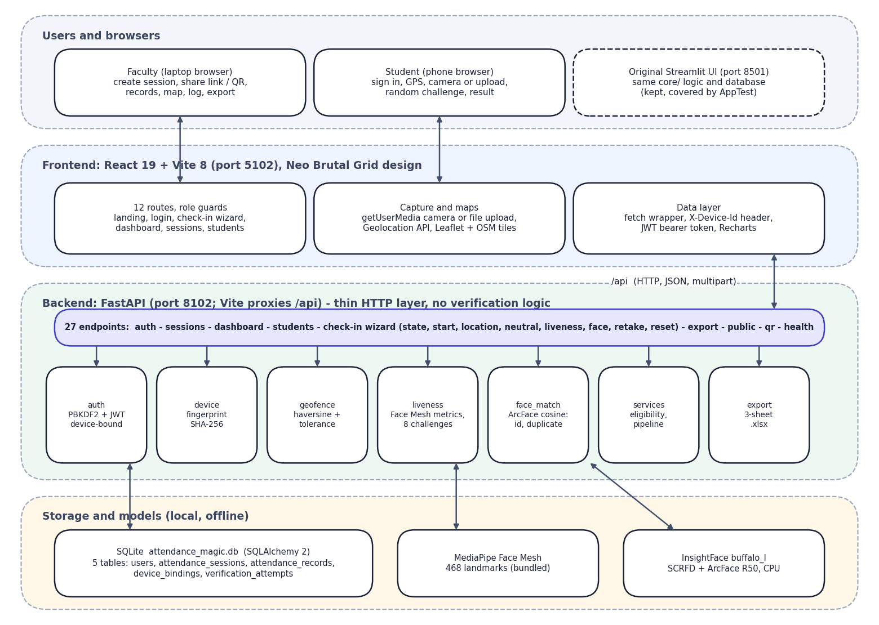
Fig. 5.1: System architecture of Attendance Magic

5.2 High-Level Workflow
The workflow has ten steps. The faculty member creates a session (1) and shares its link and QR code (2). The student opens the link and signs in (3); the server checks eligibility (4) and the geo-fence (5), issues a random live challenge (6) and verifies the face (7). A successful check-in writes the attendance record (8); the faculty member monitors records, map, log and analytics (9) and exports to Excel (10).
A failed stage stops the check-in with a plain reason and the attempt is logged. Three failed liveness tries lock the wizard until the student starts over.
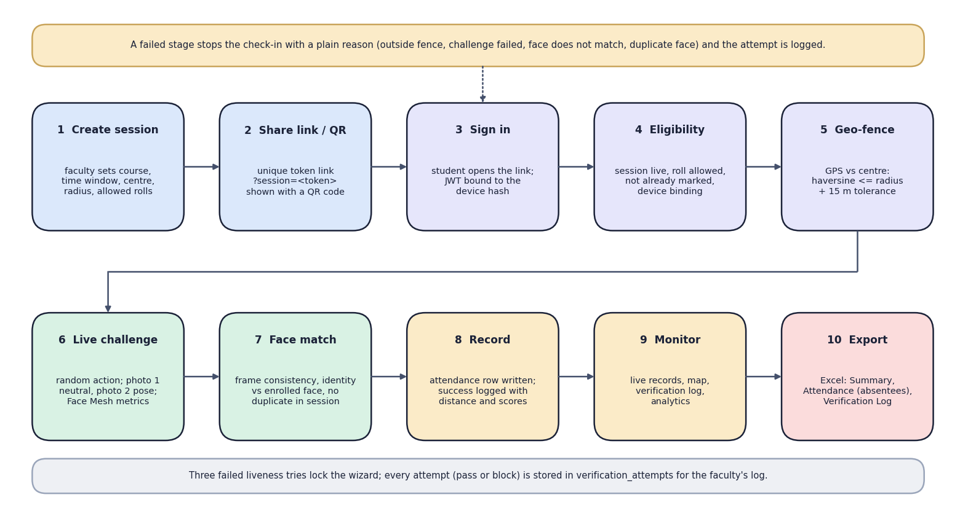
Fig. 5.2: High-level workflow from session creation to export

5.3 Data-Flow Diagrams (Levels 0, 1 and 2)
The data-flow diagrams use the Yourdon notation: ellipses are processes, open rectangles are data stores and rounded boxes are external entities.
The context diagram shows Attendance Magic as one process with two external entities. The faculty member sends session details, roll patterns and commands (close, reset devices) and receives the session link and QR code, records, map, log and the Excel export. The student sends credentials, a GPS fix and two photos and receives the result of each step, with reasons, scores and the attendance confirmation.
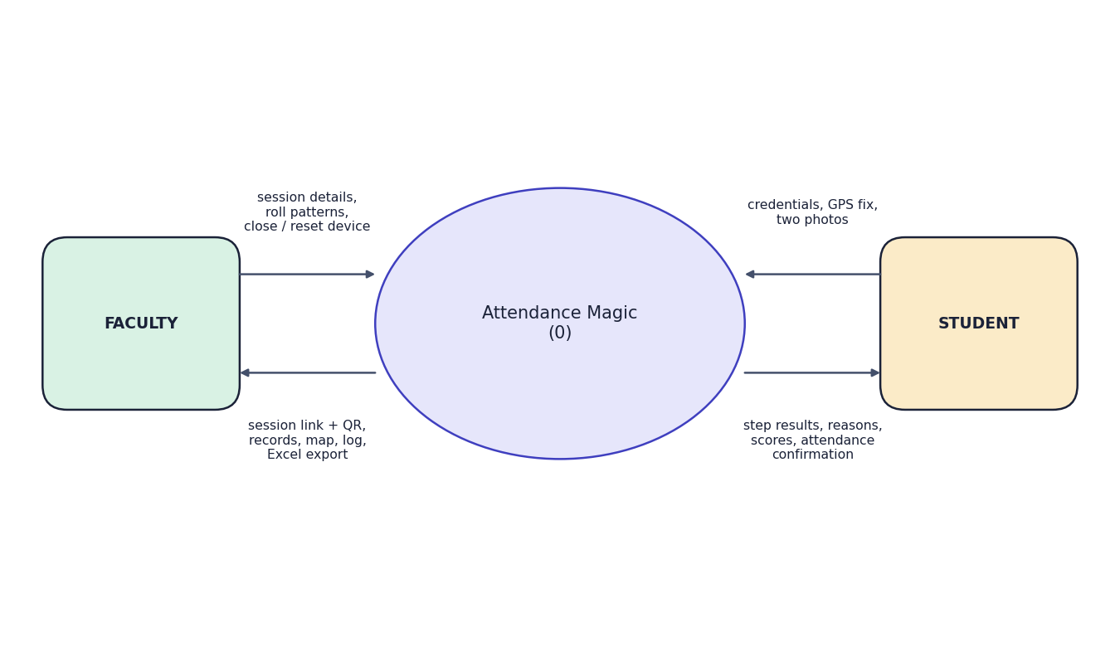
Fig. 5.3: Data-flow diagram, level 0 (context diagram)
Level 1 opens the system into eight processes and four data stores. Process 1 authenticates users against D1 (users). Process 2 manages sessions in D2 (attendance_sessions). Processes 3 to 6 form the student's verification chain: eligibility (reads D1 device bindings and D2 sessions), location, liveness and face verification. Process 7 writes the attendance record to D3 (attendance_records). Process 8 produces records, map, analytics and the Excel export from D2 and D3. Processes 3 to 7 append a row to D4 (verification_attempts) at every stage, shown by the dotted lines.
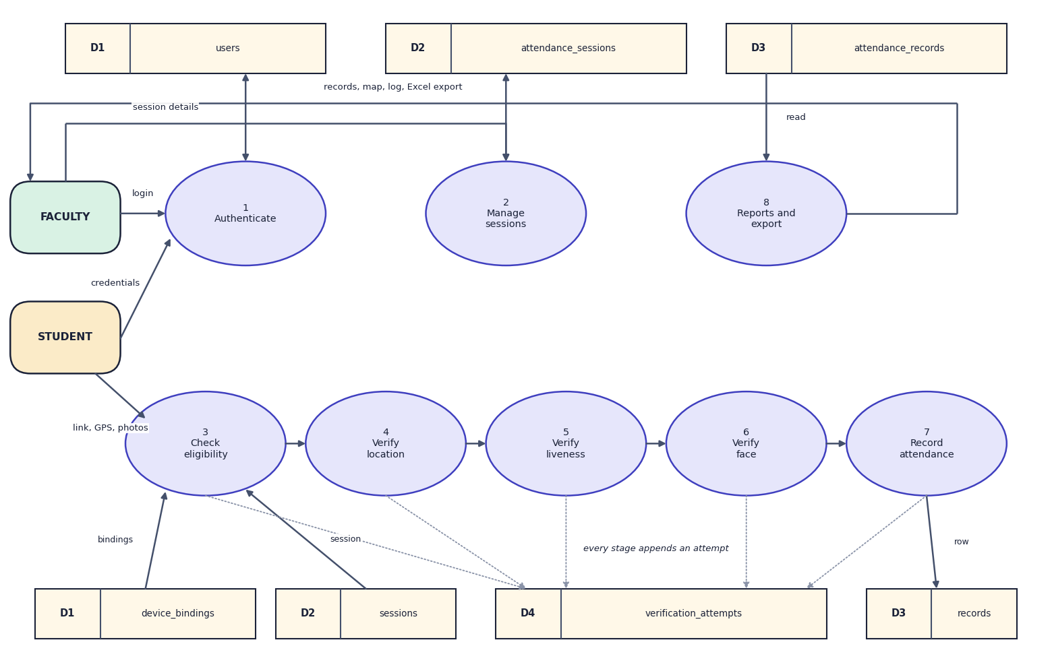
Fig. 5.4: Data-flow diagram, level 1
Level 2 opens the face-verification process into five steps. The two frames arriving from the liveness step are decoded and one face is detected in each (6.1). Frame consistency (6.2) requires the two photos to show the same person (cosine similarity at least 0.45). Identity (6.3) compares the first frame with the enrolled embedding in D1 (at least 0.40). The duplicate scan (6.4) compares it with every embedding already recorded in the session in D3 (maximum below 0.45). The decision (6.5) writes the reason and scores to D4 and either passes control to process 7 or returns the reason to the student.
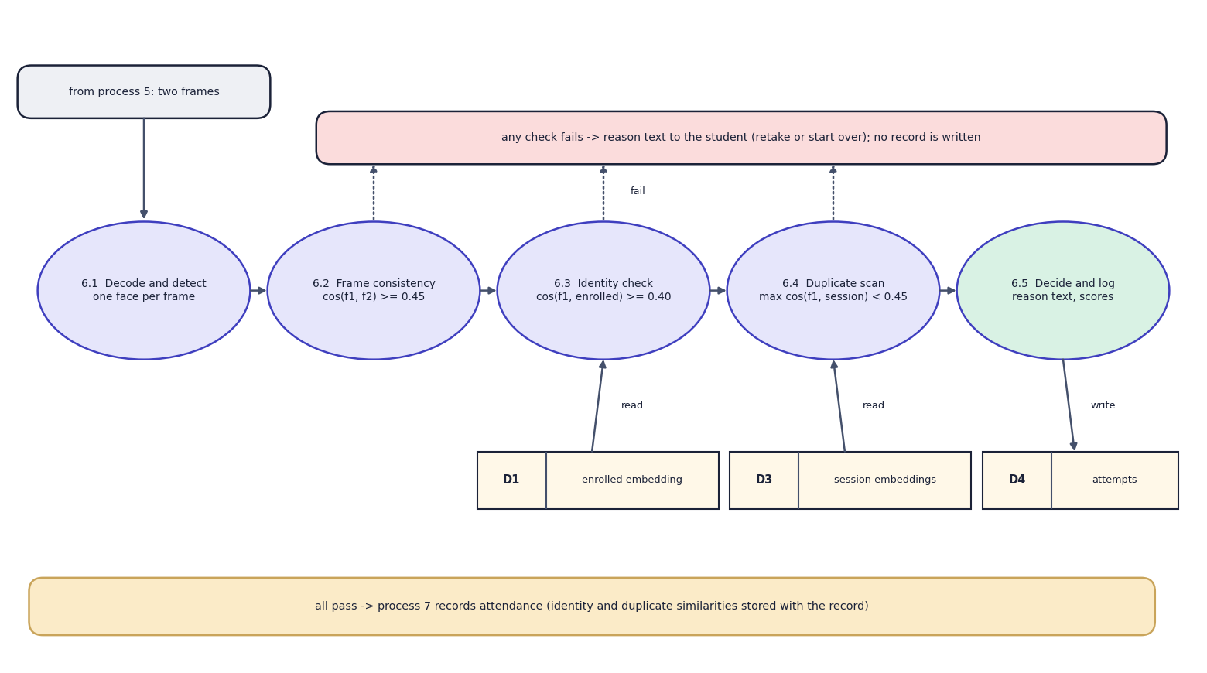
Fig. 5.5: Data-flow diagram, level 2: expansion of process 6 (verify face)

5.4 UML Diagrams

5.4.1 Use cases
The faculty member can create a time-bound session, set the geo-fence and roll patterns, share the link and QR code, view records, map, log and analytics, export to Excel, close a session or reset devices, and enrol a student's reference face. The student can register with a reference face, sign in with a device-bound token, pass the eligibility check, verify location, complete the random live challenge, pass face verification and view the result. Every student step is logged in verification_attempts.
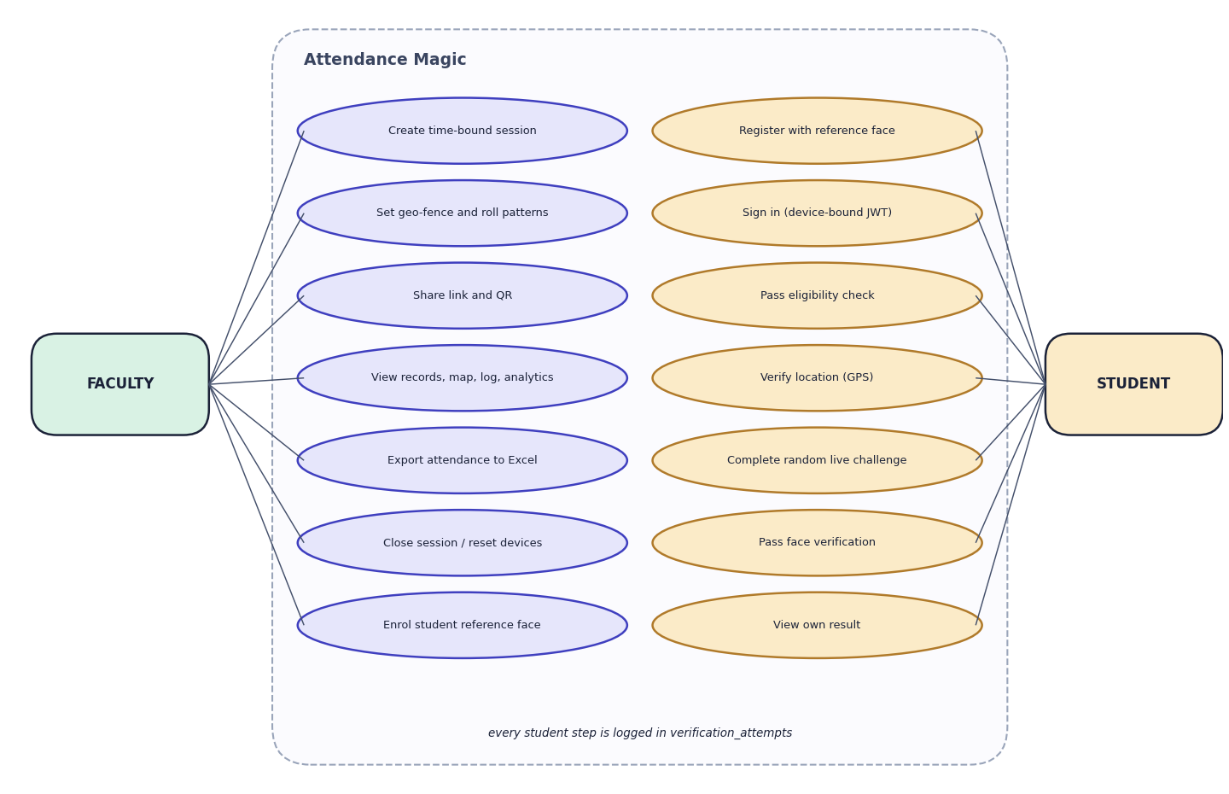
Fig. 5.6: Use-case diagram

5.4.2 Sequence of the main flow
The sequence follows the main flow. The student opens the session link and signs in; the React app posts the credentials with the device identifier to /api/auth/login, and core.services.authenticate verifies the PBKDF2 hash and issues a JWT carrying the device hash. POST /start runs check_eligibility (reading the session, the existing record and the device bindings and binding the device on first use). POST /location runs check_geofence. POST /liveness receives the two photos, runs Face Mesh on each and verify_challenge. POST /face embeds both photos, runs verify_faces against the enrolled and the session embeddings, re-checks eligibility and inserts the record and the success attempt. The result returns to the student as the 'Marked. Present.' screen.
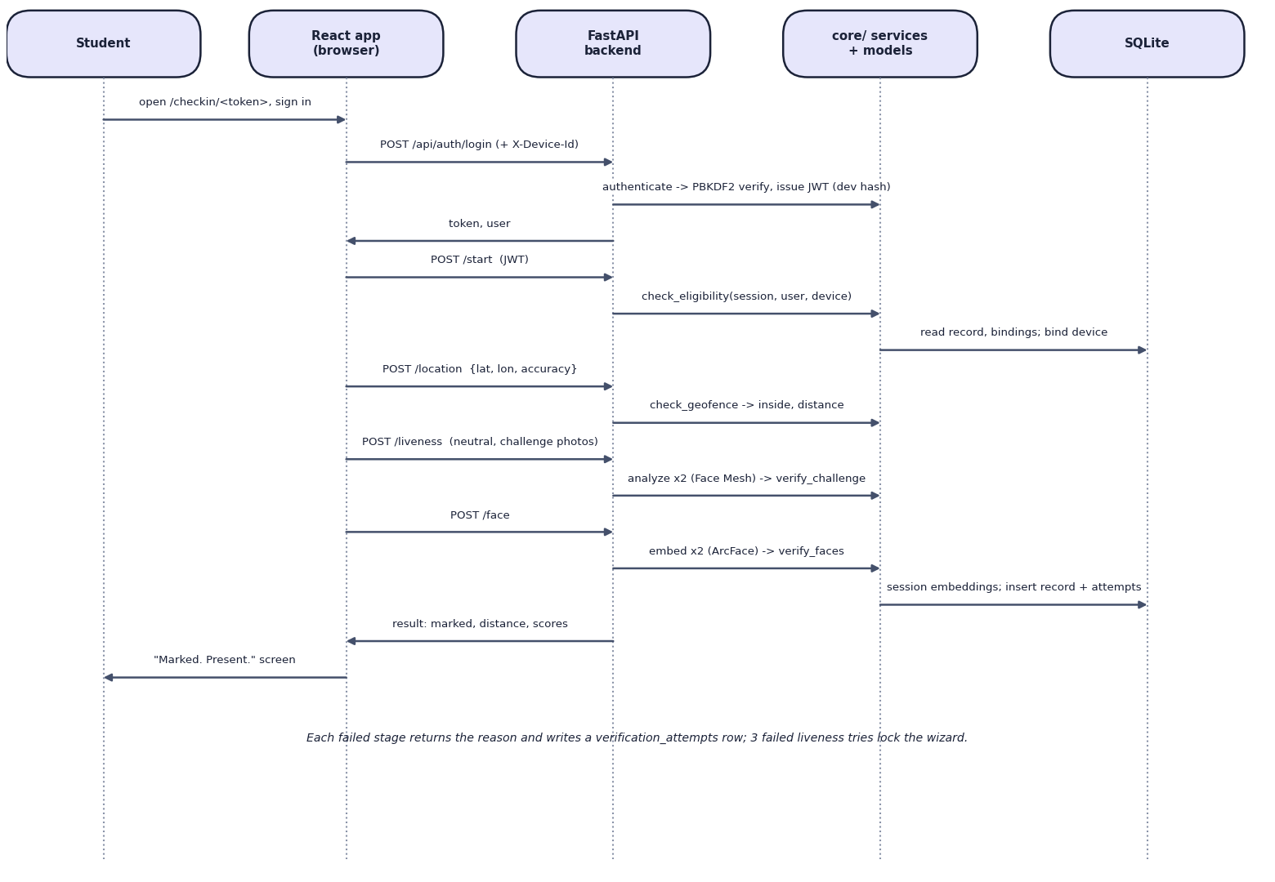
Fig. 5.7: Sequence diagram of a student check-in

5.4.3 Class diagram
The upper part of the class diagram shows the five persistent entities and their associations; AttendanceSession has the derived methods status (upcoming, live, expired or closed) and is_open. The lower part shows the modules of core/ and the plain result classes they return: MatchResult from face matching, FaceMetrics and LivenessResult from liveness, GeoResult from the geo-fence and Eligibility and PipelineResult from the services. Each decision returns a result object with a boolean outcome and a human-readable reason, which is what the API passes to the screen and writes to the log.

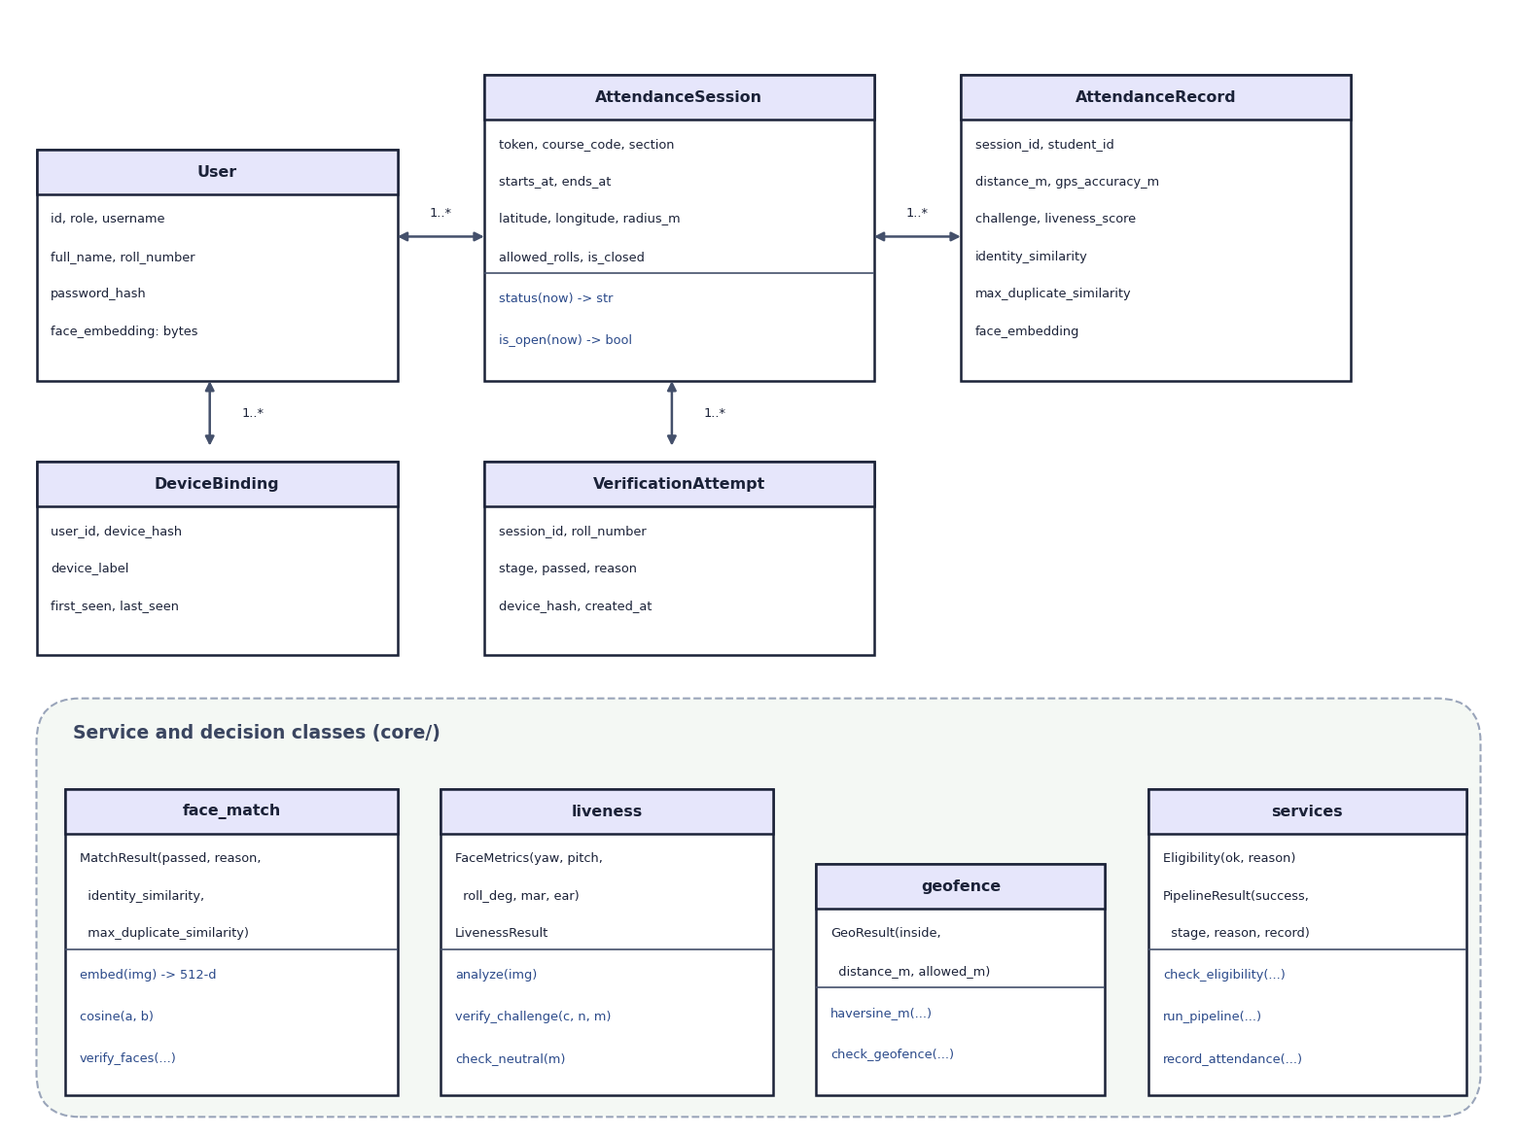
Fig. 5.8: UML class diagram: persistent entities and decision classes

5.4.4 Flowchart of the core algorithm
The flowchart is the control flow of run_pipeline and of the equivalent API wizard. After sign-in, eligibility is checked; then the geo-fence (accuracy at most 150 m and distance at most radius plus 15 m); then the liveness challenge on two photos (retry up to three times, with a new random challenge each time); then the embeddings of both photos; then frame consistency and identity; then the duplicate scan. Any 'no' leads to a block with a stored reason; only a full 'yes' chain records attendance.
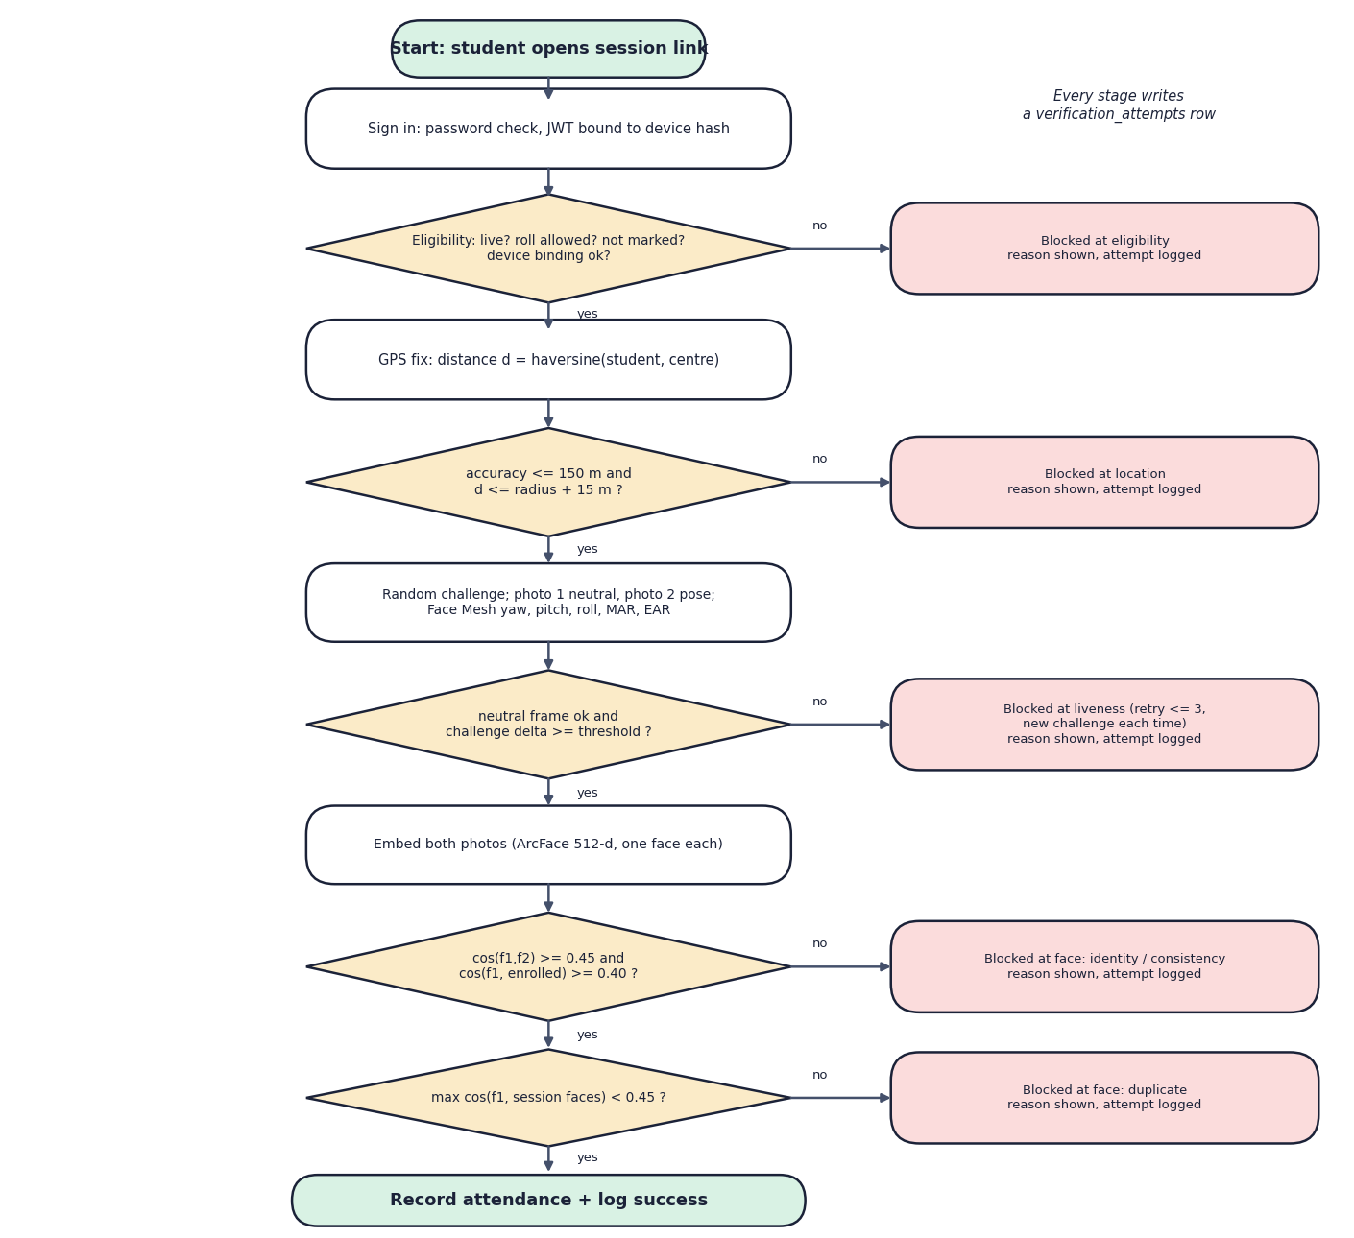
Fig. 5.9: Flowchart of the core check-in algorithm

5.5 Database Design
The schema is defined with SQLAlchemy 2 in core/models.py and created on first start (init_db). Timestamps are stored in UTC and displayed in the configured time zone (Asia/Kolkata by default). The tables and their columns are:
Table 5.1: Database tables
Table | Columns | Keys and constraints
users | id, role ('faculty' or 'student'), username, full_name, roll_number, password_hash, face_embedding (512 x float32, 2,048 bytes), created_at | PK id; username unique; roll_number unique
attendance_sessions | id, token, faculty_id, course_code, course_name, section, starts_at, ends_at, latitude, longitude, radius_m, allowed_rolls, is_closed, created_at | PK id; token unique and indexed; FK faculty_id -> users
attendance_records | id, session_id, student_id, roll_number, student_name, marked_at, latitude, longitude, gps_accuracy_m, distance_m, device_hash, challenge, liveness_score, identity_similarity, max_duplicate_similarity, face_embedding | PK id; FKs to sessions and users; UNIQUE(session_id, student_id)
device_bindings | id, user_id, device_hash, device_label, first_seen, last_seen | PK id; FK user_id; UNIQUE(user_id, device_hash)
verification_attempts | id, session_id, roll_number, stage (eligibility, location, liveness, face, success), passed, reason, device_hash, created_at | PK id; FK session_id

The database has five tables. users holds faculty and students (the student's reference embedding is a 512-float binary column). attendance_sessions belongs to a faculty user through faculty_id and holds the window, the geo-fence and the allowed roll patterns. attendance_records links a session and a student and stores the evidence of the check-in (distance, accuracy, challenge, liveness score, identity and duplicate similarities, device hash and the face embedding); a unique constraint on (session_id, student_id) makes a second record impossible. device_bindings stores the devices a student has used, unique per user and device. verification_attempts is the audit log, one row per stage attempt.

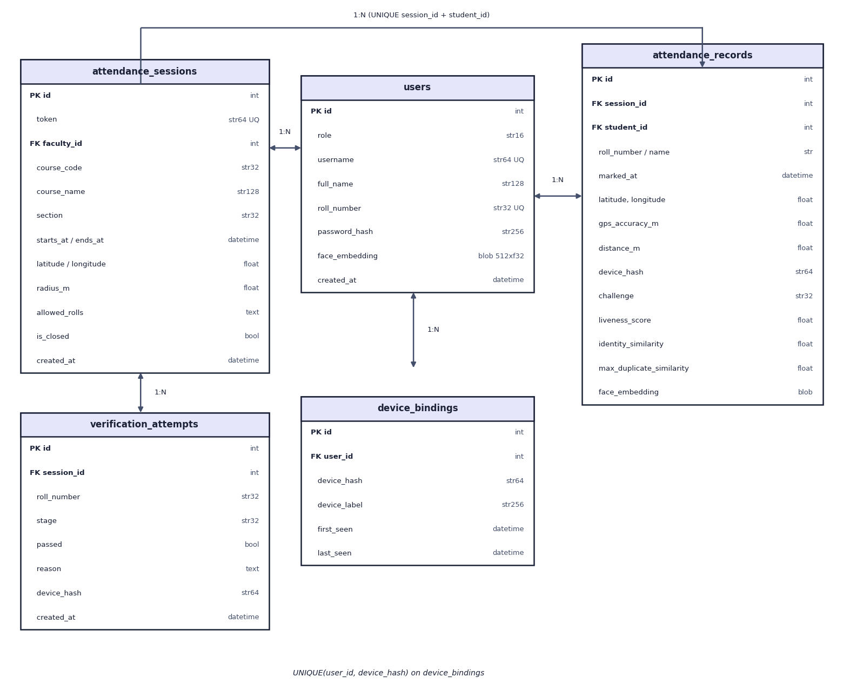
Fig. 5.10: Entity-relationship diagram of the Attendance Magic database (5 tables)

Design notes. The embedding is stored as raw float32 bytes (ndarray.tobytes) and read back with np.frombuffer, which is compact and exact. The record repeats the student's roll number and name so that an export stays correct if an account changes. The attempts table is append-only and carries no foreign key to users because attempts may involve roll numbers that do not exist as accounts.

5.6 Module Design
Table 5.2: Modules of Attendance Magic
Module | Responsibility | Key functions
config.py | All settings with environment overrides | radius, tolerance, accuracy limit, challenge thresholds, face thresholds, JWT, device limit
core/auth.py | Passwords and tokens | hash_password, verify_password, issue_token, verify_token (device claim)
core/device.py | Device identification | fingerprint (SHA-256 of user-agent, language, client hints and X-Device-Id), label
core/geofence.py | Presence by location | haversine_m, check_geofence
core/liveness.py | Random challenge | random_challenge, metrics_from_landmarks, analyze, check_neutral, verify_challenge, decode_image
core/face_match.py | Face identity | embed, cosine, verify_faces (consistency, identity, duplicate)
core/services.py | Business logic | register_user, authenticate, create_session, check_eligibility, record_attendance, run_pipeline, roll_allowed
core/export.py | Excel report | records_dataframe, to_excel_bytes (Summary, Attendance, Verification Log)
backend/api.py | HTTP layer | 27 endpoints, auth dependencies, check-in wizard state, QR generation
frontend/src | React application | 12 pages, UI components, camera and location components, API client

5.7 User Interface Design
The React interface follows a 'Neo Brutal Grid' design: thick black borders, hard offset shadows, a lime, coral and sky palette on an off-white grid, monospace labels and a light and dark theme. The design goals were legibility on a phone in bright light, large touch targets, and the reason for every outcome shown in words and colour (not colour alone).
- Public pages: landing page with live statistics, how-it-works page, sign-in for each role, registration with reference-face upload, and a page to paste a session link.
- Student check-in: a six-step stepper (Sign in, Eligibility, Location, Live challenge, Face match, Done) with the session header on top; each step shows one task and its error, if any.
- Faculty area: a sidebar (Dashboard, Sessions, New session, Students), KPI tiles, tabs for records, map, log and analytics on a session, and a drawer for managing one student.
- Accessibility: labelled controls, reduced-motion support and text labels next to every status colour.
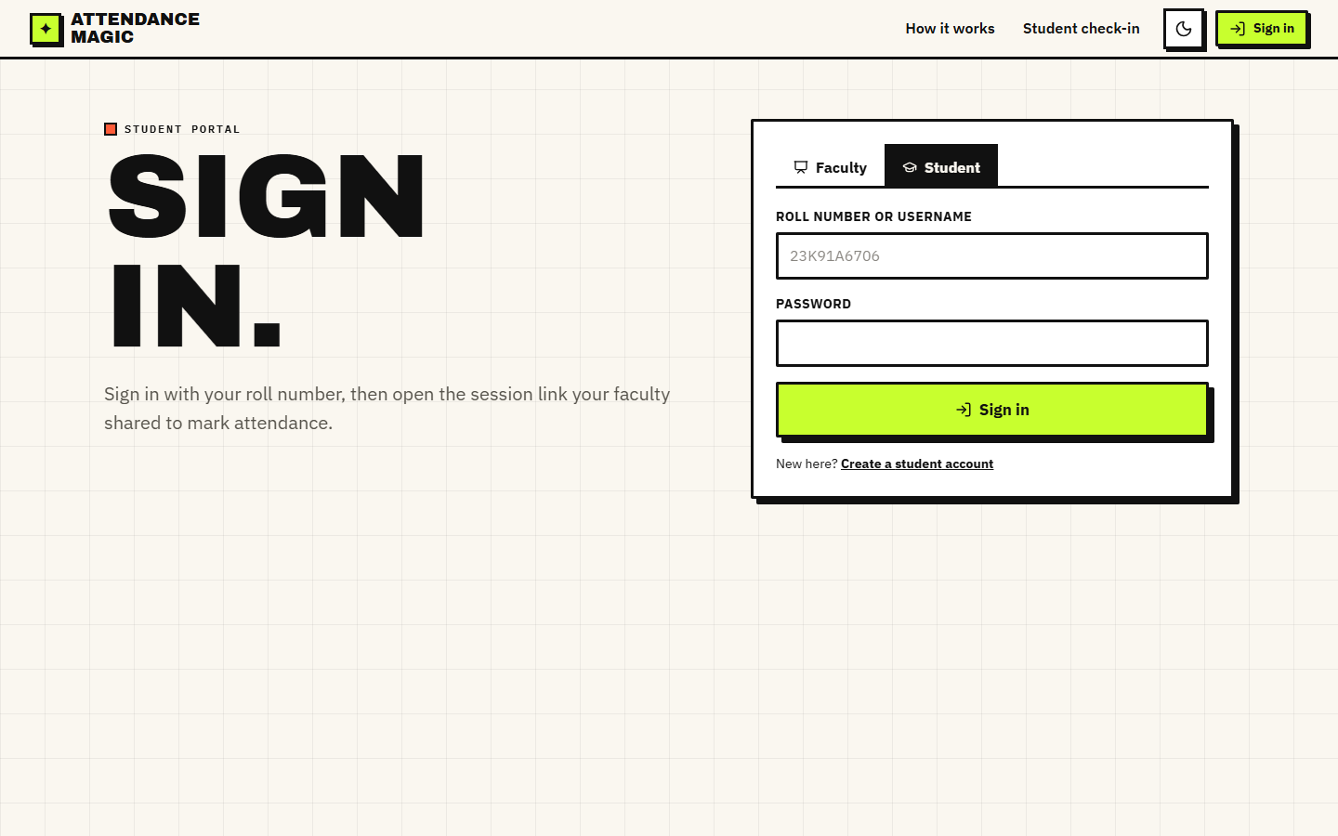
Fig. 5.11: Student sign-in screen
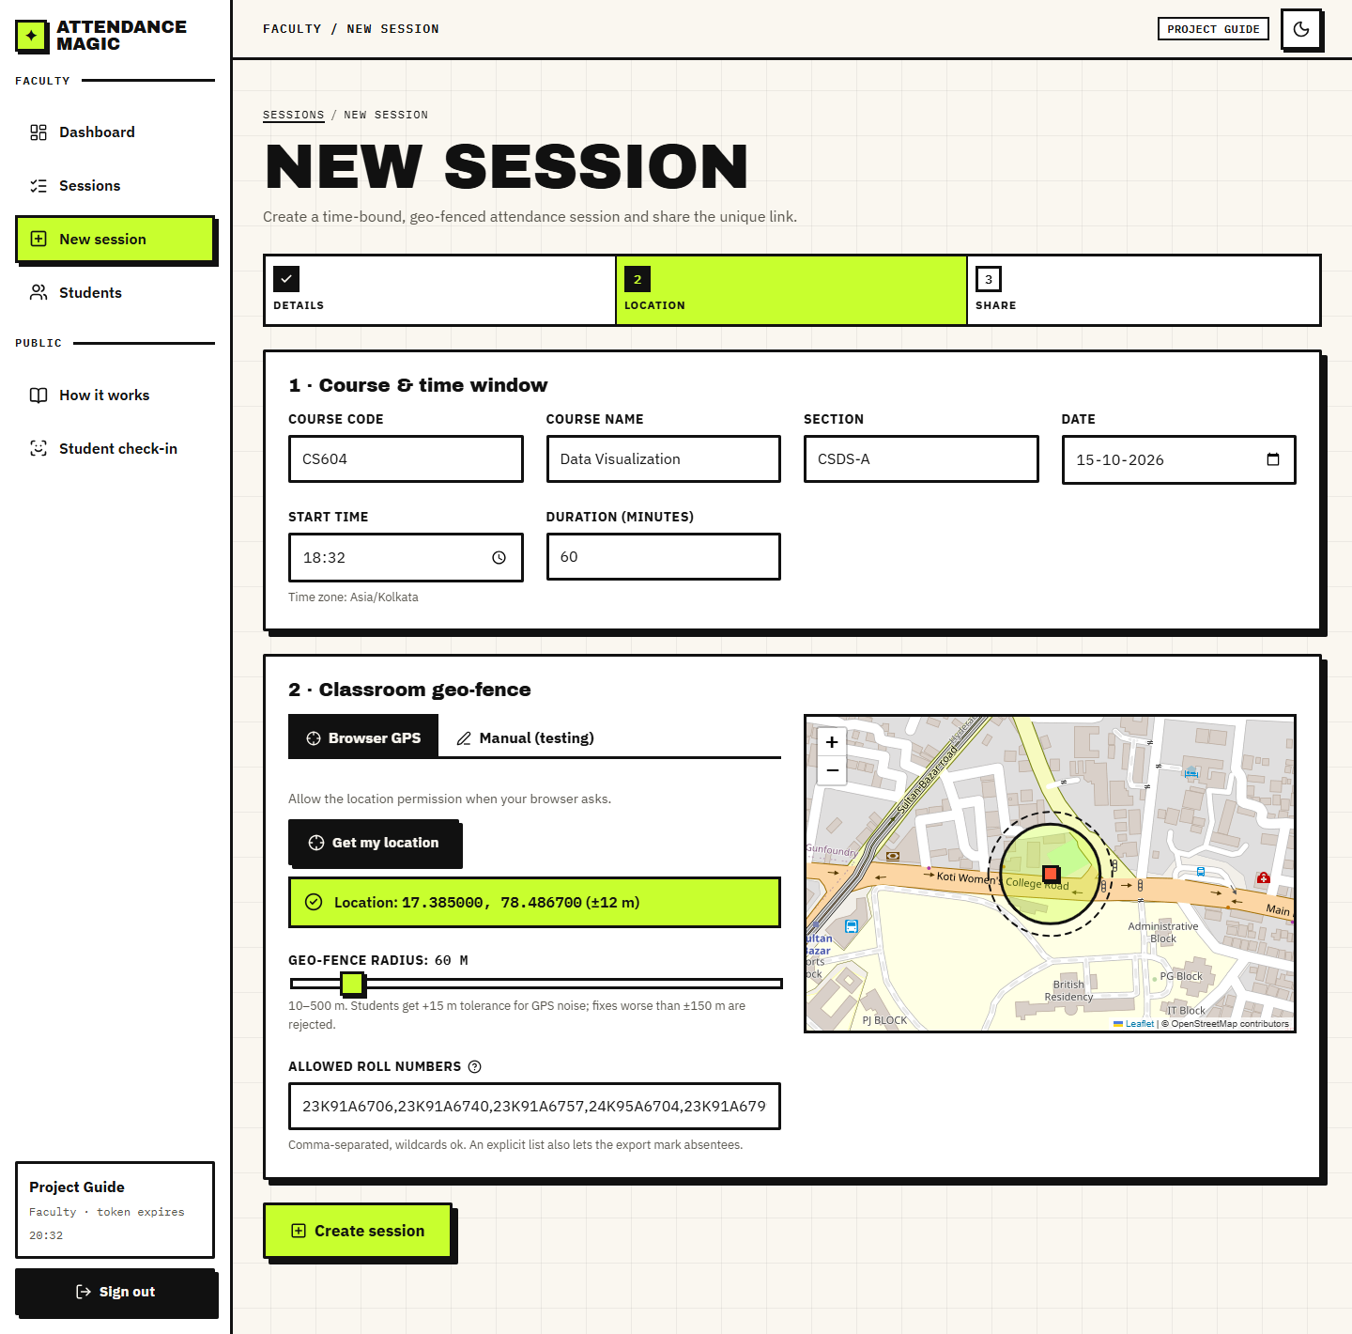
Fig. 5.12: New-session form with geo-fence preview

CHAPTER 6
METHODOLOGY AND SOFTWARE IMPLEMENTATION

6.1 Overall Methodology
The methodology is a verification chain rather than a learning pipeline: no model is trained. Two pre-trained models supply measurements (facial landmarks and face embeddings) and deterministic rules turn those measurements into decisions. The chain runs in the order of the check-in wizard, and each stage can end the check-in with a stored reason.
Table 6.1: Stages of the verification chain
Step | Input | Computation | Output / decision
1 Sign-in | username or roll number, password, X-Device-Id | PBKDF2-HMAC-SHA256 verify; JWT with device hash | token or 401
2 Eligibility | session, user, device hash | window, roll pattern, existing record, device record, device binding | eligible or reason
3 Location | latitude, longitude, accuracy | haversine distance; limit = radius + 15 m; accuracy <= 150 m | inside or reason
4 Challenge | neutral photo, challenge photo, challenge code | Face Mesh landmarks to yaw, pitch, roll, MAR, EAR; compare with thresholds | pass (score) or reason; retry up to 3
5 Face | the two photos | ArcFace 512-d embeddings; cosines: consistency, identity, duplicate | pass or reason
6 Record | all of the above | insert the attendance row and success attempt | record id; result screen

The same chain is available in two forms: services.run_pipeline executes it in one call (used by the demo script and tests) and the FastAPI wizard executes it step by step, keeping the intermediate state on the server. Both call the same functions of core/.

6.2 Dataset
There is no training dataset because no model is trained. Data enters the project in three ways.
Table 6.2: Data used in the project
Data | Source | Size | Use
LFW verification pairs | Labeled Faces in the Wild [9], pairs.txt protocol (research benchmark, downloaded from figshare, not redistributed) | 13,233 images, 5,749 people; 6,000 pairs (3,000 same, 3,000 different) in 10 folds of 600; 7,701 unique images used | Evaluate identity, duplicate and consistency thresholds
LFW stills | Same dataset | 1,000 random photos (seed 7); 157 identities with 10 or more photos | Neutral-frame, static replay, rotation and photo-bank attack experiments
Demo data | Created by scripts/seed_demo.py and capture_screenshots.py | 1 faculty and 6 student accounts, 2 sessions, 30 attempts logged in the live session | Screens, smoke test, walkthrough

Split. The LFW protocol is used exactly as published: the identity threshold is evaluated on all scored pairs, and the 10-fold accuracy (99.82% mean, standard deviation 0.22%) picks the best threshold on nine folds and tests on the tenth. The deployed thresholds (0.40 and 0.45) were set before the evaluation and were not tuned on it.
Licence and privacy. LFW images are news photographs of public figures, distributed for research on face recognition. They are used here only to evaluate the verification chain and, with their file names anonymised, as stand-ins for student photographs in the demo screenshots; they are not redistributed with the project. No student photographs were collected.

6.3 Preprocessing
- Image decoding. decode_image decodes the uploaded bytes with OpenCV and shrinks any image whose longer side exceeds 1,280 px (area interpolation) to keep inference fast on phone photos.
- Colour order. Images are kept in BGR for InsightFace and converted to RGB for MediaPipe.
- Single-face rule. Face Mesh must find exactly one face in each photo; InsightFace must find one face, or a second face whose width is at most half that of the largest face.
- Neutral frame. The first photo must be frontal (|yaw| <= 0.10) and the mouth closed (MAR <= 0.25), so that later changes are measured from a known pose.
- Mirroring. Selfie cameras mirror the image; with AM_CAMERA_MIRRORED = true the left and right challenges flip their sign so that 'turn left' refers to the student's left.
- Embedding normalisation. Embeddings are L2-normalised before storage and before every comparison, so a dot product is a cosine similarity.
- Roll patterns. Allowed roll numbers are upper-cased and matched with fnmatch; an explicit list (no wildcards) is also used to list absentees.
On the LFW sample the neutral-frame check accepted 329 of 1,000 photos (32.9%); it rejected 499 as not frontal, 92 for several faces, 79 for an open mouth and 1 for no face. The single-face rule of the recogniser rejected 1,208 of 7,701 LFW images (15.7%), 1,197 of them as 'more than one face'.

6.4 Algorithm Choice and Justification
Table 6.3: Algorithm choices
Decision | Chosen | Alternatives | Justification
Liveness approach | Active random challenge on landmark metrics | Passive texture / learned anti-spoofing [5], [12]; blink detection [11] | No extra model, works on any camera, thresholds are transparent, and the unpredictable action defeats a prepared photo; its weaknesses are measured (Chapter 8)
Landmarks | MediaPipe Face Mesh [8] (legacy solutions API, 468 points) | dlib 68 points, 3-D head-pose solvers | Fast on CPU, bundled model, includes lips and eyelids for MAR and EAR
Recogniser | InsightFace buffalo_l (SCRFD + ArcFace R50) [6], [7] | LBPH [1], FaceNet [13] | No per-student training; margin-trained embeddings; one reference photo; high verification accuracy (Section 8.2)
Similarity | Cosine on L2-normalised 512-d embeddings | Euclidean distance, classifier head | Standard for ArcFace; a dot product; thresholds are interpretable
Distance | Haversine on a sphere [14] | Vincenty [15] | 0.47% error (0.35 m at the 75 m limit) is far below GPS noise; far simpler
Tokens | JWT HS256 with a device claim [16] | Server sessions | Stateless API; a stolen token fails on another device
Password hash | PBKDF2-HMAC-SHA256, 200,000 iterations [17] | bcrypt, Argon2 | Available in the Python standard library; no extra dependency

6.5 Mathematical Formulation

6.5.1 Geo-fence
For a student at latitude phi2 and longitude lambda2 and a centre at phi1 and lambda1 (radians), the great-circle distance on a sphere of radius R = 6,371,000 m is
a = sin^2((phi2 - phi1)/2) + cos(phi1) cos(phi2) sin^2((lambda2 - lambda1)/2)
d = 2 R asin( sqrt(a) )

The check-in is accepted if the reported accuracy is at most 150 m and d <= r + t, where r is the session radius (60 m by default) and t = 15 m is the tolerance. Against the ellipsoidal (Vincenty) distance at latitude 17.385 degrees the spherical formula is off by a constant 0.469%, which is 0.35 m at 75 m and 4.7 m at 1 km.

6.5.2 Landmark metrics
Let p_i be the 2-D landmark with Face Mesh index i, and x_L, x_R the x-coordinates of the cheek landmarks 234 and 454. With nose tip 1, chin 152, eye corners (33, 133) and (263, 362), eyelids (159, 145) and (386, 374) and lip landmarks 13, 14, 61, 291:
yaw = (x_nose - min(x_L, x_R)) / |x_R - x_L| - 0.5
pitch = (y_nose - y_eyes_mid) / (y_chin - y_eyes_mid)
roll = atan2(y_Reye - y_Leye, x_Reye - x_Leye) (degrees)
MAR = |p13 - p14| / |p61 - p291|
EAR = mean over both eyes of |top - bottom| / |outer - inner|

A frontal, mouth-closed face has yaw near 0 (measured standard deviation 0.053 on accepted LFW frames), pitch near 0.35, MAR near 0.09 and EAR near 0.28.

6.5.3 Challenge decision
With the neutral frame n and the challenge frame c, and s = -1 for mirrored cameras and +1 otherwise, the measured quantity m is:
Table 6.4: Challenge decision rules
Challenge | Measured quantity m | Pass if | Score
Turn left / right | s (yaw_c - yaw_n) / -s (yaw_c - yaw_n) | m >= 0.12 | min(1, m/0.12)
Look up / down | -(pitch_c - pitch_n) / (pitch_c - pitch_n) | m >= 0.08 | min(1, m/0.08)
Tilt left / right | s (roll_c - roll_n) / -s (roll_c - roll_n) | m >= 12 degrees | min(1, m/12)
Open mouth | MAR_c | m >= 0.35 | min(1, m/0.35)
Close eyes | 2 x 0.18 - EAR_c | EAR_c <= 0.18 | min(1, m/0.18)

6.5.4 Face decision
With L2-normalised embeddings f1 (neutral photo), f2 (challenge photo), e (enrolled) and g_j (faces already recorded in the session), and cos(a, b) = a . b:
consistent = cos(f1, f2) >= 0.45
identity = cos(f1, e) >= 0.40
unique = max_j cos(f1, g_j) < 0.45
pass = consistent and identity and unique

The three thresholds are environment settings (AM_FRAME_CONSISTENCY_THRESHOLD, AM_IDENTITY_THRESHOLD, AM_DUPLICATE_THRESHOLD). Section 8.2 shows how they sit between the same-person and different-person similarity distributions.

6.6 Models, Configuration and Training
No model is trained in this project. There is therefore no training set, no loss curve, no epochs and no validation split; the documents of the earlier reviews that listed 'training configuration' refer to the configuration of the verification chain given below. Both models are used as published:
Table 6.5: Pre-trained models
Model | Role | Details
MediaPipe Face Mesh 0.10.21 (legacy solutions API) | Landmarks for liveness | static_image_mode, up to 3 faces, refine_landmarks on, min detection confidence 0.5; 468 landmarks; bundled model; CPU
InsightFace buffalo_l (insightface 2.0, ONNX Runtime 1.31, CPUExecutionProvider) | Detection and recognition | detection (SCRFD) and recognition (ArcFace ResNet-50) modules only; det_size 640 x 640; 512-d embeddings; about 280 MB download on first use

Table 6.6: Configuration of the verification chain
Setting | Default | Environment variable
Geo-fence radius / tolerance / accuracy limit | 60 m / 15 m / 150 m | AM_DEFAULT_RADIUS_M, AM_GEOFENCE_TOLERANCE_M, AM_MAX_GPS_ACCURACY_M
Challenge thresholds | yaw 0.12, pitch 0.08, roll 12 deg, MAR 0.35, EAR 0.18 | AM_LIVENESS_YAW_DELTA, _PITCH_DELTA, _ROLL_DEG, _MAR, _EAR
Neutral frame | |yaw| <= 0.10, MAR <= 0.25 | (constants in config.py)
Face thresholds | consistency 0.45, identity 0.40, duplicate 0.45 | AM_FRAME_CONSISTENCY_THRESHOLD, AM_IDENTITY_THRESHOLD, AM_DUPLICATE_THRESHOLD
Enrolment required | true | AM_REQUIRE_ENROLLMENT
Devices per student | 1 | AM_MAX_DEVICES_PER_STUDENT
JWT validity / password iterations | 120 min / 200,000 | AM_JWT_EXPIRY_MINUTES / (constant)
Liveness tries | 3 | (constant in ui/student.py)
Camera mirrored | true | AM_CAMERA_MIRRORED
Time zone / database | Asia/Kolkata / SQLite file | AM_TIMEZONE / DATABASE_URL

6.7 Application Architecture
The back end is a FastAPI application (backend/api.py). At start-up it creates the tables and loads the two models in a background thread, so the first request after start-up does not pay the model-loading time (0.8 s and 1.5 s measured). Every protected endpoint declares a dependency that verifies the bearer token against the device hash recomputed from the request (current_claims), and a second dependency that enforces the role (faculty_claims or student_claims).
Check-in wizard state. A student's progress is kept in a server-side dictionary keyed by (user, session, device): the step, the current random challenge, the number of failed liveness tries, the GPS fix, the distance, the liveness score and, between the liveness and face steps, the two photographs as bytes. The photographs are dropped from the state after a successful record, the whole state on reset and on sign-out, and the photographs are never written to disk. The React page reads the state from /state when it loads, so a refresh returns the student to the same step.
Front end. React 19 with React Router 7; each page is a lazy-loaded chunk (the production build splits 20 chunks, the largest 581 kB or 194 kB gzipped). A small fetch wrapper adds the device id and the token and turns error responses into readable messages. The camera component calls getUserMedia, mirrors the captured frame to match camera_mirrored, and every photo slot has an upload tab for testing without a camera. Maps use Leaflet with OpenStreetMap tiles.

6.8 Key Code Walkthroughs

6.8.1 Geo-fence check
check_geofence rejects a fix whose reported accuracy is worse than the limit, then compares the haversine distance with the radius plus the tolerance. The returned object carries the distance, the allowed distance and a sentence for the student.
Listing: core/geofence.py: check_geofence
def check_geofence(
student_lat: float,
student_lon: float,
center_lat: float,
center_lon: float,
radius_m: float,
accuracy_m: float | None = None,
) -> GeoResult:
"""
Verify a student's GPS position against the session boundary.

The allowed distance is radius + a small fixed tolerance for GPS noise.
Readings with very poor accuracy are rejected outright.
"""
if accuracy_m is not None and accuracy_m > config.MAX_GPS_ACCURACY_M:
return GeoResult(
False,
haversine_m(student_lat, student_lon, center_lat, center_lon),
radius_m,
f"GPS accuracy too low (±{accuracy_m:.0f} m). Move to an open area and retry.",
)

distance = haversine_m(student_lat, student_lon, center_lat, center_lon)
allowed = radius_m + config.GEOFENCE_TOLERANCE_M
if distance <= allowed:
return GeoResult(True, distance, allowed, f"Inside geo-fence ({distance:.1f} m from centre).")
return GeoResult(
False,
distance,
allowed,
f"Outside geo-fence: you are {distance:.0f} m away, limit is {allowed:.0f} m.",
)

6.8.2 Liveness: landmark metrics and challenge decision
Listing: core/liveness.py: metrics_from_landmarks
def metrics_from_landmarks(pts: np.ndarray, n_faces: int = 1) -> FaceMetrics:
"""
Compute pose/expression metrics from an (N, 2) array of normalised landmark
coordinates (x, y in 0..1). Pure numpy so it is unit-testable without MediaPipe.
"""
nose, chin = pts[NOSE_TIP], pts[CHIN]
fl, fr = pts[FACE_LEFT], pts[FACE_RIGHT]
x_left, x_right = min(fl[0], fr[0]), max(fl[0], fr[0])
yaw = (nose[0] - x_left) / max(x_right - x_left, 1e-6) - 0.5

l_eye_c = (pts[L_EYE_OUTER] + pts[L_EYE_INNER]) / 2
r_eye_c = (pts[R_EYE_OUTER] + pts[R_EYE_INNER]) / 2
eyes_mid = (l_eye_c + r_eye_c) / 2
pitch = (nose[1] - eyes_mid[1]) / max(chin[1] - eyes_mid[1], 1e-6)

# image-left eye -> image-right eye angle
left_eye, right_eye = (l_eye_c, r_eye_c) if l_eye_c[0] < r_eye_c[0] else (r_eye_c, l_eye_c)
roll_deg = math.degrees(math.atan2(right_eye[1] - left_eye[1], right_eye[0] - left_eye[0]))

mar = _dist(pts[LIP_TOP], pts[LIP_BOTTOM]) / max(_dist(pts[MOUTH_LEFT], pts[MOUTH_RIGHT]), 1e-6)

ear_l = _dist(pts[L_EYE_TOP], pts[L_EYE_BOTTOM]) / max(_dist(pts[L_EYE_OUTER], pts[L_EYE_INNER]), 1e-6)
ear_r = _dist(pts[R_EYE_TOP], pts[R_EYE_BOTTOM]) / max(_dist(pts[R_EYE_OUTER], pts[R_EYE_INNER]), 1e-6)
ear = (ear_l + ear_r) / 2

return FaceMetrics(n_faces=n_faces, yaw=float(yaw), pitch=float(pitch), roll_deg=float(roll_deg),
mar=float(mar), ear=float(ear))

Listing: core/liveness.py: verify_challenge
def verify_challenge(challenge: str, neutral: FaceMetrics, chal: FaceMetrics) -> LivenessResult:
"""Compare the challenge frame against the neutral frame for the requested action."""
if err := check_neutral(neutral):
return LivenessResult(False, 0.0, f"Neutral photo problem: {err}", neutral, chal)
if chal.n_faces == 0:
return LivenessResult(False, 0.0, "No face detected in the challenge photo.", neutral, chal)
if chal.n_faces > 1:
return LivenessResult(False, 0.0, "More than one face in the challenge photo.", neutral, chal)

# In a mirrored (selfie) image the student's left is the image's left, so a
# LEFT turn moves the nose to smaller x (negative yaw). Non-mirrored flips it.
direction = -1.0 if config.CAMERA_MIRRORED else 1.0

d_yaw = chal.yaw - neutral.yaw
d_pitch = chal.pitch - neutral.pitch
d_roll = chal.roll_deg - neutral.roll_deg

def result(measured: float, threshold: float, label: str) -> LivenessResult:
measured = float(measured)
score = max(0.0, min(1.0, measured / threshold)) if threshold > 0 else 0.0
passed = bool(measured >= threshold)
reason = (f"{label}: measured {measured:.3f}, required {threshold:.3f} — "
+ ("PASS" if passed else "not enough movement, try a bigger motion"))
return LivenessResult(passed, round(score, 3), reason, neutral, chal)

if challenge == "TURN_LEFT":
return result(direction * d_yaw, config.LIVENESS_YAW_DELTA, "Head turn left")
if challenge == "TURN_RIGHT":
return result(-direction * d_yaw, config.LIVENESS_YAW_DELTA, "Head turn right")
if challenge == "LOOK_UP":
return result(-d_pitch, config.LIVENESS_PITCH_DELTA, "Look up")
if challenge == "LOOK_DOWN":
return result(d_pitch, config.LIVENESS_PITCH_DELTA, "Look down")
if challenge == "TILT_LEFT":
return result(direction * d_roll, config.LIVENESS_ROLL_DEG, "Tilt left")
if challenge == "TILT_RIGHT":
return result(-direction * d_roll, config.LIVENESS_ROLL_DEG, "Tilt right")
if challenge == "OPEN_MOUTH":
return result(chal.mar, config.LIVENESS_MOUTH_OPEN_MAR, "Mouth open ratio")
if challenge == "CLOSE_EYES":
# Lower EAR = more closed. Score by how far below the threshold we are.
measured = config.LIVENESS_EYES_CLOSED_EAR - chal.ear + config.LIVENESS_EYES_CLOSED_EAR
r = result(measured, config.LIVENESS_EYES_CLOSED_EAR, "Eyes closed")
r.reason = (f"Eyes closed: eye-aspect-ratio {chal.ear:.3f}, must be below "
f"{config.LIVENESS_EYES_CLOSED_EAR:.3f} — " + ("PASS" if r.passed else "eyes still open"))
return r
return LivenessResult(False, 0.0, f"Unknown challenge {challenge}", neutral, chal)

6.8.3 Face decision
Listing: core/face_match.py: verify_faces
def verify_faces(
live_embedding: np.ndarray,
enrolled_embedding: np.ndarray | None,
session_embeddings: list[tuple[str, np.ndarray]],
second_frame_embedding: np.ndarray | None = None,
) -> MatchResult:
"""
1. Both captured frames must be the same person (no swapping people mid-check).
2. Live face must match the enrolled reference face (identity).
3. Live face must NOT match any face already recorded in this session under
another roll number (duplicate / proxy check).
"""
consistency = None
if second_frame_embedding is not None:
consistency = cosine(live_embedding, second_frame_embedding)
if consistency < config.FRAME_CONSISTENCY_THRESHOLD:
return MatchResult(
False,
f"The two photos appear to be different people (similarity {consistency:.2f}).",
frame_consistency=consistency,
)

identity = None
if enrolled_embedding is not None:
identity = cosine(live_embedding, enrolled_embedding)
if identity < config.IDENTITY_THRESHOLD:
return MatchResult(
False,
f"Face does not match the enrolled reference face for this roll number "
f"(similarity {identity:.2f}, required ≥ {config.IDENTITY_THRESHOLD:.2f}).",
identity_similarity=identity,
frame_consistency=consistency,
)
elif config.REQUIRE_ENROLLMENT:
return MatchResult(False, "No enrolled reference face. Please enrol your face first.",
frame_consistency=consistency)

max_dup, dup_of = 0.0, None
for roll, emb in session_embeddings:
s = cosine(live_embedding, emb)
if s > max_dup:
max_dup, dup_of = s, roll
if dup_of is not None and max_dup >= config.DUPLICATE_THRESHOLD:
return MatchResult(
False,
f"This face has already marked attendance in this session as {dup_of} "
f"(similarity {max_dup:.2f}). Proxy attendance blocked.",
identity_similarity=identity,
max_duplicate_similarity=max_dup,
duplicate_of=dup_of,
frame_consistency=consistency,
)

return MatchResult(
True,
"Face verified: identity matched and no duplicate in this session.",
identity_similarity=identity,
max_duplicate_similarity=max_dup if session_embeddings else None,
frame_consistency=consistency,
)

6.8.4 Eligibility and the pipeline
Listing: core/services.py: check_eligibility
def check_eligibility(session: AttendanceSession, user: User, device_hash: str,
device_label: str = "", now: datetime | None = None) -> Eligibility:
"""Session window, roll-number restriction, duplicate record, device binding."""
now = now or utcnow()
status = session.status(now)
if status != "live":
msgs = {"upcoming": "This session has not started yet.",
"expired": "This session has expired.",
"closed": "This session was closed by the faculty."}
return Eligibility(False, msgs[status])
if user.role != "student" or not user.roll_number:
return Eligibility(False, "Only student accounts can mark attendance.")
if not roll_allowed(session.allowed_rolls, user.roll_number):
return Eligibility(False, f"Roll number {user.roll_number} is not allowed in this session.")

with get_session() as db:
already = db.scalar(select(AttendanceRecord).where(
AttendanceRecord.session_id == session.id, AttendanceRecord.student_id == user.id))
if already:
return Eligibility(False, "Attendance already marked for this session.")

# One device may mark only one roll number per session.
other = db.scalar(select(AttendanceRecord).where(
AttendanceRecord.session_id == session.id, AttendanceRecord.device_hash == device_hash,
AttendanceRecord.student_id != user.id))
if other:
return Eligibility(False, f"This device already marked attendance for {other.roll_number} in this session.")

# Device binding: a student may use at most MAX_DEVICES_PER_STUDENT devices.
bindings = list(db.scalars(select(DeviceBinding).where(DeviceBinding.user_id == user.id)))
known = next((b for b in bindings if b.device_hash == device_hash), None)
if known:
known.last_seen = now
elif len(bindings) >= config.MAX_DEVICES_PER_STUDENT:
return Eligibility(False, "This device is not registered to your account. "
"Use your usual device or ask faculty to reset your devices.")
else:
db.add(DeviceBinding(user_id=user.id, device_hash=device_hash, device_label=device_label))
return Eligibility(True, "Eligible.")

Listing: core/services.py: run_pipeline
def run_pipeline(session: AttendanceSession, user: User, device_hash: str, lat: float, lon: float,
accuracy: float | None, challenge: str, neutral_bgr: np.ndarray,
challenge_bgr: np.ndarray, now: datetime | None = None) -> PipelineResult:
"""Run every check in order exactly as the UI does, logging each stage."""
roll = user.roll_number or user.username

elig = check_eligibility(session, user, device_hash, now=now)
log_attempt(session.id, roll, "eligibility", elig.ok, elig.reason, device_hash)
if not elig.ok:
return PipelineResult(False, "eligibility", elig.reason)

geo = geofence.check_geofence(lat, lon, session.latitude, session.longitude, session.radius_m, accuracy)
log_attempt(session.id, roll, "location", geo.inside, geo.reason, device_hash)
if not geo.inside:
return PipelineResult(False, "location", geo.reason)

live = liveness.verify_challenge(challenge, liveness.analyze(neutral_bgr), liveness.analyze(challenge_bgr))
log_attempt(session.id, roll, "liveness", live.passed, live.reason, device_hash)
if not live.passed:
return PipelineResult(False, "liveness", live.reason)

try:
emb_neutral = face_match.embed(neutral_bgr)
emb_chal = face_match.embed(challenge_bgr)
except face_match.FaceError as exc:
log_attempt(session.id, roll, "face", False, str(exc), device_hash)
return PipelineResult(False, "face", str(exc))

enrolled = face_match.from_bytes(user.face_embedding) if user.face_embedding else None
match = face_match.verify_faces(emb_neutral, enrolled, session_embeddings(session.id, user.id), emb_chal)
log_attempt(session.id, roll, "face", match.passed, match.reason, device_hash)
if not match.passed:
return PipelineResult(False, "face", match.reason)

rec = record_attendance(session, user, lat=lat, lon=lon, accuracy=accuracy, distance=geo.distance_m,
device_hash=device_hash, challenge=challenge, liveness_score=live.score,
identity_sim=match.identity_similarity, dup_sim=match.max_duplicate_similarity,
embedding=emb_neutral)
return PipelineResult(True, "success", "Attendance recorded.", rec)

6.9 Implementation Decisions and their Reasoning
Table 6.7: Implementation decisions
Decision | Alternatives considered | Reasoning
Pre-trained models, no training | Train a recogniser per class (as the base paper does) | ArcFace embeddings need one reference photo and no retraining; training data would have to be collected and protected
Random active challenge for liveness | Passive anti-spoofing model; blink detection | No extra model; works on any camera; transparent thresholds; cannot be prepared in advance. Its weakness against rotated and multiple photos was then measured
Two still photographs instead of video | Continuous video capture | Works with a browser file upload and a phone camera alike; small payload; simple server logic
Thin FastAPI layer over core/ | Rules inside the HTTP handlers | One implementation shared with the Streamlit UI and with scripts and tests
Wizard state on the server | State in the browser | Steps cannot be skipped (409); the random challenge and photos never leave the server's control
JWT with a device claim | Cookie sessions | Stateless API for phones; a stolen token fails on another device
Device hash from headers plus X-Device-Id | Cookies only | Stable across requests; combined with a per-browser identifier
Embeddings stored, photographs not | Store photographs | Smaller, less sensitive data; the duplicate scan needs only vectors
Haversine, tolerance and accuracy gate | Vincenty; no tolerance | 0.47% error is negligible against GPS noise; tolerance and gate absorb poor fixes
Conservative thresholds (0.40 and 0.45) | Equal-error threshold (0.19) | Margin against look-alikes; measured cost 1.3-2.9% retakes or missed duplicates
SQLite | PostgreSQL (the abstract mentioned Supabase) | Zero setup for one college; adequate for the measured load; PostgreSQL is available by DATABASE_URL
FastAPI and React | Django REST Framework (the abstract), Streamlit only | Typed models and automatic docs; a responsive phone-first interface; Streamlit kept as the original UI
Public benchmark and attack experiments | Only demo runs | Gives numbers that can be reproduced and exposes the weak points

6.10 API Design
All endpoints are under /api, accept and return JSON (photos as multipart form data) and are documented automatically at /docs (Figure in Appendix C). Errors use HTTP status codes with a detail message that the UI shows to the user: 400 invalid input, 401 not signed in or token problem, 403 wrong role, 404 not found, 409 wizard step out of order.
Table 6.8: REST API of Attendance Magic (27 endpoints)
Method and path | Role | Purpose
GET /api/health, /api/config, /api/models, /api/stats | public | status, public settings and thresholds, loaded models, landing-page totals
GET /api/qr?text= | public | QR code PNG for a link
POST /api/auth/register | public | create a faculty or student account (student: reference face required, checked for a frontal single face)
POST /api/auth/login, /logout; GET /api/auth/me | any | sign in (JWT bound to the device), sign out, current user and device
GET, POST /api/sessions; GET /api/sessions/{id} | faculty | list own sessions, create a session, detail with records, rows and attempts
POST /api/sessions/{id}/close; GET .../export | faculty | close a session; download the Excel report
GET /api/dashboard | faculty | aggregates: totals, per-session rows, checks by stage, latest attempts
GET /api/students; POST /api/students/{id}/reset-devices, /enroll | faculty | list students, remove device bindings, replace a reference face
GET /api/public/sessions/{token} | public | session header for the check-in page
GET /api/checkin/{token}/state; POST .../start, /location, /neutral, /liveness, /face, /retake, /reset | student | the check-in wizard (eligibility, location, neutral-frame check, challenge, face verification, retake, start over)

6.11 Security and Error Handling
Table 6.9: Security controls
Threat | Control | Evidence
Password disclosure | PBKDF2-HMAC-SHA256, 200,000 iterations, 16-byte random salt; constant-time comparison | test_password_hash_roundtrip
Token theft | JWT HS256 with 120-minute expiry and a device claim checked on every request | test_jwt_bound_to_device; smoke test: token from another device -> 401
Privilege misuse | Role dependencies; session ownership check (404 for another faculty's session) | smoke test: student on faculty API -> 403; faculty check-in -> 403
Forwarded link | Link grants only a sign-in page; every check still applies | demo scenarios 3-6
Repeat or proxy marking | UNIQUE(session_id, student_id); device may mark one roll per session; duplicate-face scan | smoke test; demo scenarios 2, 6, 8
Out-of-order calls | Wizard steps enforced on the server (HTTP 409) | api._require_step
Cross-origin abuse | CORS limited to localhost origins | api.py middleware
Bad input | Pydantic models, image decode errors -> 400, face errors -> reasons | api._read_image, FaceError

Known weaknesses. The default AM_JWT_SECRET is a placeholder and PyJWT warns that the 30-byte default is shorter than the recommended 32 bytes; it must be changed for any real use. There is no rate limit or lockout on sign-in, the manual-location tab is enabled by default for testing (AM_ALLOW_MANUAL_LOCATION) and must be disabled in production, and wizard state in memory is lost on restart.

6.12 Installation and Execution
Windows: run setup.bat once (creates a Python 3.11 virtual environment, installs the requirements, seeds the demo accounts and runs npm install) and run.bat every time; it starts the API on port 8102 and the React app on port 5102 and opens the browser. stop.bat stops both. Linux and macOS: pip install -r requirements.txt -r backend/requirements.txt, python scripts/seed_demo.py, uvicorn backend.api:app --port 8102 and npm run dev in frontend/. The original interface starts with streamlit run app.py. Full steps are in Appendix B and in docs/03_HOW_TO_RUN.md.

CHAPTER 7
SYSTEM TESTING

7.1 Testing Strategy
Testing combined four layers. Unit tests (pytest) check the pure functions of core/ with synthetic landmarks and embeddings so that they run without a camera. Model-backed tests run the real MediaPipe and InsightFace models on the sample photograph bundled with InsightFace. An API smoke test drives the whole FastAPI application in-process through its HTTP interface with the real models and a throw-away database. Scripted attack and benchmark experiments (scripts/eval_*.py) measure the behaviour of the checks on public images. The React interface was checked by a production build and by Playwright walkthroughs that produced the screenshots of Chapter 8.
Table 7.1: Test layers
Layer | Tool | Count / result
Unit and model-backed tests | pytest 9.1.1 (tests/test_core.py) | 23 tests passed in 17.8 s
API end-to-end smoke test | scripts/smoke_test.py (FastAPI TestClient, real models) | 41 of 41 checks passed in 9.9 s
Headless pipeline demo | scripts/demo_pipeline.py | 2 passes and 8 blocked attempts, each at the intended stage
Attack and threshold experiments | scripts/eval_*.py on LFW | Chapter 8
UI walkthrough | Playwright with Chrome (scripts/capture_screenshots.py) | 34 screens captured with data

7.2 Unit Tests
Table 7.2: Unit and model-backed tests (23 items in 13 test functions)
Test | Items | What it checks
test_password_hash_roundtrip | 1 | correct password verifies; wrong password and a malformed hash do not
test_jwt_bound_to_device | 1 | claims round-trip; a token presented from another device and a tampered token raise TokenError
test_haversine_known_distance | 1 | Charminar to Golconda Fort lies between 8 and 9 km (about 8.5 km)
test_geofence_inside_outside_and_accuracy | 1 | a point about 7 m away is inside, one 556 m away is outside, an accuracy of 1,000 m is rejected
test_metrics_from_synthetic_landmarks | 1 | yaw 0.2, pitch 0.6, roll 10 degrees, MAR 0.4 and EAR 0.25 are recovered from constructed 478-point landmarks
test_verify_challenge | 11 | with the mirrored-camera setting, each challenge passes for the right movement and fails for the wrong direction or too little movement
test_neutral_frame_must_be_frontal_and_single_face | 1 | a turned head and two faces are rejected, a frontal single face is accepted
test_verify_faces_identity_and_duplicate_logic | 1 | identity pass, wrong person, duplicate of another roll (duplicate_of set), frames of different people, missing enrolment (required and optional), embedding bytes round-trip
test_roll_patterns | 1 | wildcard and explicit roll patterns, case-insensitive; explicit lists are de-duplicated and wildcard lists return None
test_session_lifecycle_and_eligibility | 1 | live, upcoming, expired and closed sessions; device binding and reset; roll not allowed; record, 'already marked', one device one roll per session; session embeddings; success attempt logged; Excel bytes
test_models_on_sample_image | 1 | real models: two faces found in the sample photograph, one face for Face Mesh, a mirrored copy scores above 0.8 and two people below 0.3, a rotated copy passes TILT_LEFT and a still copy fails OPEN_MOUTH
test_streamlit_faculty_flow, test_streamlit_student_flow_to_liveness_step | 2 | Streamlit AppTest end-to-end flows of the original interface

7.3 Integration Tests
The API smoke test registers a faculty member and three students with reference faces, creates a live session and runs the real six-step wizard through HTTP. Its 41 checks cover:
Table 7.3: Groups of the API smoke test (41 checks, all passed)
Group | Checks
Meta (4) | health, 8 challenges in the configuration, models loaded, QR code returns a PNG
Registration and sign-in (10) | faculty registration, a student without a face is rejected, three students with faces, wrong-portal login 403, bad password 401, faculty login, /me with a device-bound token, token from another device 401
Session (4) | create a live session, public session by token, invalid token 404, faculty cannot check in
Student A check-in (8) | eligibility, outside the fence blocked, inside passes, neutral frame accepted, static photo fails the challenge (2 tries left), tilted frame passes liveness and face match, identity similarity above the threshold, second attempt 'already marked'
Proxy attempts (2) | same face under another roll blocked as duplicate; someone else's face blocked as identity mismatch
Faculty screens (13) | sessions list, session detail with blocked attempts, records, verification log, Excel export, dashboard totals, students list, reset devices, re-enrolment, student on faculty API 403, close session, closed session refuses check-in, stats

7.4 Functional Testing
Each functional requirement of Section 4.3 was exercised by at least one automated check or one of the scripted scenarios below. The scenarios were run with demo_pipeline.py (service layer), the smoke test (HTTP) and the UI walkthrough (browser).
Table 7.4: Functional scenarios
Scenario | Expected | Observed
Genuine student, inside the fence, right challenge | Attendance recorded | Recorded (distance 7.7 m, liveness 1.00)
Same student again | Blocked at eligibility | 'Attendance already marked for this session.'
Student 556 m away | Blocked at location | 'Outside geo-fence: you are 556 m away, limit is 75 m.'
Static photo for OPEN_MOUTH | Blocked at liveness | 'Mouth open ratio: measured 0.073, required 0.350'
Another person's face under this roll number | Blocked at identity | 'Face does not match ... similarity 0.02, required >= 0.40'
Same face under a second roll number | Blocked as duplicate | 'This face has already marked attendance in this session as 23K91A6706 (similarity 1.00)'
Roll number not on the list | Blocked at eligibility | 'Roll number 99X99X9999 is not allowed in this session.'
Second device for the same student | Blocked at eligibility | 'This device is not registered to your account.'
Three failed challenges | Wizard locked | 'Check-in locked after repeated failed liveness challenges'
Closed session | Refused | 'This session was closed by the faculty.'

In the demo pipeline the same photograph is used for enrolment and check-in, so the identity similarity is 1.00 there; with different photographs of one person (the UI walkthrough, using LFW images) the identity similarities were 0.59, 0.63 and 0.86.

7.5 Security Testing
Table 7.5: Security tests
Test | Result
Wrong password | HTTP 401 'Incorrect username / roll number or password.'
Student account on the faculty portal login | HTTP 403 'This account is a student account. Please use the student portal.'
Faculty token replayed from another device | HTTP 401 'This login token was issued to a different device.'
Tampered token | TokenError 'Invalid authentication token.'
Student token on a faculty endpoint | HTTP 403
Faculty token on the check-in endpoints | HTTP 403 'Faculty accounts cannot mark attendance.'
Check-in steps out of order | HTTP 409 'Complete the previous step first.'
Another faculty's session | HTTP 404 (not revealed)

Not performed: penetration testing, brute-force testing of sign-in, HTTPS configuration review and a review of the dependency versions for known vulnerabilities.

7.6 Validation and Edge Cases
Table 7.6: Edge cases
Case | Behaviour
No face, several faces or a turned head in the neutral photo | Rejected with a specific message before the challenge is evaluated
Second, small face in the background | Tolerated if its width is at most half that of the main face
Student has no enrolled face | Blocked with 'Please enrol your face first' when enrolment is required
GPS accuracy worse than 150 m | Blocked with 'GPS accuracy too low'
Session end before start, radius not positive | Session creation rejected
Duration outside 1-600 minutes, empty password under 6 characters | Rejected by the form and the API model
Session expires while the student is in the wizard | Eligibility is re-checked before the record is written; the check-in is refused
Page refresh in the middle of the wizard | Wizard state is read back from the server, the student continues at the same step
Explicit roll list | Absentees are listed in the records view and in the Excel export

7.7 Performance Testing
Measurements were made on an Intel Core i5-12500 (6 cores, 12 threads, 15.7 GB RAM) running Windows 11 with Python 3.11.9, CPU only. Other desktop applications were running; a run made while the CPU was at about 100% from other processes gave an embedding median of 277 ms instead of 176 ms, so the figures below should be read as typical rather than best case. Network time is excluded because the HTTP test uses an in-process client.
Table 7.7: Performance measurements
Stage (median / 95th percentile, ms) | Value
Model load at start: MediaPipe / InsightFace | 812 / 1547 (single load)
JPEG decode and resize (1280 x 886) | 4.8 / 8.5
MediaPipe landmarks, one photo | 6.8 / 8.8
Challenge decision | 0.004 / 0.006
InsightFace embedding, one photo | 176 / 244
Face decision with 30 session faces | 0.38 / 0.56
AI work for one check-in (2 landmark + 2 embedding passes) | 368 / 525
HTTP: login (PBKDF2) | 106 / 123
HTTP: eligibility / location | 13 / 15 and 8 / 10
HTTP: liveness (two uploads) | 23 / 27
HTTP: face match and record | 521 / 759
HTTP: complete check-in after login | 564 / 806 (40 runs)

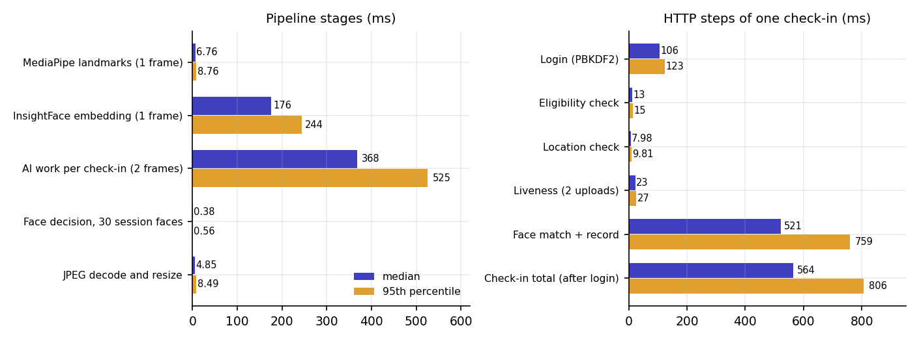
Fig. 7.1: Latency of the pipeline stages and of the HTTP steps of one check-in (median and 95th percentile)
The duplicate scan is a linear loop over the embeddings already recorded in the session. It took 0.14 ms for 10 faces, 1.15 ms for 100, 11.9 ms for 1,000 and 41 ms for 5,000, so a lecture-sized session adds no noticeable time.
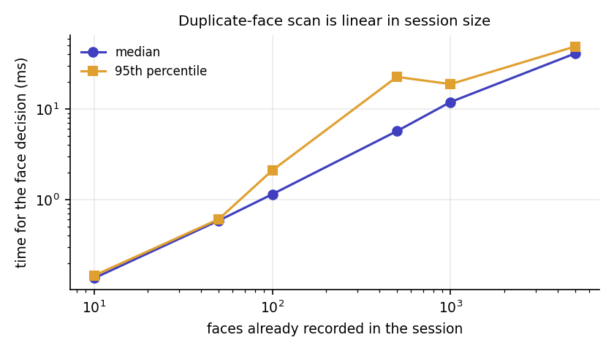
Fig. 7.2: Time of the duplicate-face scan against the number of faces recorded in the session
Not measured: concurrent users (a single uvicorn process serialises model inference behind a lock), memory use, other hardware, mobile network latency.

7.8 User Acceptance
No user-acceptance test with real faculty or students was carried out. The interface was verified by the team through the walkthrough that produced the screenshots. A trial with volunteers is the first item of future work: it should record the genuine pass rate of each challenge, the number of retakes per check-in, the time to complete a check-in on a phone and a short usability questionnaire.

7.9 Limits of the Testing Done
- All face photographs are still images from LFW or stand-ins for student photographs; no live camera, phone browser or human volunteer was involved.
- The challenge photo in the automated flows is either a real second photograph that satisfies the issued challenge or a rotated copy for the tilt challenges; this exercises the logic but is not the same as a person performing the action.
- GPS positions are supplied by the test (or by the browser's emulated geolocation); real phone GPS behaviour was not measured.
- No load, stress, soak or penetration testing was done; the tests run in one process on one machine.
- Coverage was not measured with a coverage tool; the 23 tests concentrate on core/, and the React interface has no automated unit tests.

CHAPTER 8
RESULTS AND OUTPUT SCREENS

8.1 Output Screens
All screens below are real captures of the running application at a width of 1440 px with demo data in it: two sessions, a closed one with four students present and a live one with three present and seven blocked attempts. Face photographs are public LFW images used as stand-ins for student photographs (their file names were anonymised) because the project holds no student photographs and no camera was attached; camera capture was replaced by the application's own Upload photo tab. Nothing is mocked up.
The public front page with the Student check-in and Faculty actions and live statistics read from /api/stats (sessions, check-ins, blocked attempts, students enrolled).
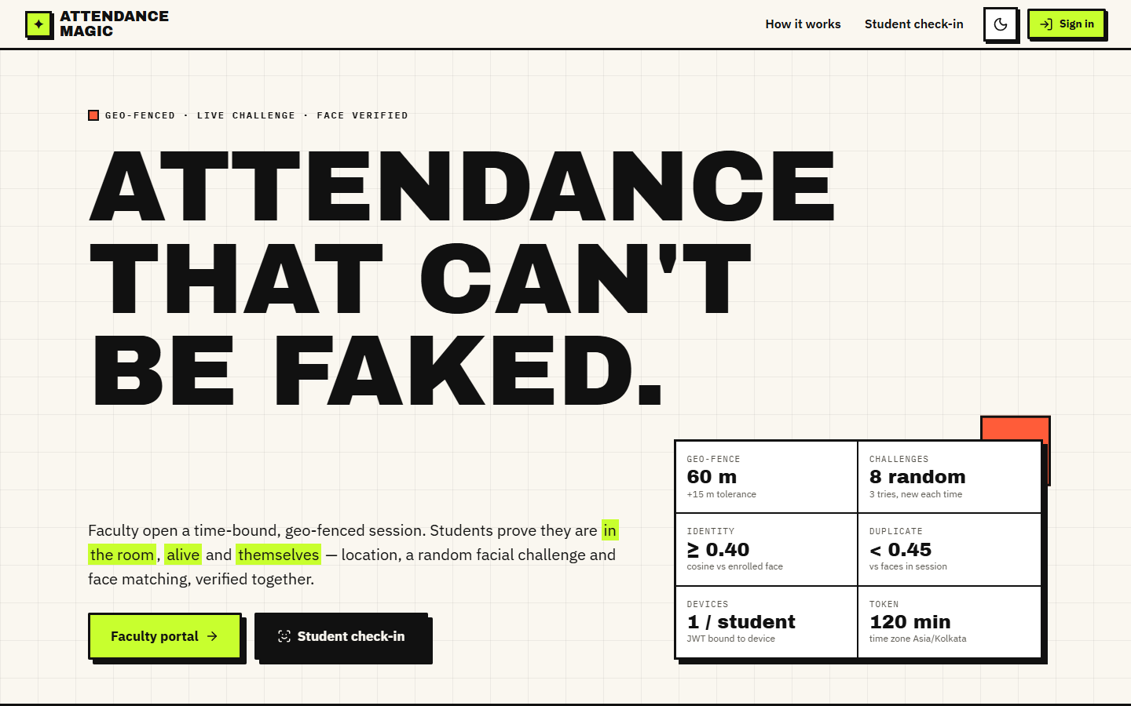
Fig. 8.1: Landing page
Sign-in for students with a roll number or username; the JWT issued on success is bound to the browser's device hash.
Fig. 8.2: Student sign-in
Faculty enter the course, section, date, start time, duration, the classroom location (browser GPS or manual coordinates), the radius (10-500 m slider) and the allowed roll numbers; the map previews the fence and its 15 m tolerance ring.
Fig. 8.3: New session form with geo-fence preview
After creation the page shows the unique link and a QR code to display in class, with a summary of the window, radius and allowed rolls.
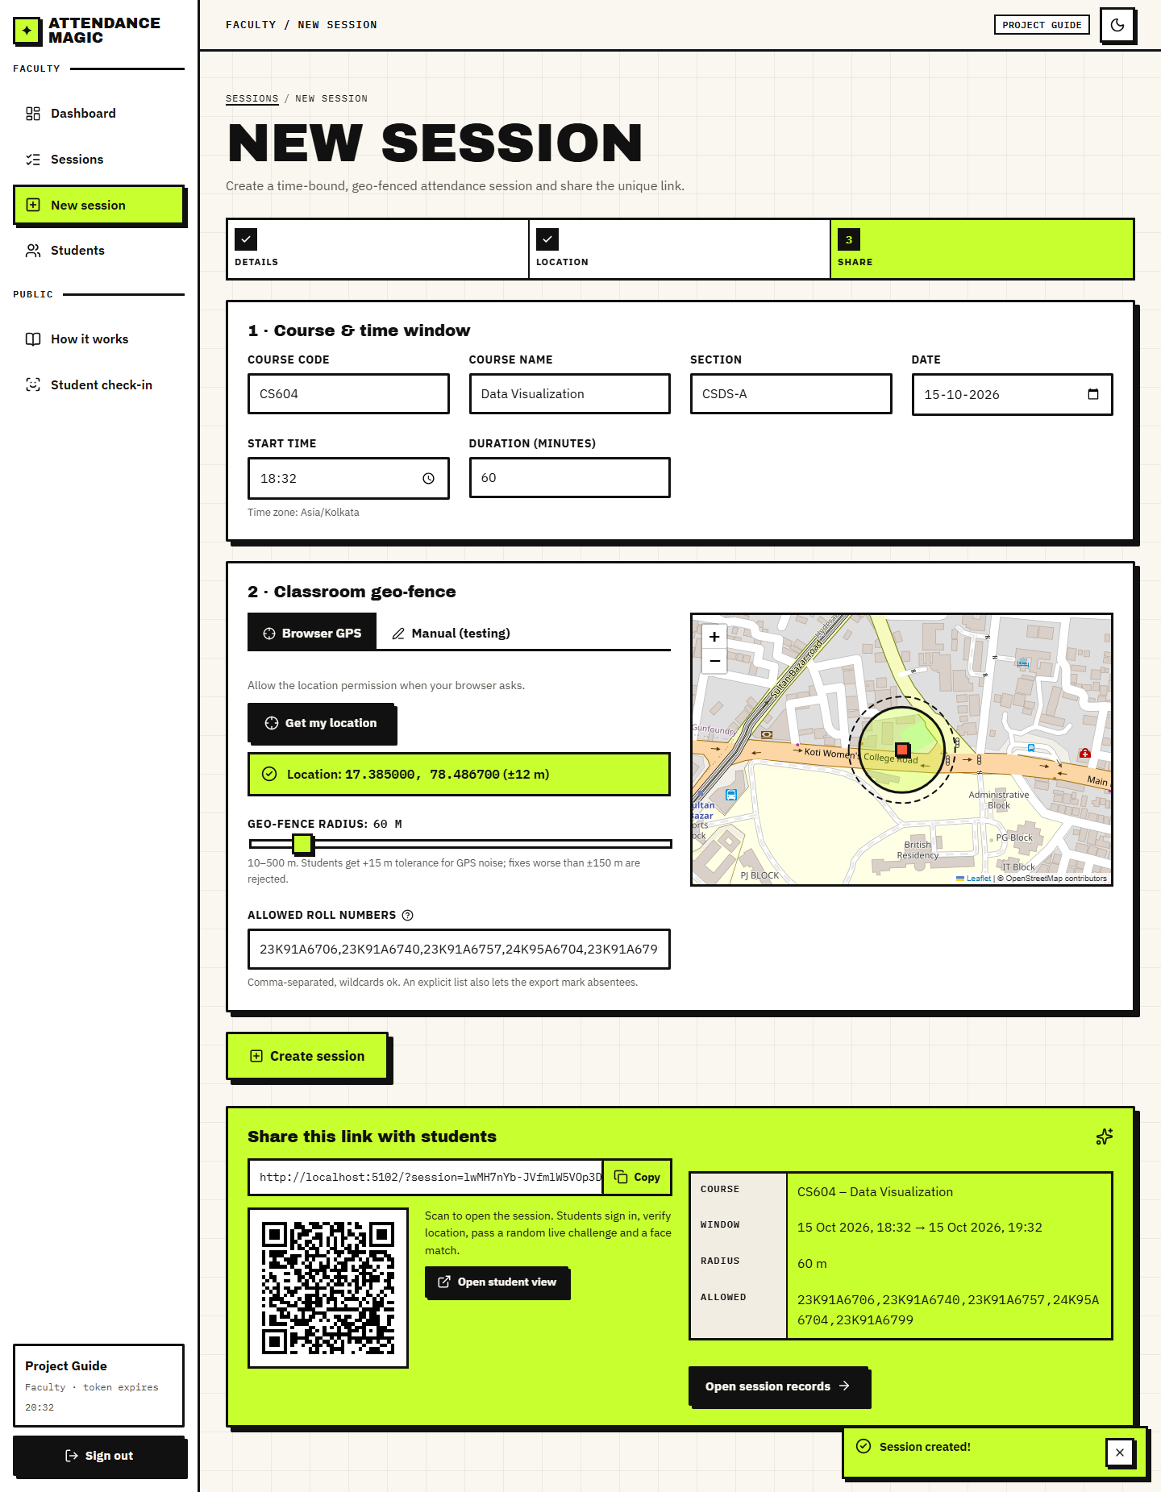
Fig. 8.4: Session created: link and QR code
KPI tiles (2 sessions, 1 live, 7 check-ins, 11 blocked attempts, 18% blocked), check-ins per session, checks by stage (passed and blocked) and the latest verification attempts with reasons.
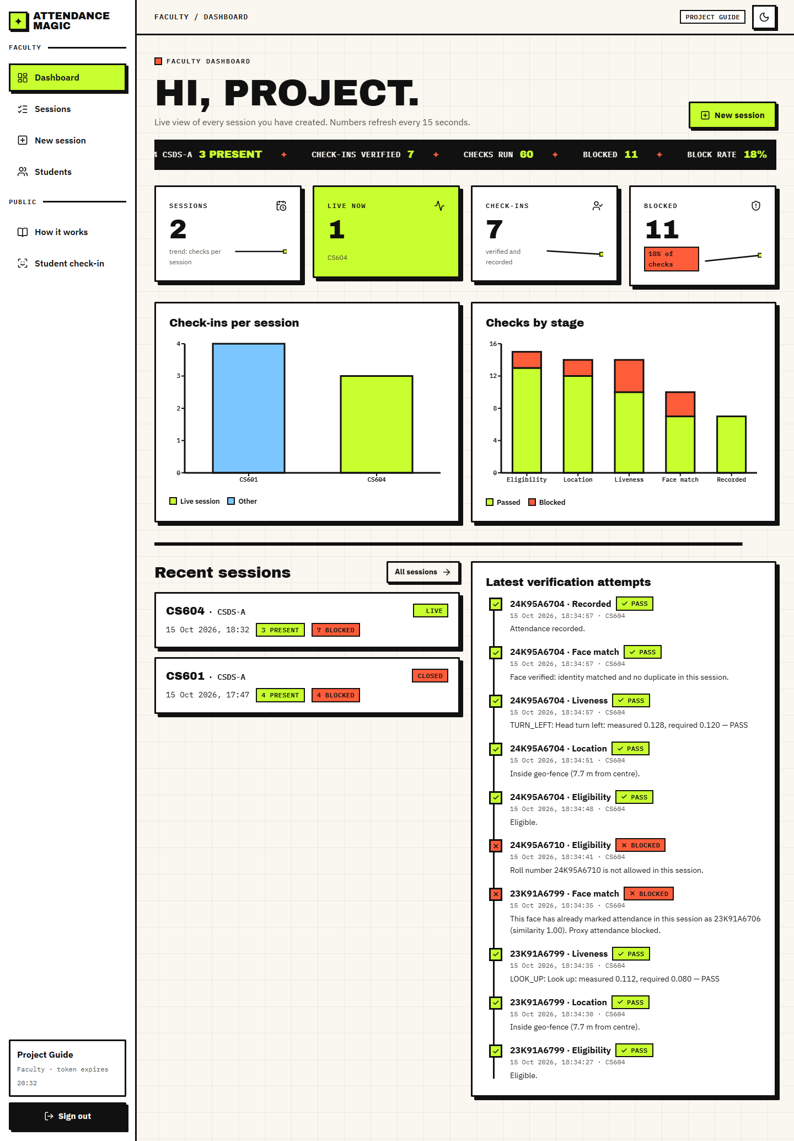
Fig. 8.5: Faculty dashboard
The live session CS604 with 3 present of 5 expected (explicit roll list) and 7 blocked attempts out of 30 checks; the share link and QR code; the records table shows distance, GPS accuracy, challenge, liveness score, identity similarity and the maximum duplicate similarity, and lists absentees.
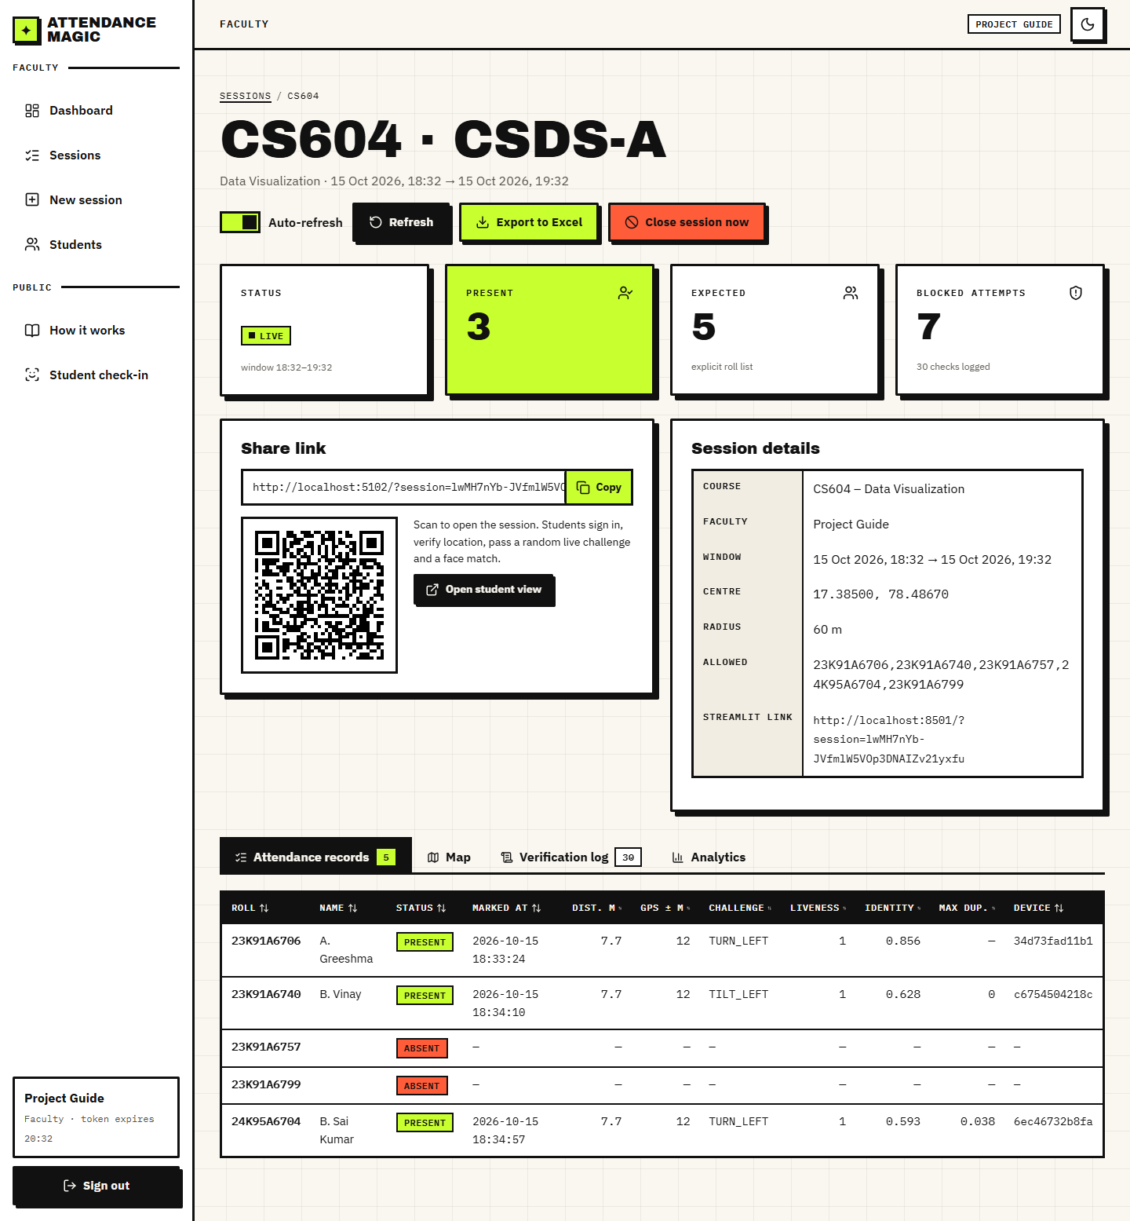
Fig. 8.6: Live session: records
The geo-fence centre (red), the 60 m radius and the 15 m tolerance ring on an OpenStreetMap map, with the check-in positions of the present students (blue).
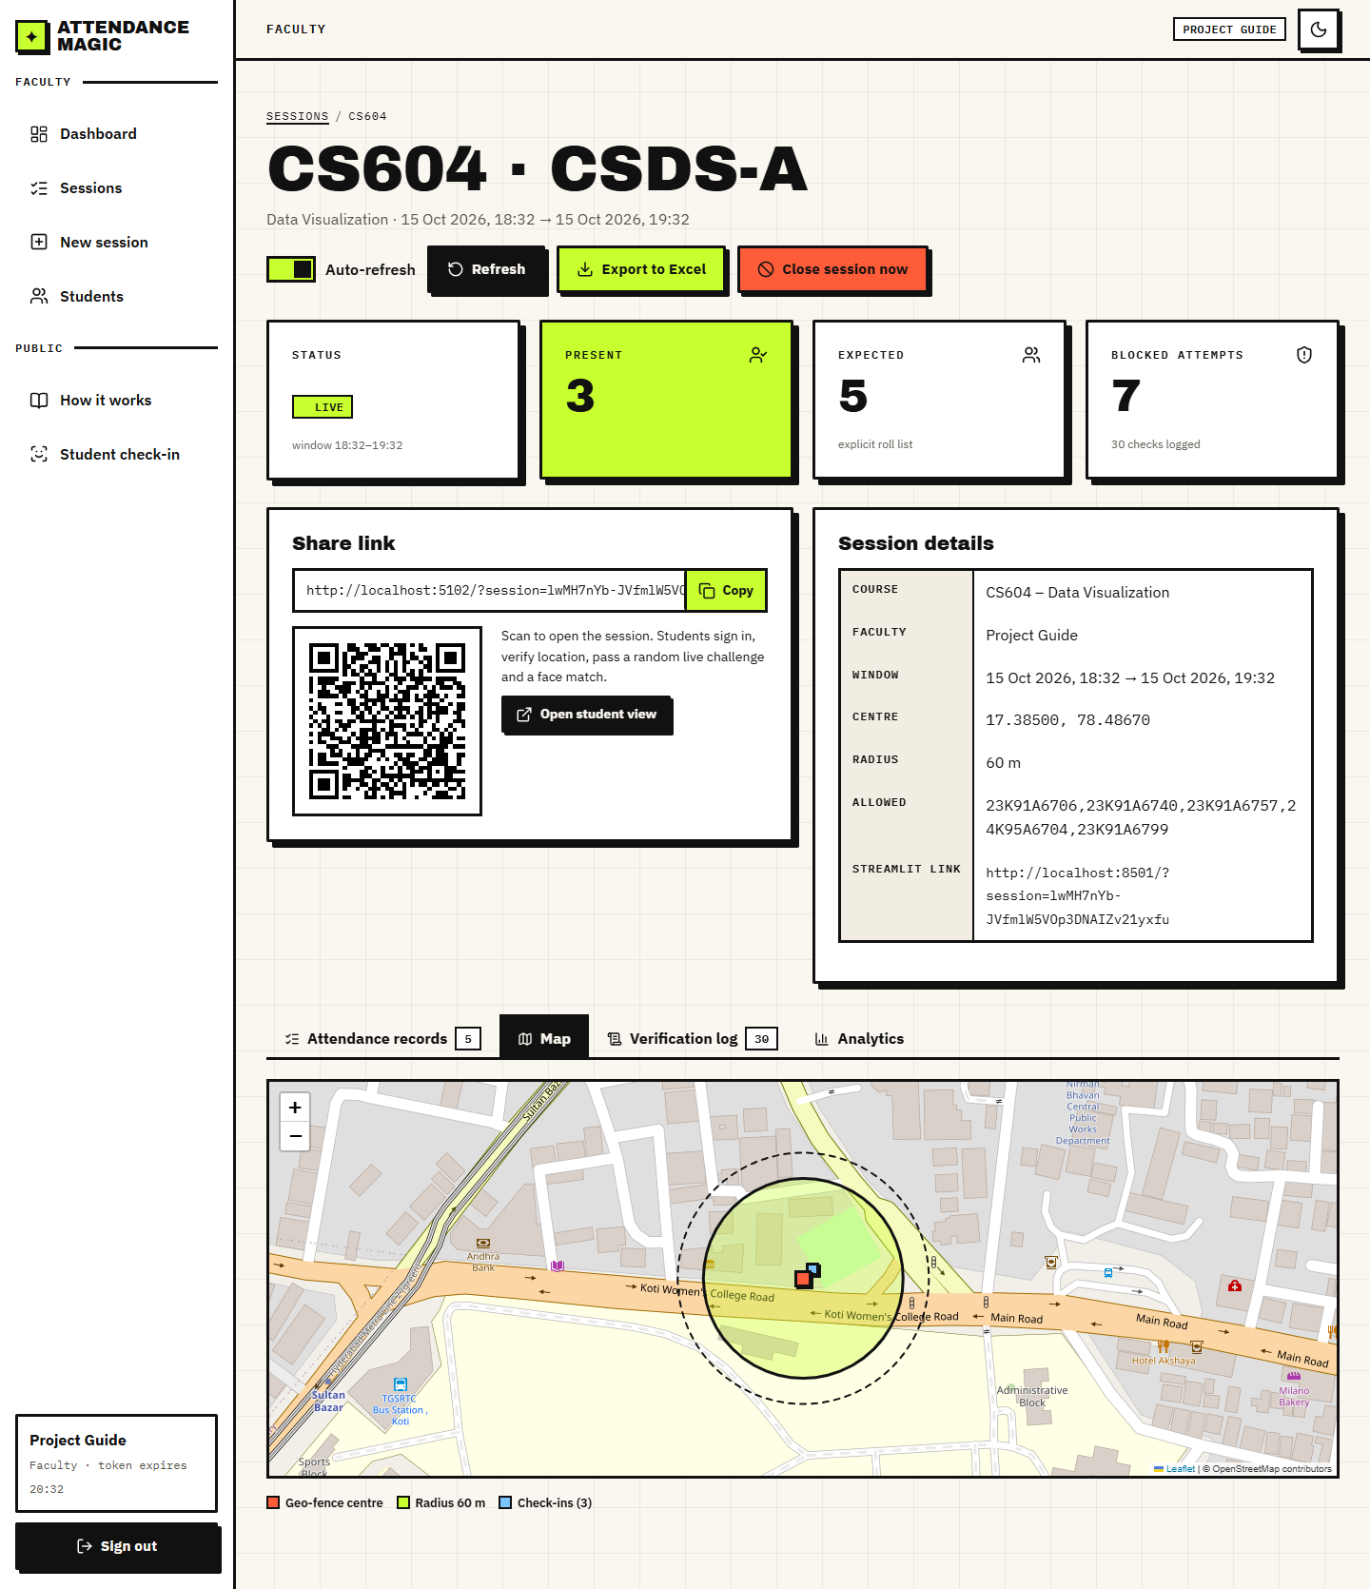
Fig. 8.7: Session map
Every attempt, newest first, with the roll number, stage, PASS or BLOCKED and the reason text; the blocked rows include the out-of-fence, challenge, identity and duplicate-face reasons.
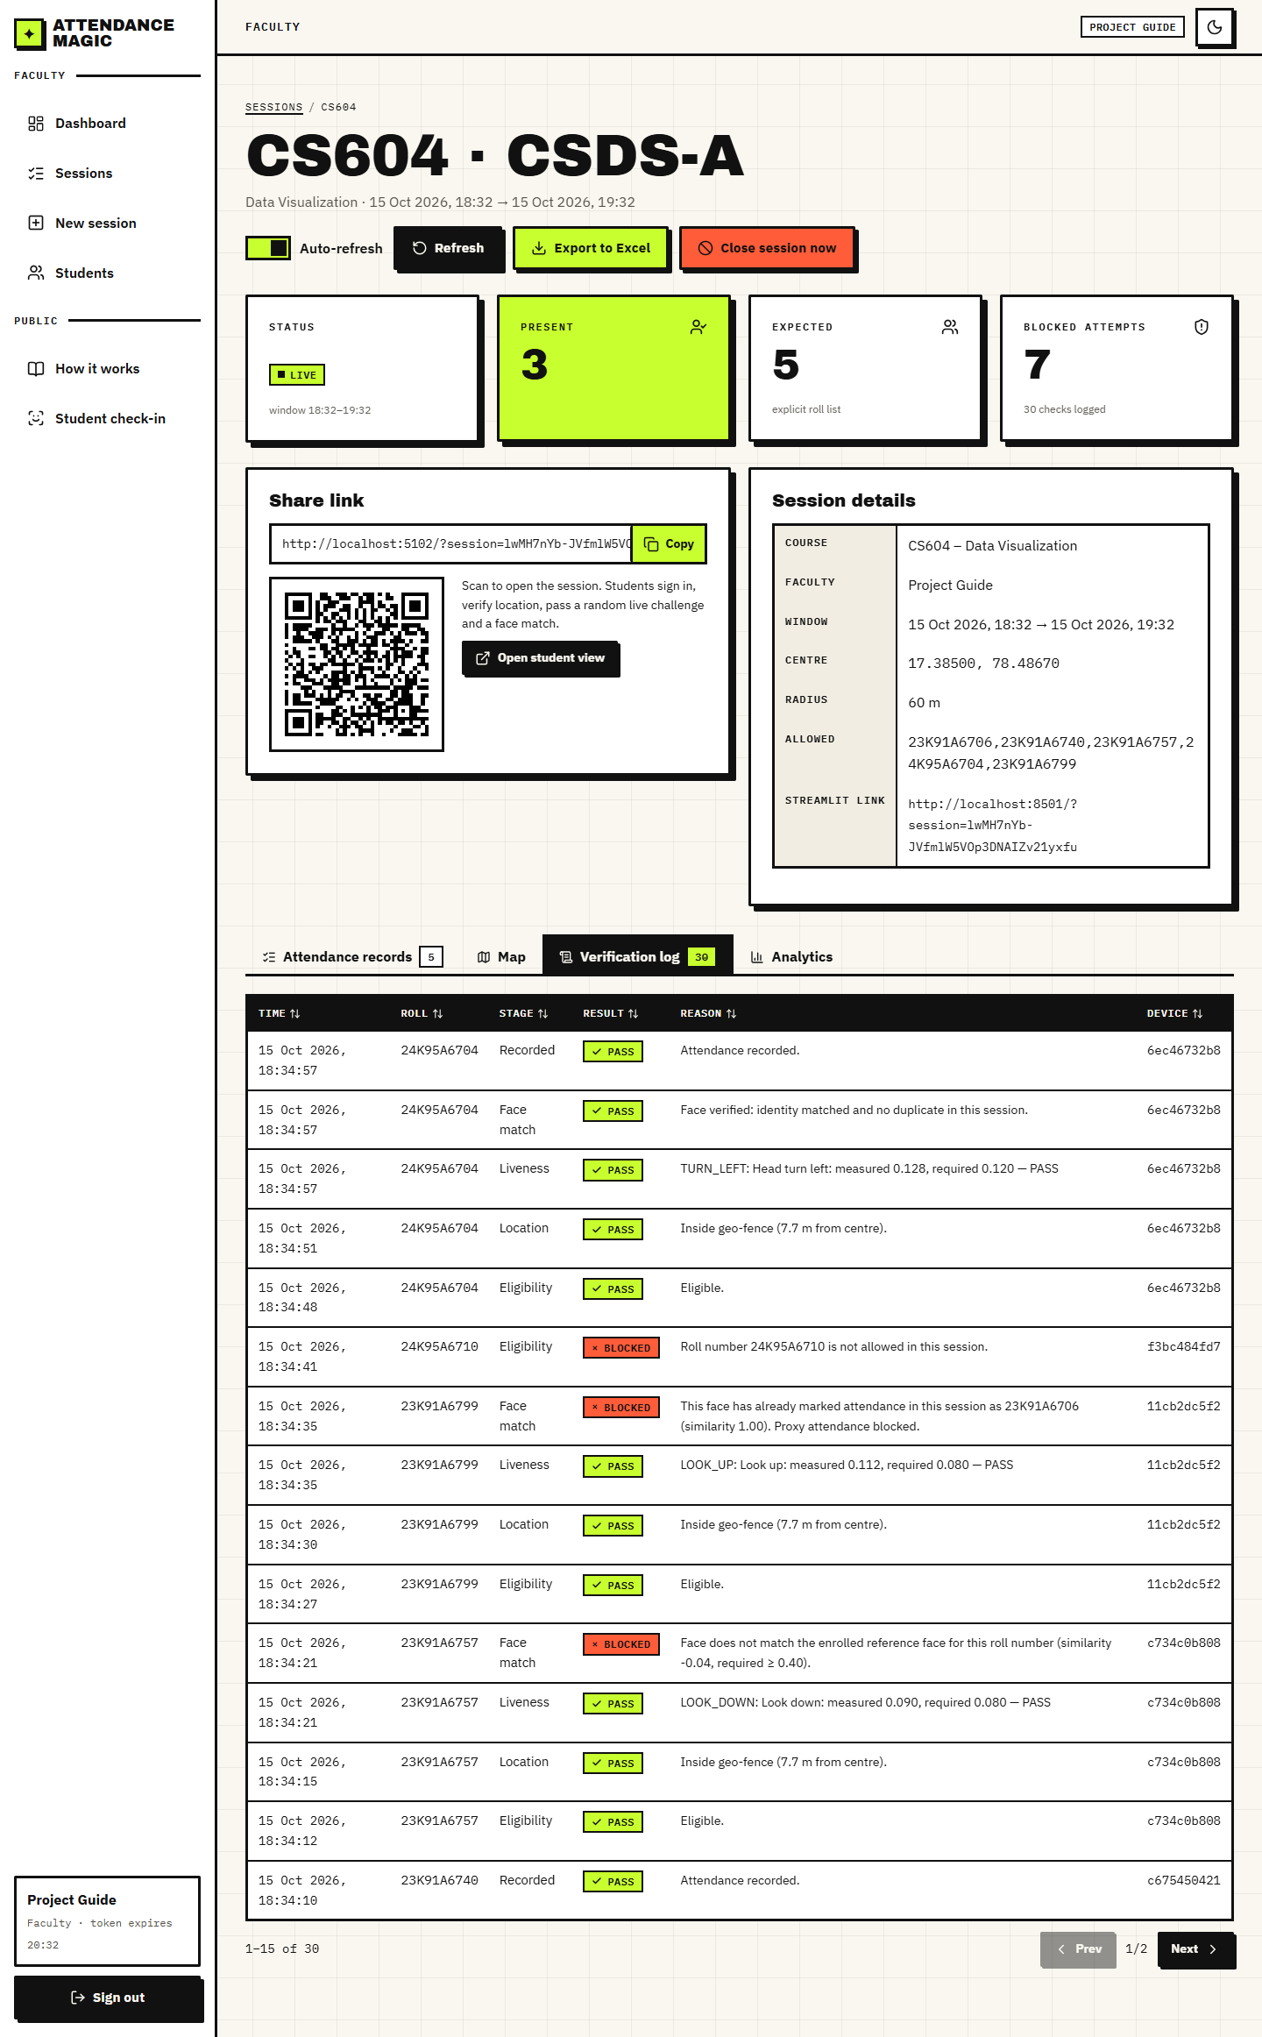
Fig. 8.8: Verification log
A drawer with the student's details, a button to remove device bindings and an upload to replace the reference face.
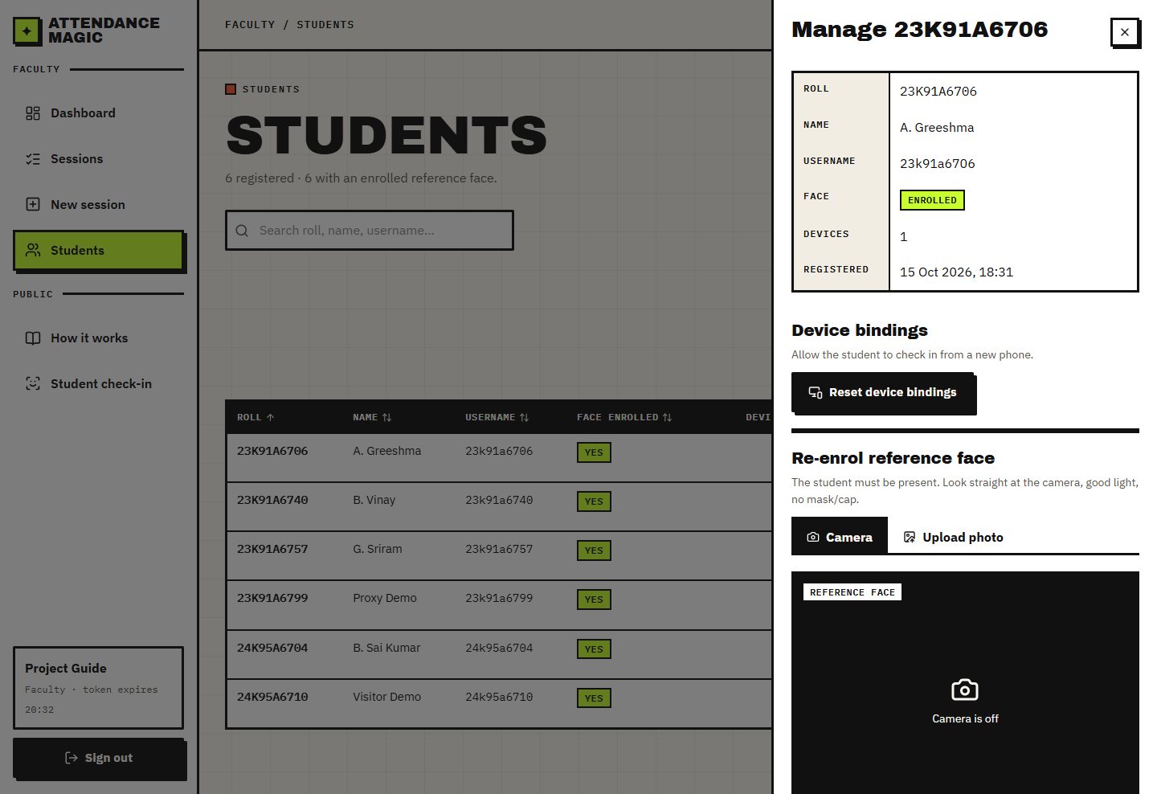
Fig. 8.9: Manage a student
Step 2: the student taps Get my location; the browser fix is shown with its accuracy and the map shows the fence and the student's position.
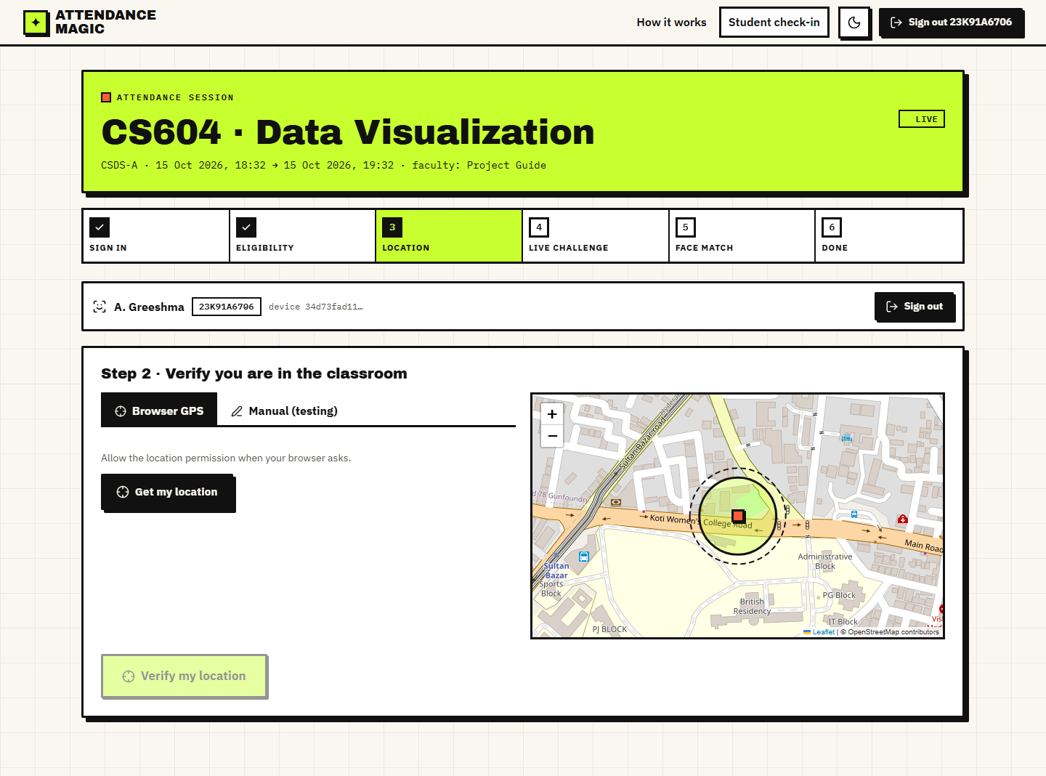
Fig. 8.10: Check-in: location
Both photos loaded for a turn left challenge. The first photo was accepted as a good neutral frame.
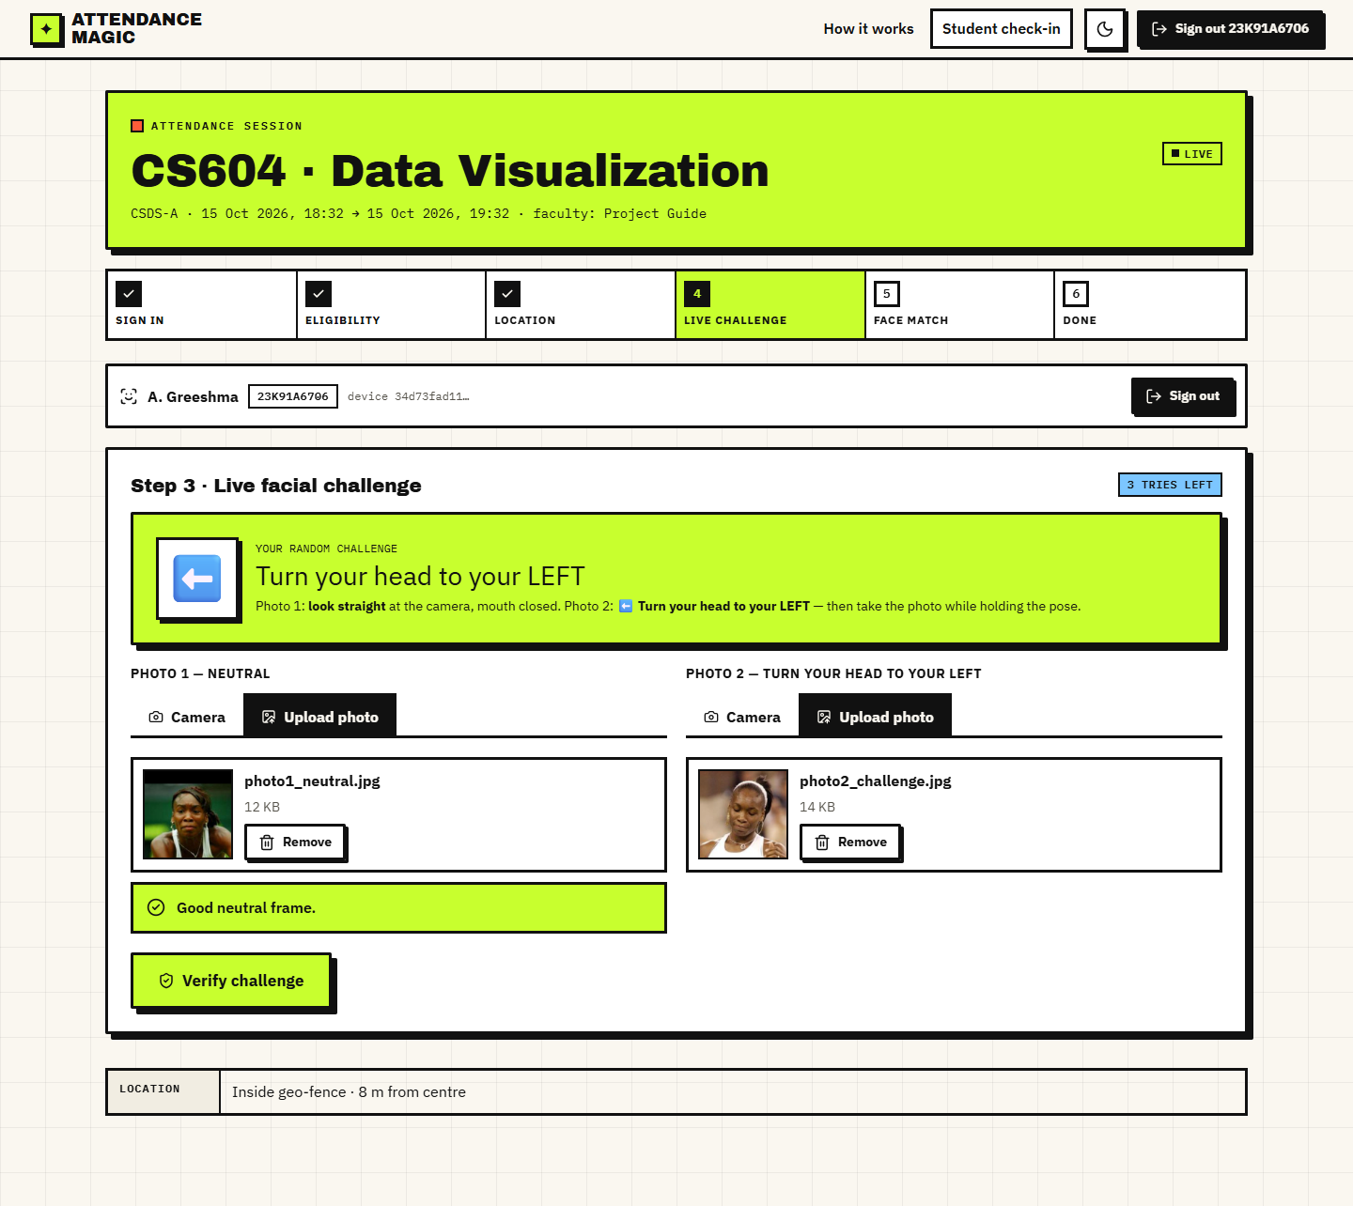
Fig. 8.11: Check-in: photos loaded
Step 5: 'Marked. Present.' with the distance (shown as 8 m, 7.7 m in the record), the liveness score (1.00), the identity similarity (0.86, required at least 0.4) and the thresholds that applied.
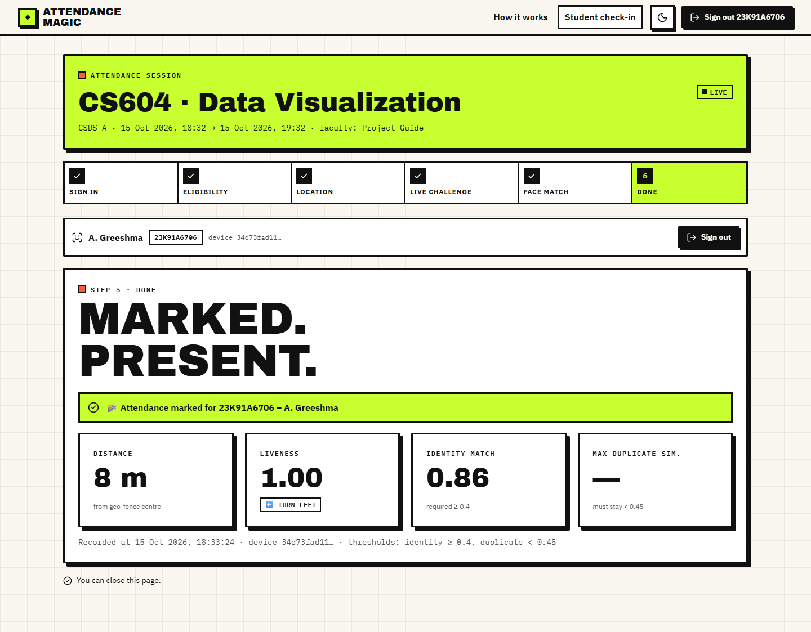
Fig. 8.12: Check-in: marked present
A student 556 m from the centre is told 'Outside geo-fence: you are 556 m away, limit is 75 m.' The map shows the position far outside the circle.
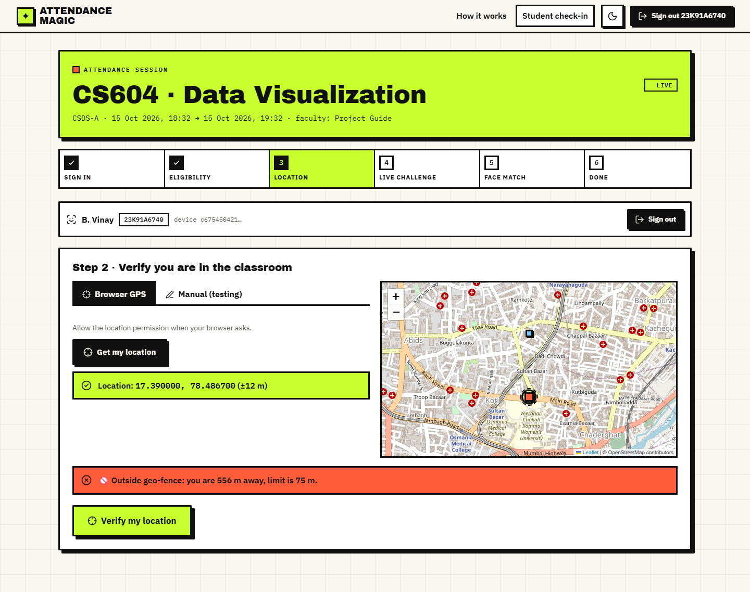
Fig. 8.13: Blocked: outside the geo-fence
The same photograph submitted twice fails the challenge; the reason reports the measured and required values and a new random challenge is issued with two tries left.
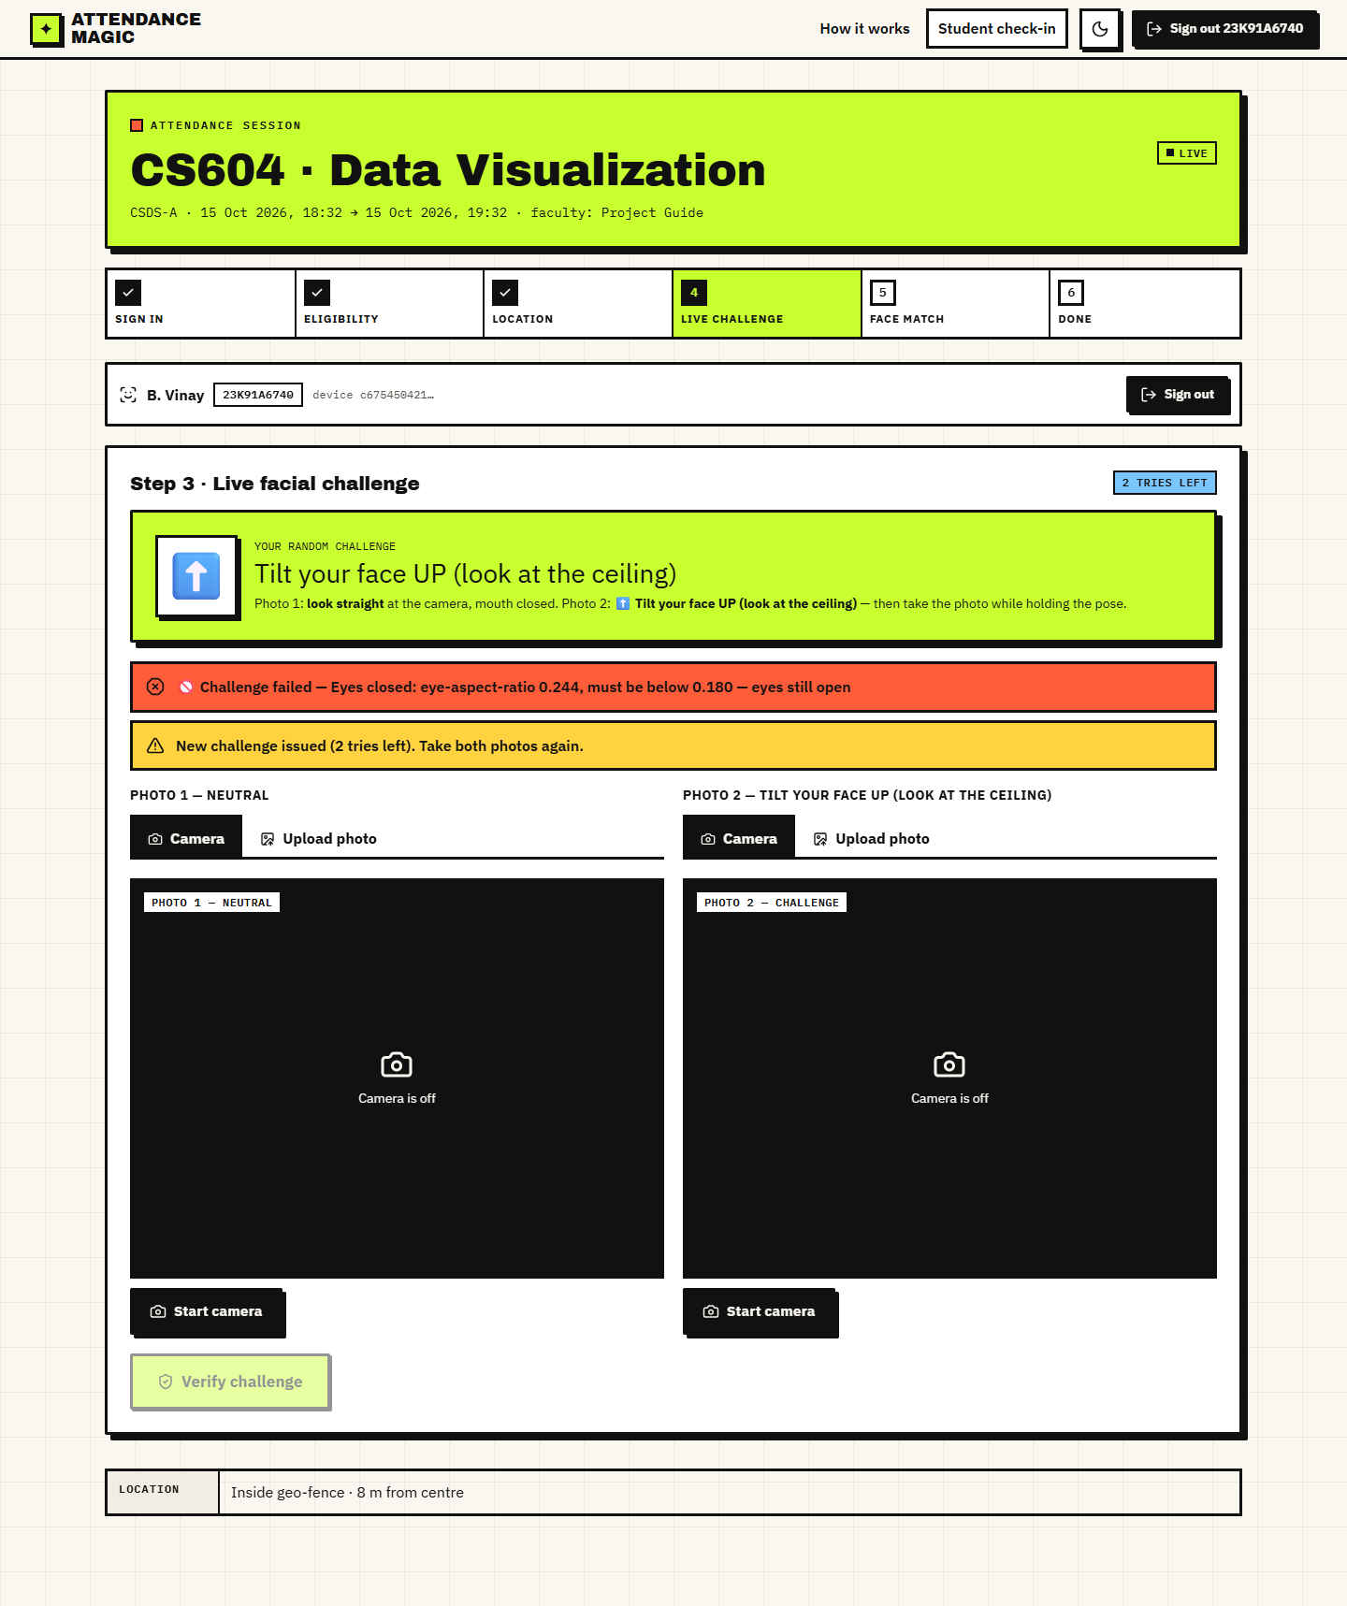
Fig. 8.14: Blocked: static photo
A student presents another person's photographs; the face step reports that the face does not match the enrolled reference face for this roll number.
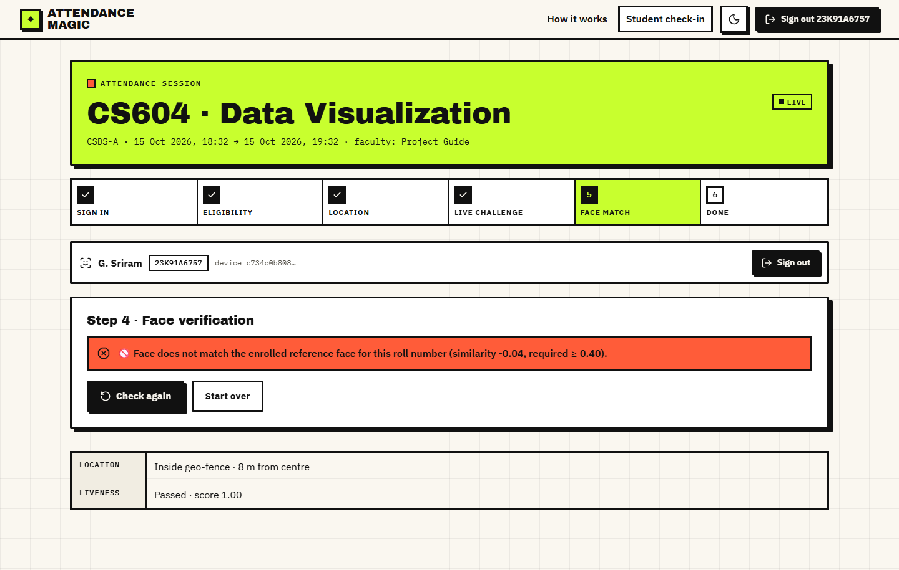
Fig. 8.15: Blocked: face does not match
A second account enrolled with the same face passes the identity check but is stopped by the duplicate scan: 'This face has already marked attendance in this session as 23K91A6706 (similarity 1.00). Proxy attendance blocked.'
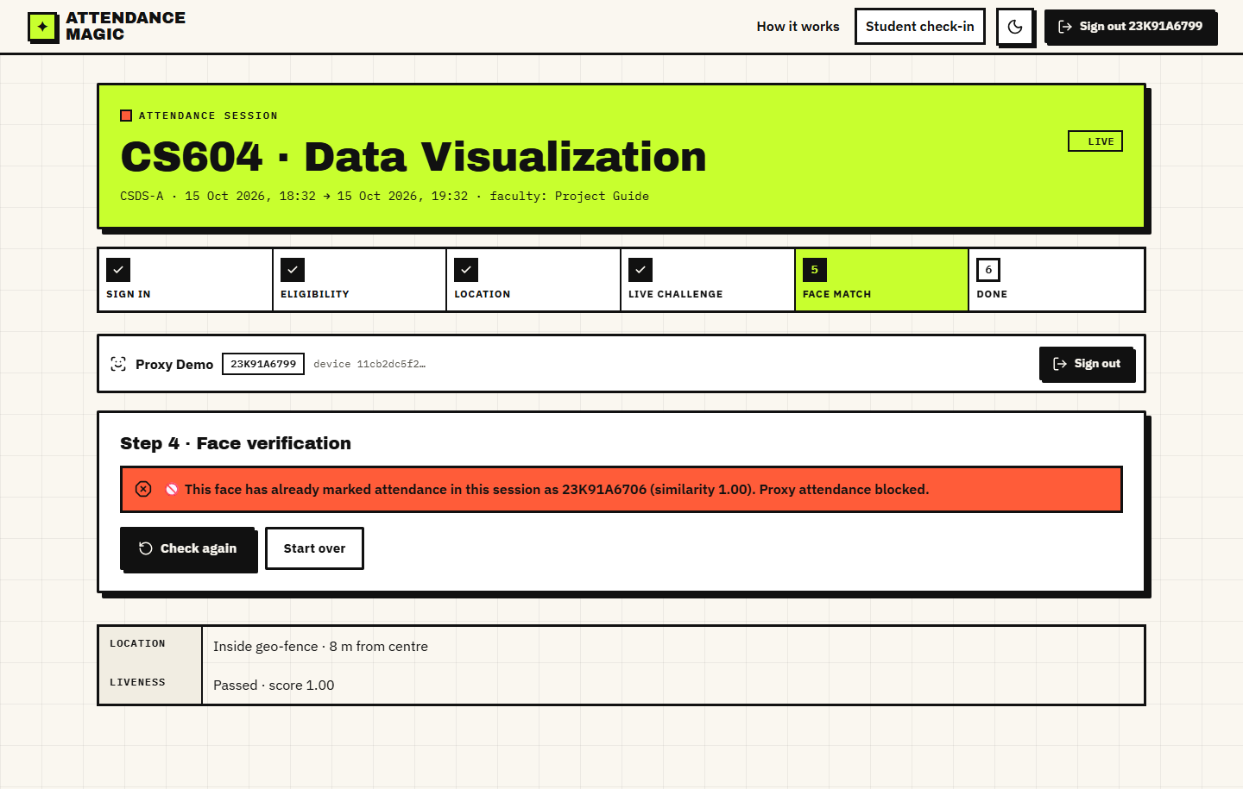
Fig. 8.16: Blocked: duplicate face
Course, section, faculty, window, geo-fence centre, radius, present, absent and blocked-attempt counts.
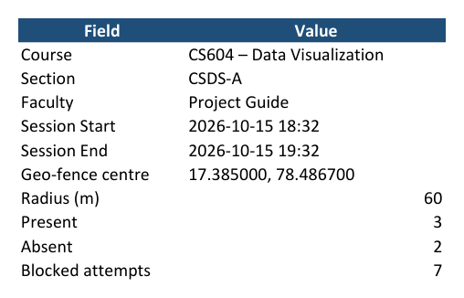
Fig. 8.17: Excel export: Summary sheet
One row per student with status, time, distance, accuracy, challenge, scores and device; absent students from the explicit list are included.
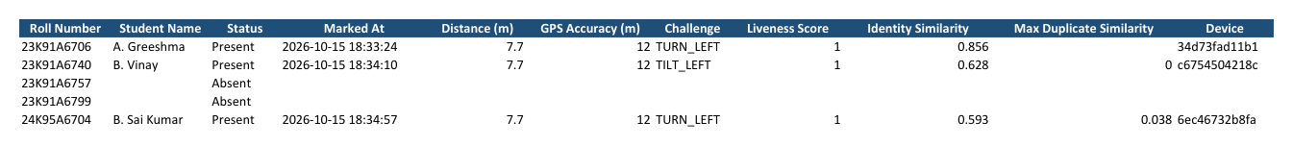
Fig. 8.18: Excel export: Attendance sheet

8.2 Performance of the Verification Chain
Because nothing is trained, the usual learning curves do not exist. The chain is evaluated by measuring each decision on public images and, for liveness, by attacking it. All figures come from the scripts in scripts/eval_*.py; their raw output is in docs/evaluation/.

8.2.1 Identity and duplicate thresholds (LFW verification protocol)
The standard LFW protocol has 6,000 pairs (3,000 same-person and 3,000 different-person). The product's own embed() rejected 1,208 of the 7,701 images used (15.7%; 1,197 as 'more than one face', 11 as 'no face'), which removed 1,693 pairs and left 4,307 scored pairs: 2,141 same-person and 2,166 different-person. Same-person similarity has a mean of 0.673 (SD 0.107, 5th percentile 0.494); different-person similarity has a mean of 0.004 (SD 0.058) and a maximum of 0.246.
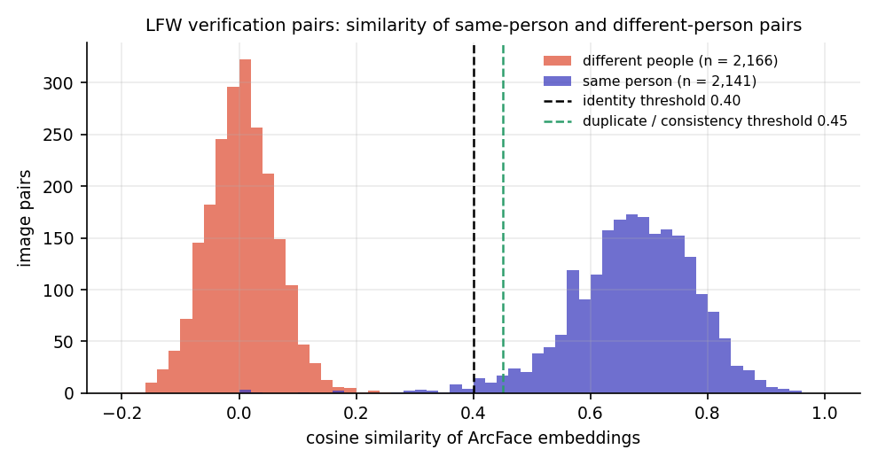
Fig. 8.19: Cosine similarity of same-person and different-person LFW pairs with the two deployed thresholds
Table 8.1: Behaviour of the similarity threshold on LFW (4,307 scored pairs)
Threshold | Same person accepted | Same person rejected | Different person accepted | Pair accuracy
0.20 | 99.67% | 0.33% | 0.18% | 99.74%
0.30 | 99.53% | 0.47% | 0.00% | 99.77%
0.35 | 99.30% | 0.70% | 0.00% | 99.65%
0.40 (identity) | 98.69% | 1.31% | 0.00% | 99.35%
0.45 (duplicate) | 97.15% | 2.85% | 0.00% | 98.58%
0.50 | 94.72% | 5.28% | 0.00% | 97.38%
0.60 | 78.47% | 21.53% | 0.00% | 89.30%

The area under the ROC curve is 0.9992. The equal error rate is 0.30% at a threshold of 0.19; the best single threshold on this data is 0.25 with 99.84% accuracy; the 10-fold protocol gives 99.82% (SD 0.22%). The deployed identity threshold of 0.40 accepts 98.7% of same-person pairs and none of the 2,166 different-person pairs, because the highest different-person similarity (0.246) is far below 0.40. The duplicate threshold of 0.45 flags 97.2% of same-person pairs as the same face; the remaining 2.8% would pass undetected when a person is photographed under very different conditions, which is the false-negative cost of a conservative threshold. The deployed thresholds therefore lie above the equal-error point and trade a small number of retakes for margin against look-alikes.
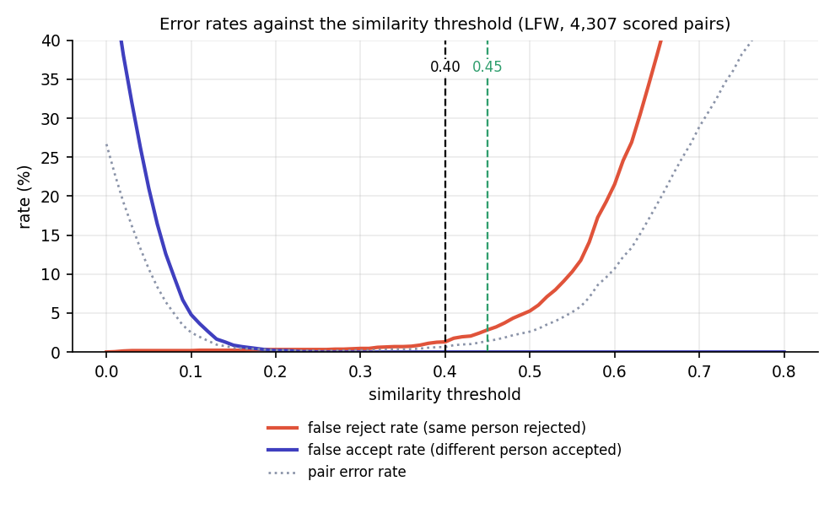
Fig. 8.20: False reject and false accept rates against the similarity threshold

8.2.2 Liveness challenge
Neutral frame. Of 1,000 random LFW photographs, 329 (32.9%) satisfied the neutral-frame rule; the others were not frontal (499), had several faces (92), an open mouth (79) or no face (1). These are press photographs taken for other purposes, so the figure says how strict the rule is, not how often students will pass it.
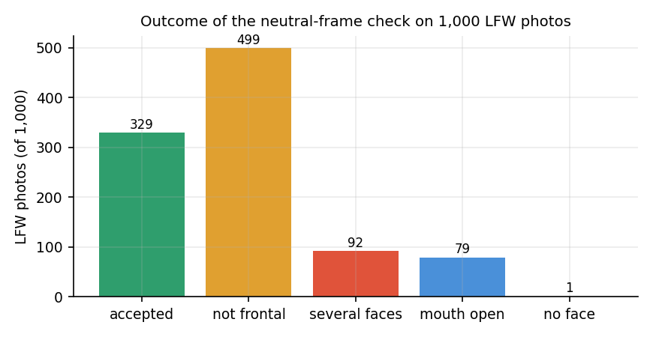
Fig. 8.21: Outcome of the neutral-frame check on 1,000 LFW photographs
Static replay. When the same photograph is submitted as both the neutral and the challenge frame (329 accepted neutral frames), none passes any head, tilt or mouth challenge. Close-eyes is the exception: 27 of 329 (8.2%) pass because the photograph already shows closed eyes (EAR at or below 0.18).

8.2.3 Attacks on the liveness check
Rotated photograph. Rotating a single photograph on screen by a signed angle changes the measured roll by exactly that angle. Rotations within 10 degrees pass neither tilt challenge; at 12 degrees (the threshold) about half pass; from 15 degrees the matching tilt challenge is passed by 98-99% of the 300 photographs. A student who holds a phone showing a photograph at a tilt can therefore pass a tilt challenge. The two tilt challenges are two of the eight random challenges.
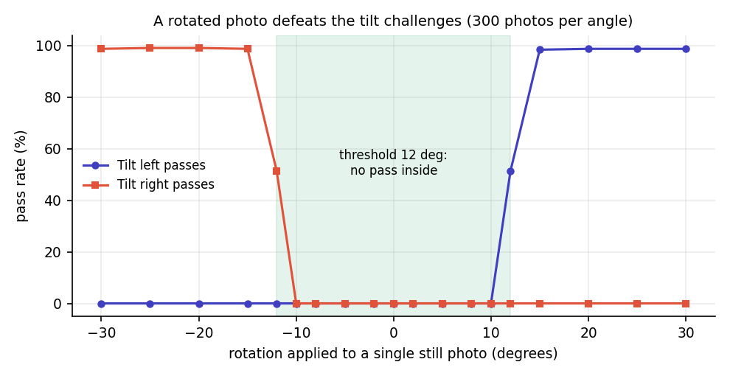
Fig. 8.22: Pass rate of the tilt challenges when one photograph is rotated
Photo bank. An attacker who owns several real photographs of the victim in different poses can pick the pair that fits the issued challenge. On the 154 LFW identities with at least 10 photographs (one photograph held out as the enrolled reference; up to five neutral candidates tried), the full chain (challenge, frame consistency at least 0.45 and identity at least 0.40) is passed as follows:
Table 8.2: Share of spoofing attempts that pass each challenge
Challenge | Static replay | Photo bank: liveness only | Photo bank: full chain
Turn left | 0.0% | 98.7% | 95.5%
Turn right | 0.0% | 97.4% | 94.2%
Look up | 0.0% | 83.1% | 79.9%
Look down | 0.0% | 77.9% | 72.7%
Tilt left | 0.0% | 73.4% | 70.1%
Tilt right | 0.0% | 73.4% | 69.5%
Open mouth | 0.0% | 50.6% | 48.7%
Close eyes | 8.2% | 56.5% | 52.6%

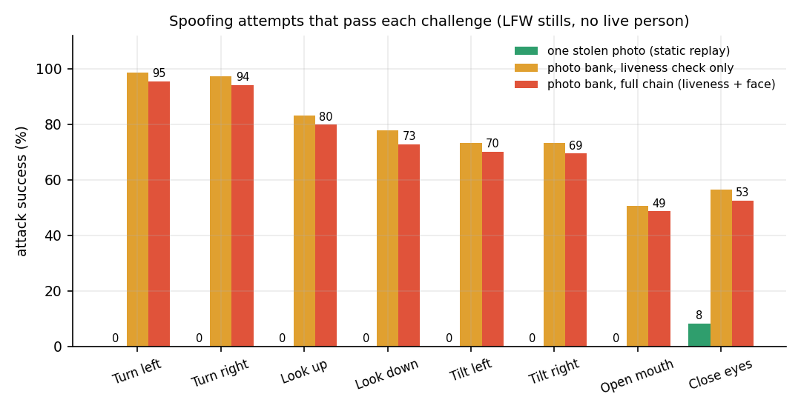
Fig. 8.23: Spoofing attempts that pass each challenge: a stolen photograph, and a bank of photographs
The result is mixed and is stated as such. The random challenge stops a single stolen photograph for seven of the eight actions. It does not stop an attacker who has collected several photographs of the victim: head-turn challenges are passed by about 94-96% of such attackers, mouth and eye challenges by about half. LFW identities with ten or more photographs are public figures with large photo collections, so these rates are an upper bound for ordinary students, but social media photographs make the scenario realistic. The attacker still has to be inside the geo-fence, use the victim's registered device and appear before the session closes; the system gives three tries and a fresh random challenge each time, so an attacker with a limited bank succeeds with a probability that depends on the draw.

8.2.4 Geo-fence
The spherical haversine distance differs from the ellipsoidal Vincenty distance by a constant 0.469% at latitude 17.385 degrees: 0.35 m at 75 m, 2.3 m at 500 m and 4.7 m at 1 km. A boundary sweep with a 60 m radius and 15 m tolerance accepts every point up to and including 75 m and rejects from 80 m (steps of 5 m); a fix with a reported accuracy of 150 m is accepted and one of 151 m is rejected.
GPS noise matters far more than the formula. A simulation (isotropic Gaussian error with standard deviation sigma per axis, 20,000 trials per point; an assumed model, not a field measurement) gives the probability that a student at a true distance is accepted:
Table 8.3: Simulated acceptance probability against GPS error
GPS error sigma | At 40 m | At 60 m | At 100 m | At 150 m
3 m | 100.0% | 100.0% | 0.0% | 0.0%
5 m | 100.0% | 99.9% | 0.0% | 0.0%
10 m | 100.0% | 92.3% | 0.5% | 0.0%
20 m | 94.2% | 72.3% | 8.5% | 0.0%
30 m | 80.8% | 60.0% | 15.7% | 0.3%

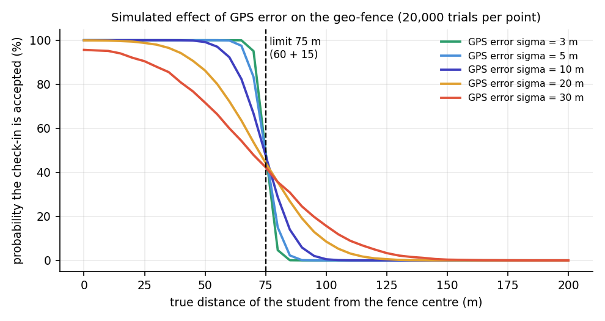
Fig. 8.24: Simulated probability of acceptance against true distance for several GPS error magnitudes
With errors of 10 m or less a student standing 60 m from the centre is accepted about 92% of the time or more, and one 100 m away is almost never accepted; with 30 m errors, typical of indoor reception, 40% of students at 60 m would be rejected and 16% at 100 m accepted. Faculty should set the radius with the building and the expected GPS quality in mind. Real phone GPS error was not measured.

8.3 Application Results
Table 8.4: Application results
Item | Result
Automated tests | 23 pytest tests passed; 41 of 41 API smoke checks passed
Endpoints / tables / pages | 27 REST endpoints, 5 database tables, 12 React routes
Code size | core/ 1,229 lines, backend 626, Streamlit UI 581, tests 353, React source about 4,470 lines
Check-in time (server, median) | 564 ms (806 ms at the 95th percentile)
Production build | Vite build in 23 s; largest chunk 581 kB (194 kB gzipped)
Demo run (UI) | Session CS601: 4 present, 4 blocked attempts; session CS604: 3 present of 5 expected, 7 blocked attempts, 30 checks logged
Identity similarities in the demo | 0.856, 0.628 and 0.593 for three students (different photographs of each person)

8.4 Comparison with the Base Paper
The comparison is qualitative and the datasets differ. The base paper [1] reports its own classroom tests with a small, unstated number of students and the LBPH recogniser; this project reports threshold behaviour on the public LFW protocol with a pre-trained ArcFace recogniser. The figures are not comparable as accuracies and no numerical advantage is claimed.
Table 8.5: Comparison with the base paper (different datasets)
Aspect | Base paper [1] | Attendance Magic
Recogniser | Haar cascade + LBPH trained on 25-50 images per student | SCRFD + ArcFace R50, one reference photo per student, no training
Reported identity result | About 92-95% recognition, 5-8% false negatives, 0% false positives (own classroom data) | 98.7% of same-person LFW pairs accepted, 0 of 2,166 different-person pairs accepted
Speed | Under 2 s per face | 176 ms per embedding; 564 ms for a whole check-in (server)
Spoof resistance | Not described | Random challenge; single photograph passes 0% of 7 of 8 challenges; rotated and multiple photographs can pass (measured)
Presence proof | None | GPS geo-fence with tolerance and accuracy gate
Duplicate identity | None | Duplicate scan; 97.2% of same-person pairs flagged at 0.45
Interface | Tkinter desktop application on the classroom computer | React web application on any browser; also the original Streamlit UI
Storage | CSV files | Database, attempt log and Excel export with absentees

8.5 Sample Inputs and Outputs
A successful check-in returns the following result (from the demo run; values rounded). The input is a GPS fix inside the fence and two photographs; the output is the record that appears in the faculty's table and in the Excel export.
Table 8.6: Sample output of a successful check-in
Field | Value | Meaning
Roll number / name | 23K91A6706 / A. Greeshma | the signed-in student
Distance | 7.7 m | haversine distance from the fence centre (limit 75 m)
GPS accuracy | 12 m | browser-reported accuracy (limit 150 m)
Challenge | TURN_LEFT, score 1.00 | random challenge and its score
Identity similarity | 0.856 | cosine between the live and the enrolled embedding (required at least 0.40)
Maximum duplicate similarity | none | the first record of the session
Device | 34d73fad11b1... | first 12 characters of the device hash

Examples of blocked outputs from the verification logs of the two demo sessions:
Table 8.7: Sample blocked outputs
Stage | Reason stored
location | Outside geo-fence: you are 556 m away, limit is 75 m.
liveness | Tilt left: measured -0.000, required 12.000 - not enough movement, try a bigger motion
face (identity) | Face does not match the enrolled reference face for this roll number (similarity ..., required >= 0.40).
face (duplicate) | This face has already marked attendance in this session as 23K91A6706 (similarity 1.00). Proxy attendance blocked.
eligibility | Roll number 24K95A6710 is not allowed in this session.

8.6 Success and Failure Analysis

8.6.1 Where the system succeeds
- A genuine student inside the fence with a correct challenge and a clear photograph is recorded in about 0.56 s of server time.
- Forwarded links, remote marking, repeat marking, second devices, disallowed rolls, another person's face and a duplicate face were each blocked at the intended stage in every scripted scenario.
- A single stolen photograph fails seven of the eight challenges, and different-person pairs never reached the identity threshold on 2,166 LFW pairs.

8.6.2 Where it fails or is weak
Table 8.8: Weak points found by the experiments
Case | Observation | Consequence
Rotated photograph | Passes tilt challenges at 15 degrees or more (98-99%) | 2 of 8 challenges are defeated by one photograph on a tilted screen
Photo bank | Passes the full chain 49-96% depending on the challenge | A determined attacker with several photos can succeed; mitigated only by the geo-fence, device binding, time window and tries
Close eyes with a blinking photograph | 8.2% of still photographs pass | A photograph that already shows closed eyes passes this challenge
Single-face rule | 15.7% of LFW photos rejected | Retakes needed; a bystander in the frame blocks the check-in
Strict neutral frame | 32.9% of LFW press photos accepted | Students must look straight, mouth closed
Very different photographs of one person | 1.3% of same-person pairs fall below 0.40 | Rare false rejections; re-enrolment with a better reference photo fixes it
Poor GPS | A 30 m error rejects 40% of students at 60 m (simulation) | Faculty should use a larger radius indoors

8.7 Limitations of the Results
- LFW photographs are news images, not selfies; the single-face and frontal-pose rates on student phone photographs are unknown.
- No live person performed any challenge. The genuine pass rate of each challenge, the time to complete a check-in and the number of retakes were not measured.
- The photo-bank attack uses public figures with many photographs; it is an upper bound for ordinary students.
- The GPS results are a simulation under an assumed noise model.
- Timings come from one machine that was running other applications; they are indicative.
- The comparison with the base paper is qualitative because its data, size and protocol are not given.

8.8 Objectives versus Outcomes
Table 8.9: Objectives against outcomes
No. | Objective | Outcome | Evidence
1 | Time-bound sessions with configurable geo-fences | Achieved | Session form, link and QR, close; screens 09, 10, 13; unit and smoke tests
2 | JWT, device identification, roll restrictions | Achieved | Token bound to device (401 from another device); device bindings; roll patterns; tests
3 | GPS location against the session boundary | Achieved; field accuracy not measured | Haversine, tolerance, accuracy gate; boundary sweep; simulation only for GPS noise
4 | Liveness by random facial challenge (MediaPipe) | Achieved with a measured weakness | 8 challenges; single photo fails 7 of 8; rotated and multiple photos can pass; no live-person trial
5 | Duplicate identities prevented with InsightFace embeddings | Achieved | Duplicate scan; proxy blocked in the UI run; 97.2% same-person pairs flagged at 0.45 (LFW)
6 | Attendance summaries and Excel export | Achieved | Records, map, log, analytics, 3-sheet Excel with absentees
7 | Verification by tests and measurement | Achieved | 23 pytest tests, 41 smoke checks, LFW threshold evaluation, attack, latency and geo-fence experiments

CHAPTER 9
CONCLUSION

9.1 Summary of the Work
This project set out to make classroom attendance fast and hard to fake. The result is Attendance Magic, a web application in which faculty open a time-bound, geo-fenced session and share a link or QR code, and students check in from a phone. The server runs a fixed chain of checks: eligibility (session window, roll pattern, repeat marking, device binding), a GPS geo-fence, a random live facial challenge measured on MediaPipe Face Mesh landmarks, and a face verification with InsightFace embeddings that requires both photos to show the same person, the enrolled person and nobody already recorded in the session. Every attempt is logged with its stage and reason, and faculty see live records, a map, the log, analytics and an Excel export.
No model was trained. The contribution is the verification chain, its thresholds, the application around it and the evidence: the thresholds were measured on the public LFW benchmark, the liveness check was attacked with rotated and multiple photographs, and the application was tested with 23 pytest tests and a 41-check API smoke test.

9.2 Objectives Achieved
All six project objectives were implemented, and a seventh (verification) was added; the objectives table at the end of Chapter 8 lists the evidence. Objective 4 (liveness) is implemented with a measured weakness that is described below.

9.3 Key Findings
1. On the LFW verification protocol the deployed identity threshold (0.40) accepts 98.7% of same-person pairs and none of 2,166 different-person pairs; the area under the ROC curve is 0.999 and the equal error rate 0.30%.
2. The duplicate threshold (0.45) flags 97.2% of same-person pairs as the same face, so a second identity using the same face is caught in almost all cases.
3. A single stolen photograph is rejected by seven of the eight random challenges; a photograph that already shows closed eyes passes the eye challenge 8.2% of the time.
4. The liveness check is the weakest link: a photograph rotated by 15 degrees or more passes both tilt challenges (98-99%), and an attacker with several photographs of the victim passes the full chain 49-96% of the time depending on the challenge.
5. A check-in costs about 564 ms of server time on a desktop CPU, dominated by two ArcFace embeddings (about 176 ms each).
6. The single-face rule rejected 15.7% of LFW photographs, so retakes are a real part of the user experience.
7. The haversine distance is accurate to 0.47%; the real limit of the geo-fence is GPS noise, which should be taken into account when setting the radius.

9.4 Practical Applications
- Lecture, laboratory and tutorial attendance in colleges, with a faculty laptop and student phones.
- Attendance at examinations or invigilated events where presence in a room matters (with a smaller radius).
- Training sessions and workshops that need a verifiable attendance record with an audit trail.
- A teaching platform for face-recognition, liveness and web-security topics, because every decision is transparent and reproducible.

9.5 Known Limitations
- No live-camera, phone or volunteer trial; the genuine pass rate of the challenges and the real retake rate are unknown.
- Liveness is defeated by rotated photographs and by banks of photographs; there is no texture, depth or video-based anti-spoofing.
- GPS accuracy, indoor drift and fake-location apps were not studied beyond a simulation.
- Single-process SQLite deployment with no load test; the default JWT secret and the manual-location option must be changed for real use.
- Evidence comes from public news photographs and a demo set, not from the institution's students.

CHAPTER 10
FUTURE SCOPE

10.1 Improvements
- Stronger liveness. Reject a challenge frame that is only a rotation of the neutral frame (for example by checking background and perspective consistency), require several short challenges in a time-limited capture, and add a passive anti-spoofing model such as silent-face anti-spoofing [5].
- Threshold calibration on real selfies. Collect consented selfies, measure the genuine pass rate and retake rate of each challenge, and tune the neutral-frame and single-face rules accordingly.
- Better reference enrolment. Enrol from several photographs and keep the best embedding, to lower the 1.3% false-reject rate.
- Security hardening. Rate limiting and lockout on sign-in, a strong secret generated at set-up, disabling manual location in production, and a dependency audit.

10.2 Additional Features
- E-mail or in-app notification to students who were blocked, with the reason and a retry link.
- Attendance percentage reports per student and per course, with shortage alerts.
- Multiple faculty per course, an administrator role and department-level reports.
- Offline-tolerant check-in with a short grace window for poor connectivity.
- An export to the institution's ERP or LMS format.

10.3 Scalability and Deployment
- Serve over HTTPS (a reverse proxy with a certificate) so that phone cameras and GPS work without workarounds.
- Switch to PostgreSQL through DATABASE_URL and test it; run several API workers with the models loaded once per worker.
- Move the check-in wizard state from memory to a shared store so that a restart or a second worker does not lose it.
- Measure concurrent load; the duplicate scan is linear (41 ms for 5,000 faces) and the embedding takes about 0.18 s per photograph, so a GPU or a small thread pool would raise the ceiling.
- Package with containers and document backup of the database, which holds the face embeddings.

10.4 Further Research
- A user study on usability and acceptance, including privacy attitudes towards face capture in class.
- Evaluation of liveness on a public presentation-attack dataset so that the active challenge can be compared with passive methods [12].
- Detection of fake GPS and of screen replay (moire, specular reflection) in the challenge photographs.
- Fairness evaluation of the face-matching thresholds across skin tones, ages and lighting.
- A privacy-preserving design that never stores face embeddings centrally (on-device matching with a signed result).

REFERENCES
[1] K. B. Dharmaraj, C. N. Dhanushree, H. V. Revanth, N. Shashank and P. M. Tejaswini, "Real-Time Student Face Recognition Attendance System Using AI," International Advanced Research Journal in Science, Engineering and Technology (IARJSET), vol. 12, no. 5, pp. 1067-1072, May 2025, doi: 10.17148/IARJSET.2025.125183.
[2] "A comprehensive review on face recognition, anti-spoofing liveness verification and automated dress code enforcement techniques for smart attendance framework," International Journal of Research Publication and Reviews, 2026.
[3] A. Shandilya and H. R. Shah, "Smart attendance framework using face recognition, anti-spoofing liveness verification and automated dress code enforcement," International Journal of Innovative Science and Research Technology (IJISRT), vol. 11, no. 6, Jun. 2026, doi: 10.38124/ijisrt/26jun403.
[4] "A classroom attendance system with anti-spoofing based on ResNet101 and ArcFace for face recognition," Journal of Intelligence and Knowledge Engineering, 2026.
[5] A. E. U. Salam et al., "Automatic attendance system using silent face anti-spoofing to detect spoof on face recognition," in Proc. 2025 Int. Conf. Smart Computing, IoT and Machine Learning (SIML), 2025, doi: 10.1109/SIML65326.2025.11081084.
[6] J. Deng, J. Guo, N. Xue and S. Zafeiriou, "ArcFace: Additive angular margin loss for deep face recognition," in Proc. IEEE/CVF Conf. Computer Vision and Pattern Recognition (CVPR), 2019, pp. 4690-4699.
[7] J. Guo, J. Deng, A. Lattas and S. Zafeiriou, "Sample and computation redistribution for efficient face detection," in Proc. Int. Conf. Learning Representations (ICLR), 2022.
[8] Y. Kartynnik, A. Ablavatski, I. Grishchenko and M. Grundmann, "Real-time facial surface geometry from monocular video on mobile GPUs," in Proc. CVPR Workshops, 2019, arXiv:1907.06724.
[9] G. B. Huang, M. Ramesh, T. Berg and E. Learned-Miller, "Labeled Faces in the Wild: A database for studying face recognition in unconstrained environments," Univ. Massachusetts Amherst, Tech. Rep. 07-49, Oct. 2007.
[10] T. Soukupova and J. Cech, "Real-time eye blink detection using facial landmarks," in Proc. 21st Computer Vision Winter Workshop, 2016.
[11] G. Pan, L. Sun, Z. Wu and S. Lao, "Eyeblink-based anti-spoofing in face recognition from a generic webcamera," in Proc. IEEE Int. Conf. Computer Vision (ICCV), 2007.
[12] Z. Yu, Y. Qin, X. Li, C. Zhao, Z. Lei and G. Zhao, "Deep learning for face anti-spoofing: A survey," IEEE Trans. Pattern Analysis and Machine Intelligence, vol. 45, no. 5, pp. 5609-5631, 2023.
[13] F. Schroff, D. Kalenichenko and J. Philbin, "FaceNet: A unified embedding for face recognition and clustering," in Proc. IEEE CVPR, 2015, pp. 815-823.
[14] R. W. Sinnott, "Virtues of the haversine," Sky and Telescope, vol. 68, no. 2, p. 159, 1984.
[15] T. Vincenty, "Direct and inverse solutions of geodesics on the ellipsoid with application of nested equations," Survey Review, vol. 23, no. 176, pp. 88-93, 1975.
[16] M. Jones, J. Bradley and N. Sakimura, "JSON Web Token (JWT)," RFC 7519, Internet Engineering Task Force, May 2015.
[17] K. Moriarty, B. Kaliski and A. Rusch, "PKCS #5: Password-based cryptography specification version 2.1," RFC 8018, Internet Engineering Task Force, Jan. 2017.
[18] S. Ramirez, "FastAPI documentation." [Online]. Available: https://fastapi.tiangolo.com
[19] M. Bayer, "SQLAlchemy," in The Architecture of Open Source Applications, vol. 2, A. Brown and G. Wilson, Eds., 2012.
[20] Meta Platforms, "React documentation." [Online]. Available: https://react.dev

APPENDIX A
IMPORTANT CODE
This appendix lists further code that complements Section 6.8 (the geo-fence, liveness, face decision, eligibility and pipeline are listed there).

A.1 Token and Password Handling
Listing: core/auth.py: PBKDF2 password hash and verification
def hash_password(password: str) -> str:
salt = os.urandom(16)
digest = hashlib.pbkdf2_hmac("sha256", password.encode(), salt, config.PBKDF2_ITERATIONS)
return "pbkdf2$%d$%s$%s" % (
config.PBKDF2_ITERATIONS,
base64.b64encode(salt).decode(),
base64.b64encode(digest).decode(),
)

def verify_password(password: str, stored: str) -> bool:
try:
_, iterations, salt_b64, digest_b64 = stored.split("$")
salt = base64.b64decode(salt_b64)
expected = base64.b64decode(digest_b64)
except (ValueError, TypeError):
return False
digest = hashlib.pbkdf2_hmac("sha256", password.encode(), salt, int(iterations))
return hmac.compare_digest(digest, expected)

Listing: core/auth.py: JWT issue and verification with the device claim
def issue_token(user, device_hash: str) -> str:
now = datetime.now(timezone.utc)
payload = {
"sub": str(user.id),
"role": user.role,
"username": user.username,
"name": user.full_name,
"roll": user.roll_number,
"dev": device_hash,
"iat": now,
"exp": now + timedelta(minutes=config.JWT_EXPIRY_MINUTES),
}
return jwt.encode(payload, config.JWT_SECRET, algorithm=config.JWT_ALGORITHM)

class TokenError(Exception):
pass

def verify_token(token: str, device_hash: str | None = None) -> TokenClaims:
"""Decode a JWT; optionally make sure it is presented from the same device it was issued to."""
try:
payload = jwt.decode(token, config.JWT_SECRET, algorithms=[config.JWT_ALGORITHM])
except jwt.ExpiredSignatureError as exc:
raise TokenError("Your login has expired. Please sign in again.") from exc
except jwt.InvalidTokenError as exc:
raise TokenError("Invalid authentication token.") from exc

if device_hash is not None and payload.get("dev") != device_hash:
raise TokenError("This login token was issued to a different device.")

return TokenClaims(
user_id=int(payload["sub"]),
role=payload["role"],
username=payload["username"],
full_name=payload["name"],
roll_number=payload.get("roll"),
device_hash=payload["dev"],
expires_at=datetime.fromtimestamp(payload["exp"], tz=timezone.utc),
)

A.2 Face Embedding and Single-Face Rule
Listing: core/face_match.py: embed, cosine and byte conversion
def embed(image_bgr: np.ndarray) -> np.ndarray:
"""Return the normalised embedding of the single face in the image."""
faces = get_embedder().faces(image_bgr)
if len(faces) == 0:
raise FaceError("No face detected for recognition. Face the camera in good light.")
if len(faces) > 1:
# Use the largest face only if the others are tiny background faces.
faces = sorted(faces, key=lambda f: -(f.bbox[2] - f.bbox[0]) * (f.bbox[3] - f.bbox[1]))
w0 = faces[0].bbox[2] - faces[0].bbox[0]
w1 = faces[1].bbox[2] - faces[1].bbox[0]
if w1 > 0.5 * w0:
raise FaceError("More than one face detected. Only the student may be in frame.")
emb = faces[0].normed_embedding.astype(np.float32)
return emb / (np.linalg.norm(emb) + 1e-9)

def cosine(a: np.ndarray, b: np.ndarray) -> float:
a = a / (np.linalg.norm(a) + 1e-9)
b = b / (np.linalg.norm(b) + 1e-9)
return float(np.dot(a, b))

def to_bytes(emb: np.ndarray) -> bytes:
return emb.astype(np.float32).tobytes()

def from_bytes(data: bytes) -> np.ndarray:
return np.frombuffer(data, dtype=np.float32)

A.3 Device Fingerprint
Listing: core/device.py: device hash
def fingerprint(headers: dict | None, extra: str = "") -> str:
"""
Build a stable device hash from request headers (+ an optional extra seed,
e.g. a per-browser id). Falls back to a random id when headers are unavailable
(bare-mode tests).
"""
headers = {k.lower(): v for k, v in (headers or {}).items()}
parts = [headers.get(h, "") for h in FINGERPRINT_HEADERS]
raw = "|".join(parts) + "|" + extra
if not any(parts) and not extra:
raw = uuid.uuid4().hex
return hashlib.sha256(raw.encode()).hexdigest()

A.4 Liveness Step of the Check-in Wizard
Listing: backend/api.py: POST /api/checkin/{token}/liveness
@app.post("/api/checkin/{token}/liveness")
def checkin_liveness(token: str, request: Request, neutral: UploadFile = File(...),
challenge: UploadFile = File(...), claims: auth.TokenClaims = Depends(student_claims)) -> dict:
s, dev = _session_by_token(token), device_hash(request)
user = services.get_user(claims.user_id)
ck = _ck(user.id, s.id, dev)
_require_step(ck, 3)
n_bytes, c_bytes = neutral.file.read(), challenge.file.read()
n_img, c_img = _read_image(n_bytes), _read_image(c_bytes)
asked = ck["challenge"]
res = liveness.verify_challenge(asked, liveness.analyze(n_img), liveness.analyze(c_img))
services.log_attempt(s.id, user.roll_number, "liveness", res.passed, f"{asked}: {res.reason}", dev)
message = None
if res.passed:
ck.update(step=4, neutral_bytes=n_bytes, challenge_bytes=c_bytes,
liveness_score=res.score, liveness_reason=res.reason)
else:
ck["liveness_tries"] += 1
if ck["liveness_tries"] >= MAX_LIVENESS_RETRIES:
ck["step"] = 99
message = "Too many failed attempts. Start over, or contact faculty."
else:
ck["challenge"] = liveness.random_challenge() # new random challenge each retry
message = (f"New challenge issued ({MAX_LIVENESS_RETRIES - ck['liveness_tries']} tries left). "
"Take both photos again.")
return {"passed": res.passed, "score": res.score, "reason": res.reason, "challenge": asked,
"message": message, "state": _ck_out(ck)}

A.5 Face Step and Recording
Listing: backend/api.py: POST /api/checkin/{token}/face
@app.post("/api/checkin/{token}/face")
def checkin_face(token: str, request: Request, claims: auth.TokenClaims = Depends(student_claims)) -> dict:
s, dev = _session_by_token(token), device_hash(request)
user = services.get_user(claims.user_id)
ck = _ck(user.id, s.id, dev)
_require_step(ck, 4)
try:
n_img = liveness.decode_image(ck["neutral_bytes"])
c_img = liveness.decode_image(ck["challenge_bytes"])
emb_n, emb_c = face_match.embed(n_img), face_match.embed(c_img)
except (face_match.FaceError, ValueError) as exc:
services.log_attempt(s.id, user.roll_number, "face", False, str(exc), dev)
return {"passed": False, "reason": str(exc), "retake": True, "state": _ck_out(ck)}
enrolled = face_match.from_bytes(user.face_embedding) if user.face_embedding else None
match = face_match.verify_faces(emb_n, enrolled, services.session_embeddings(s.id, user.id), emb_c)
services.log_attempt(s.id, user.roll_number, "face", match.passed, match.reason, dev)
if not match.passed:
return {"passed": False, "reason": match.reason, "retake": False, "state": _ck_out(ck)}
# Re-check eligibility right before writing (session may have expired meanwhile).
elig = services.check_eligibility(s, user, dev)
if not elig.ok:
return {"passed": False, "reason": elig.reason, "retake": False, "state": _ck_out(ck)}
rec = services.record_attendance(
s, user, lat=ck["loc"]["lat"], lon=ck["loc"]["lon"], accuracy=ck["loc"].get("accuracy"),
distance=ck["distance"], device_hash=dev, challenge=ck["challenge"],
liveness_score=ck["liveness_score"], identity_sim=match.identity_similarity,
dup_sim=match.max_duplicate_similarity, embedding=emb_n,
)
text, emoji = liveness.describe(ck["challenge"])
ck.update(step=5, record_id=rec.id, result={
"roll_number": user.roll_number, "full_name": user.full_name, "distance_m": ck["distance"],
"liveness_score": ck["liveness_score"], "challenge": ck["challenge"], "challenge_text": text,
"challenge_emoji": emoji, "identity_similarity": match.identity_similarity,
"max_duplicate_similarity": match.max_duplicate_similarity,
"recorded_at": timeutil.fmt(rec.marked_at, True), "device": dev[:10],
"identity_threshold": config.IDENTITY_THRESHOLD, "duplicate_threshold": config.DUPLICATE_THRESHOLD,
})
for k in ("neutral_bytes", "challenge_bytes"):
ck.pop(k, None)
return {"passed": True, "reason": "Attendance recorded.", "state": _ck_out(ck)}

APPENDIX B
INSTALLATION AND USER GUIDE

B.1 Installation
1. Install Python 3.11 (mediapipe 0.10.21 has no wheel for newer versions) and Node.js.
2. Windows: run setup.bat once. It creates venv\, installs requirements.txt and backend\requirements.txt, seeds the demo accounts and runs npm install in frontend\. The first run downloads the InsightFace buffalo_l model (about 280 MB) to %USERPROFILE%\.insightface.
3. Linux or macOS: python3.11 -m venv .venv, activate it, pip install -r requirements.txt -r backend/requirements.txt, python scripts/seed_demo.py, then cd frontend && npm install.
4. Optionally copy .env.example to .env and set AM_JWT_SECRET, AM_ALLOW_MANUAL_LOCATION=false, ports and thresholds.

B.2 Running
- Windows: run.bat starts the API on http://127.0.0.1:8102 and the React app on http://localhost:5102 and opens the browser; stop.bat stops both.
- Manual: venv\Scripts\python -m uvicorn backend.api:app --host 127.0.0.1 --port 8102 and, in frontend\, npm run dev.
- Original interface: venv\Scripts\streamlit run app.py (port 8501).
- Tests: venv\Scripts\python -m pytest -q (23 tests) and venv\Scripts\python scripts\smoke_test.py (41 checks).

B.3 Demo accounts
Table B.1: Demo accounts created by scripts/seed_demo.py (change before real use)
Role | Login | Password
Faculty | faculty@college.edu | faculty123
Students | 23K91A6706, 23K91A6740, 23K91A6757, 24K95A6704 | student123

B.4 Faculty guide
1. Sign in at the faculty portal and open New session.
2. Enter the course code, name, section, date, start time and duration; set the classroom location with Get my location (or the manual tab for testing); set the radius (60 m is the default) and the allowed roll numbers (a pattern such as 23K91A67* or an explicit list, which also lists absentees).
3. Press Create session; show the QR code or send the link.
4. Watch the session page: records appear with distance and scores; the Verification log shows blocked attempts and their reasons; the Map shows positions.
5. Use Students > Manage to enrol a face or remove a student's device bindings; use Close session now when the class ends and Export to Excel for the report.

B.5 Student guide
1. Open the session link on your phone (or paste it on the check-in page) and sign in with your roll number and password. New students register first with a clear, frontal photograph.
2. Allow location access and press Get my location, then Verify my location.
3. Read the random challenge. Take photo 1 looking straight at the camera with your mouth closed; take photo 2 while performing the action. Camera access needs HTTPS on phones; otherwise use Upload photo.
4. Press Verify challenge. If it fails, read the reason, take both photos again (a new challenge is issued); after three failures press Start over.
5. The face match runs automatically; a green Marked. Present. screen means your attendance is recorded.

B.6 Troubleshooting
Table B.2: Common problems
Symptom | Cause and remedy
'GPS accuracy too low' | Move near a window or outdoors and retry; faculty can increase the radius
'This device is not registered to your account' | Use your usual device or ask faculty to reset your devices
'No face detected' or 'More than one face' | Face the camera in good light with nobody behind you; retake
Camera is off on a phone | Open the site over HTTPS or use the upload tab
'This login token was issued to a different device' | Sign in again on this device

APPENDIX C
ADDITIONAL SCREENS
Additional screens of the application that are not shown in Chapter 8. Each caption names the screen; the behaviour of every screen is described in Chapter 8 and in the application guide of Appendix B.
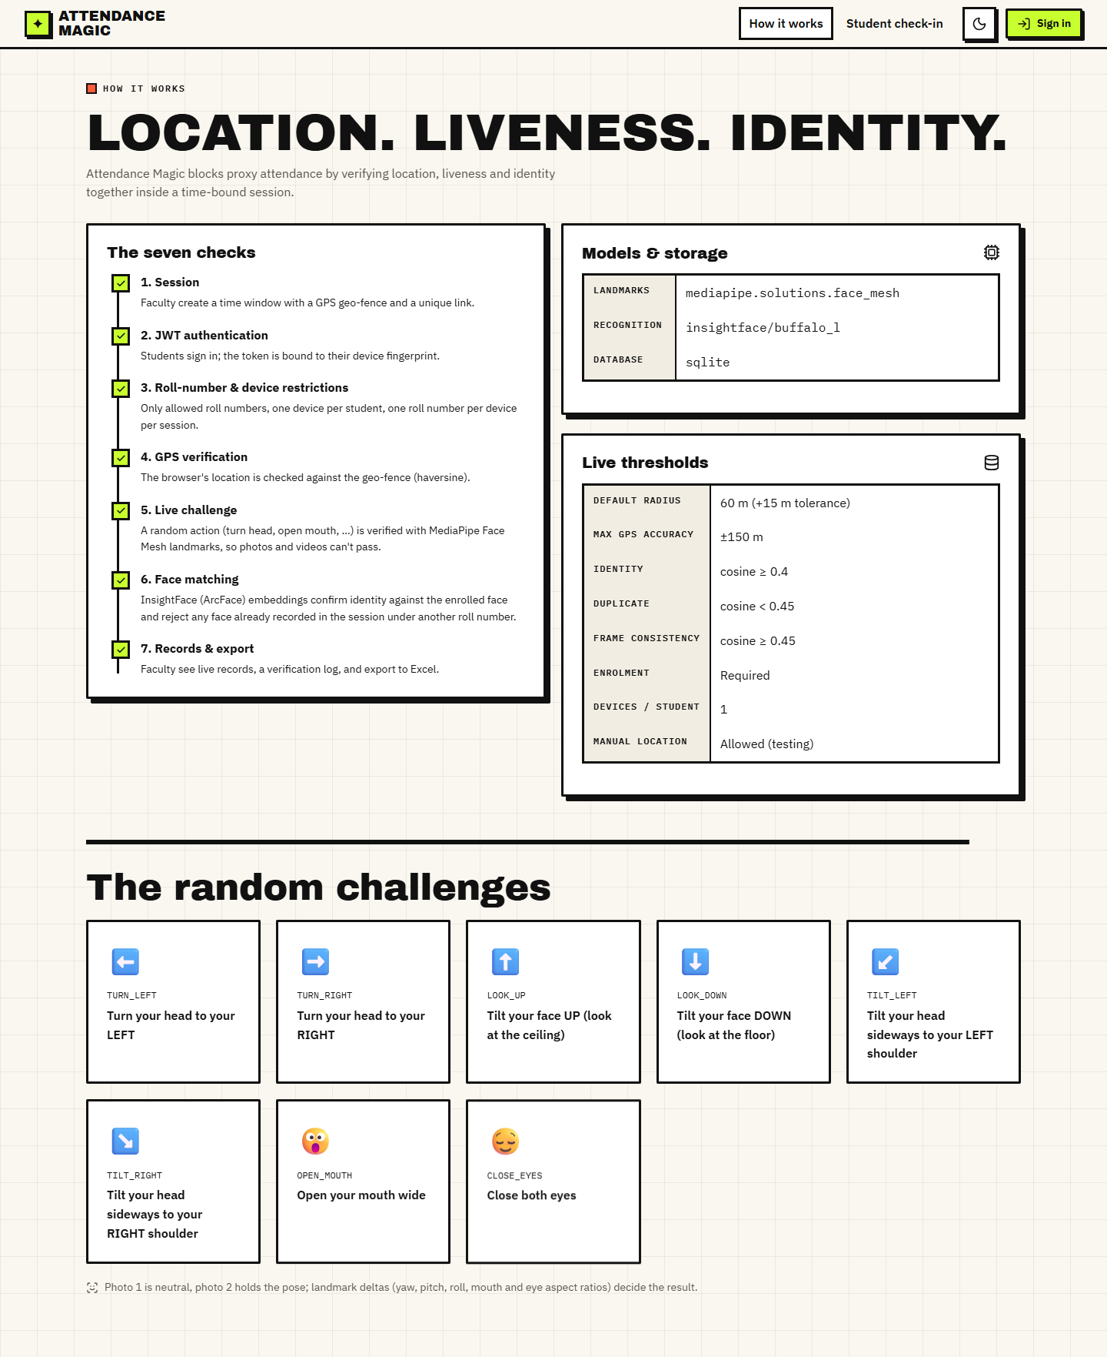  Fig. C.1: How it works page | 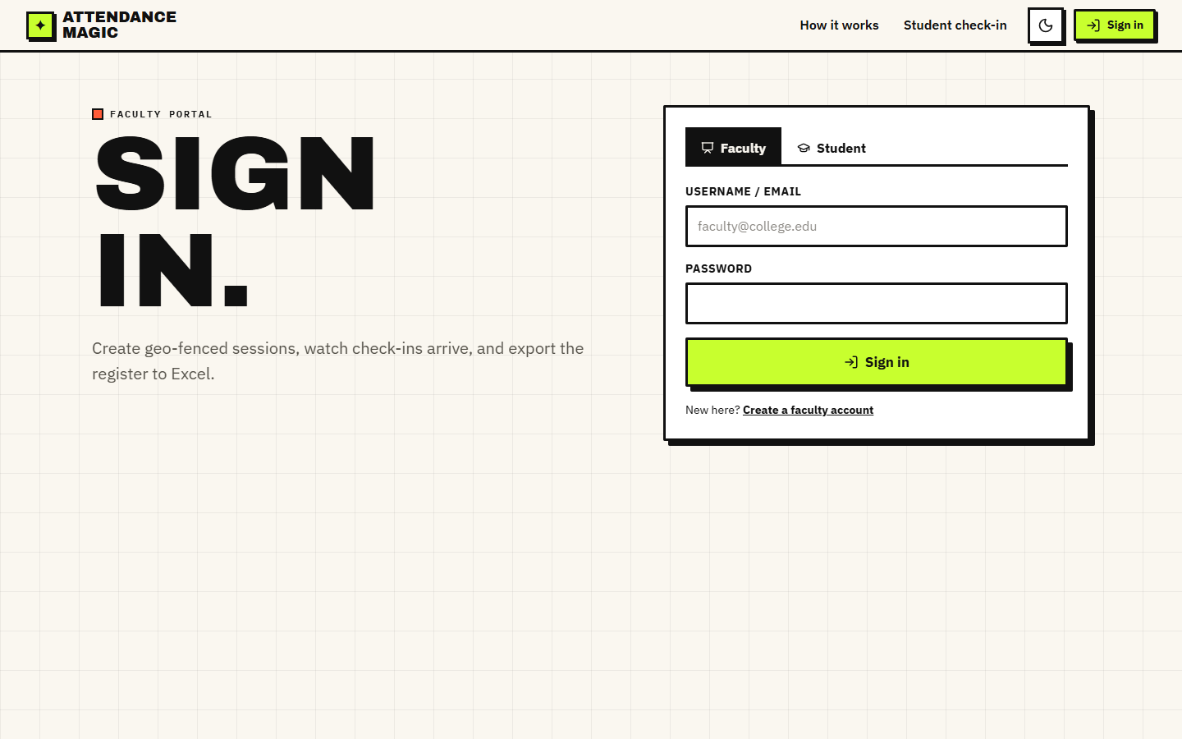  Fig. C.2: Faculty sign-in

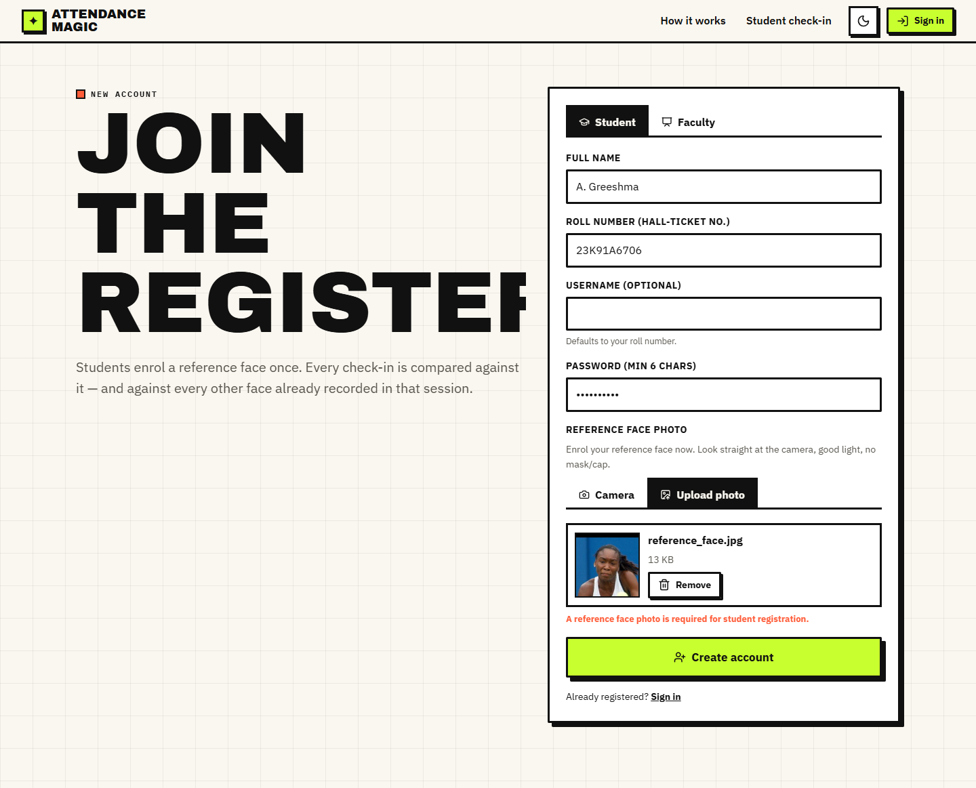  Fig. C.3: Student registration with a reference face | 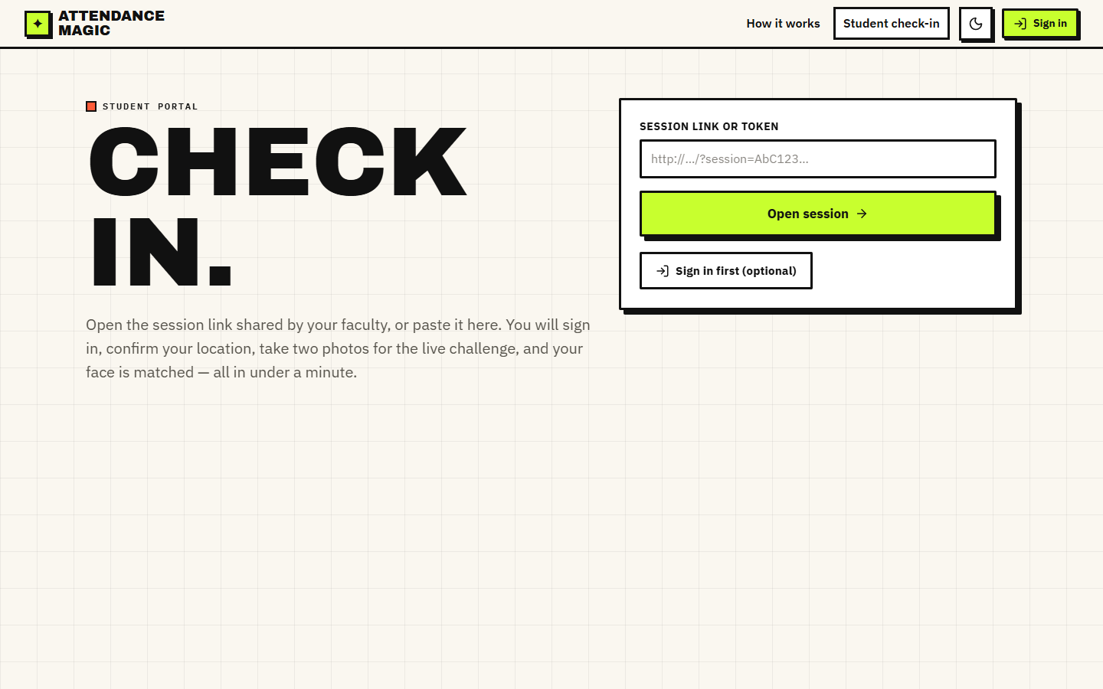  Fig. C.4: Check-in portal

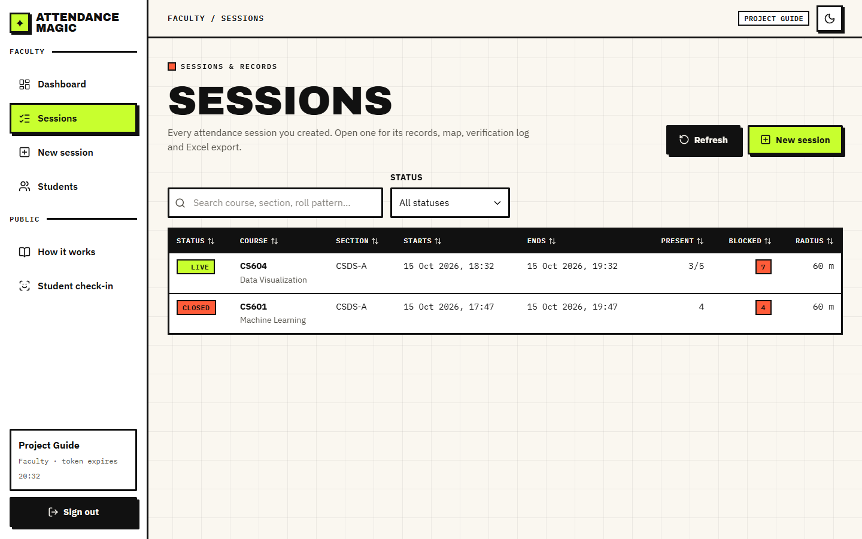  Fig. C.5: Sessions list | 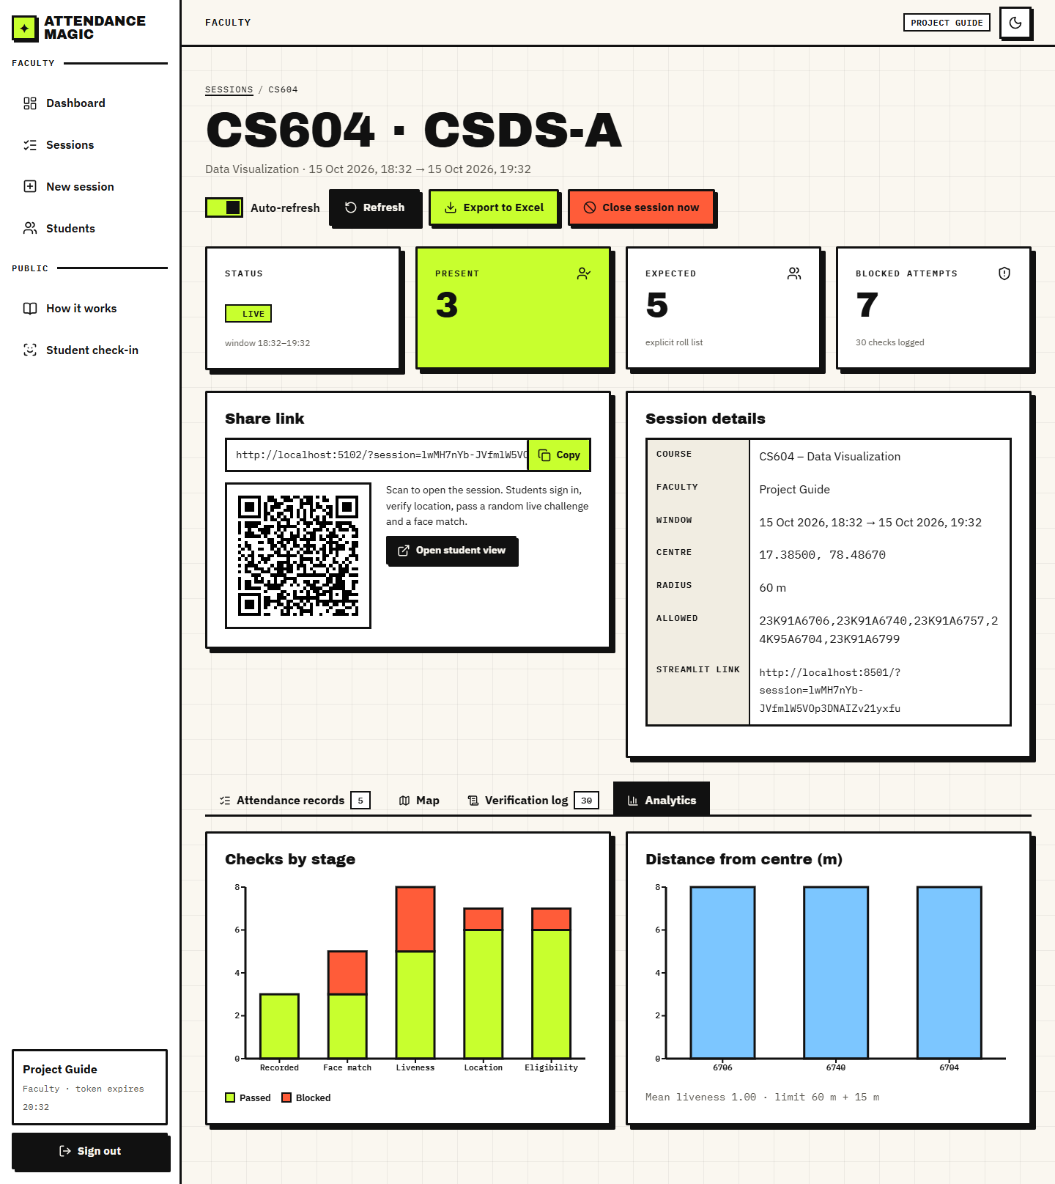  Fig. C.6: Session analytics

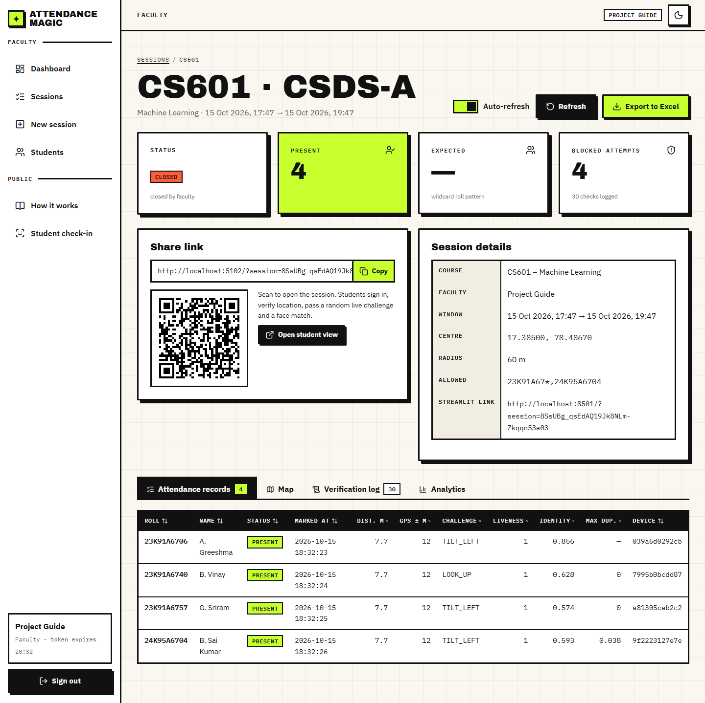  Fig. C.7: Closed session: records | 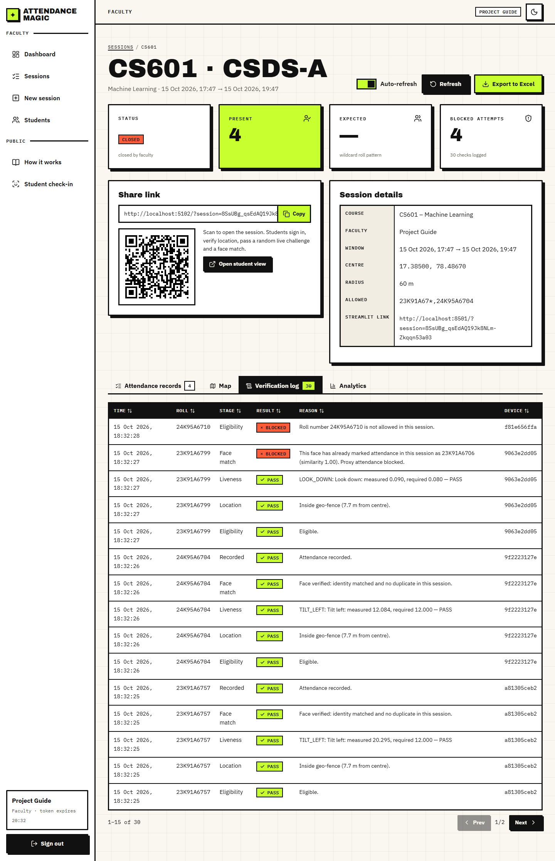  Fig. C.8: Closed session: verification log

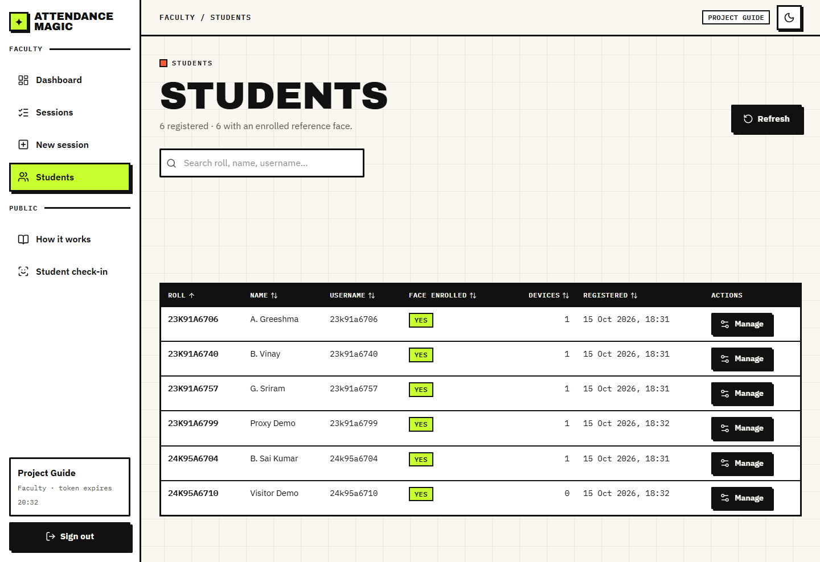  Fig. C.9: Students | 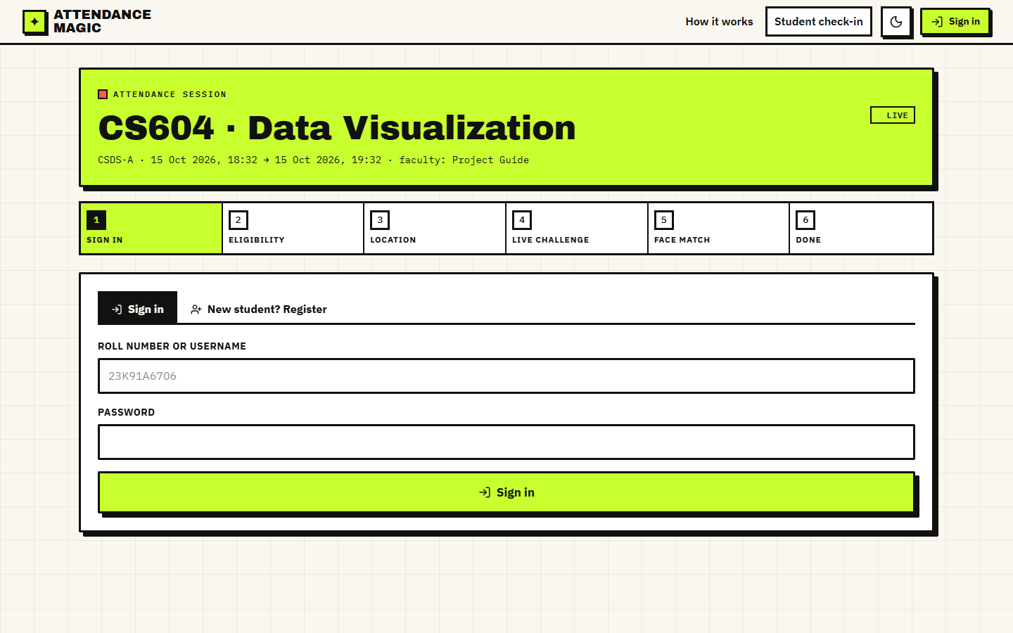  Fig. C.10: Check-in: sign in

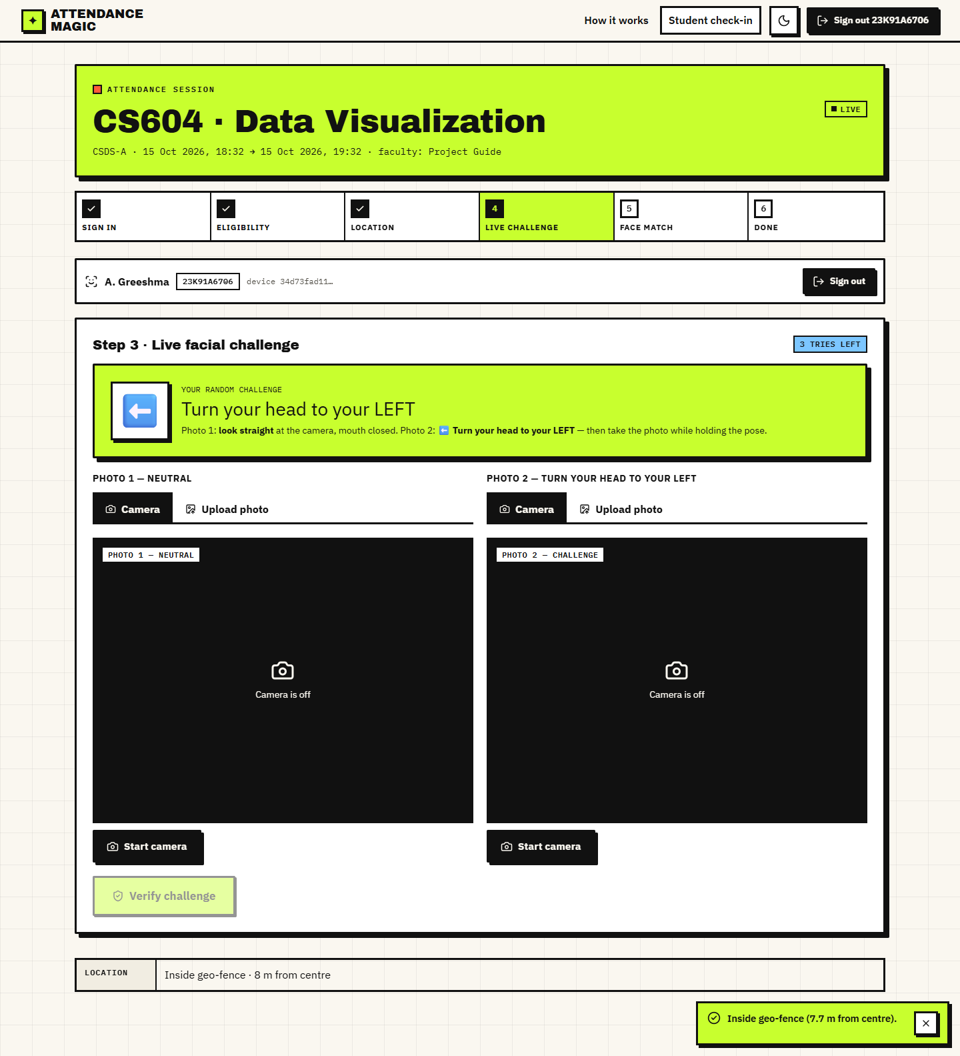  Fig. C.11: Check-in: random challenge | 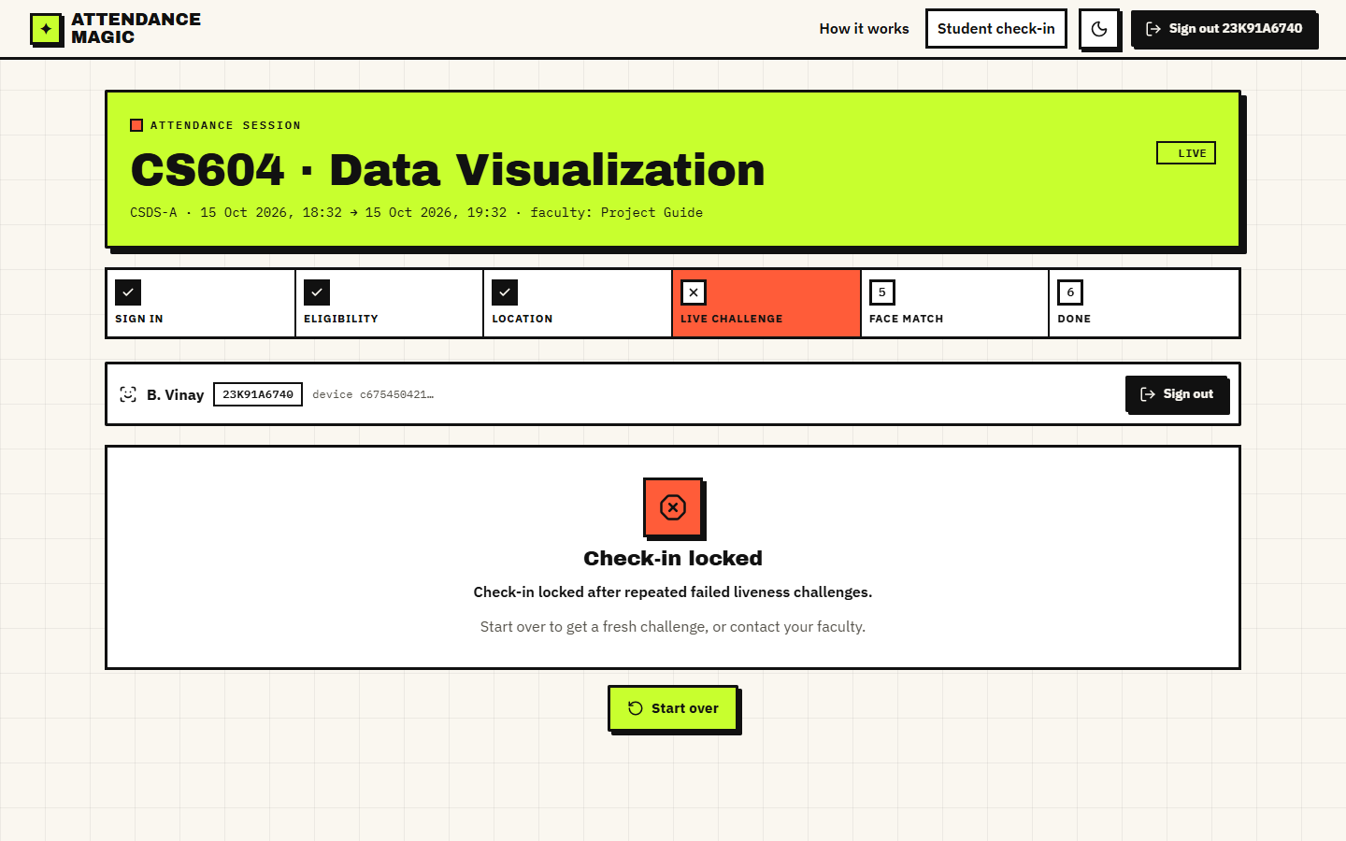  Fig. C.12: Locked after three failed challenges

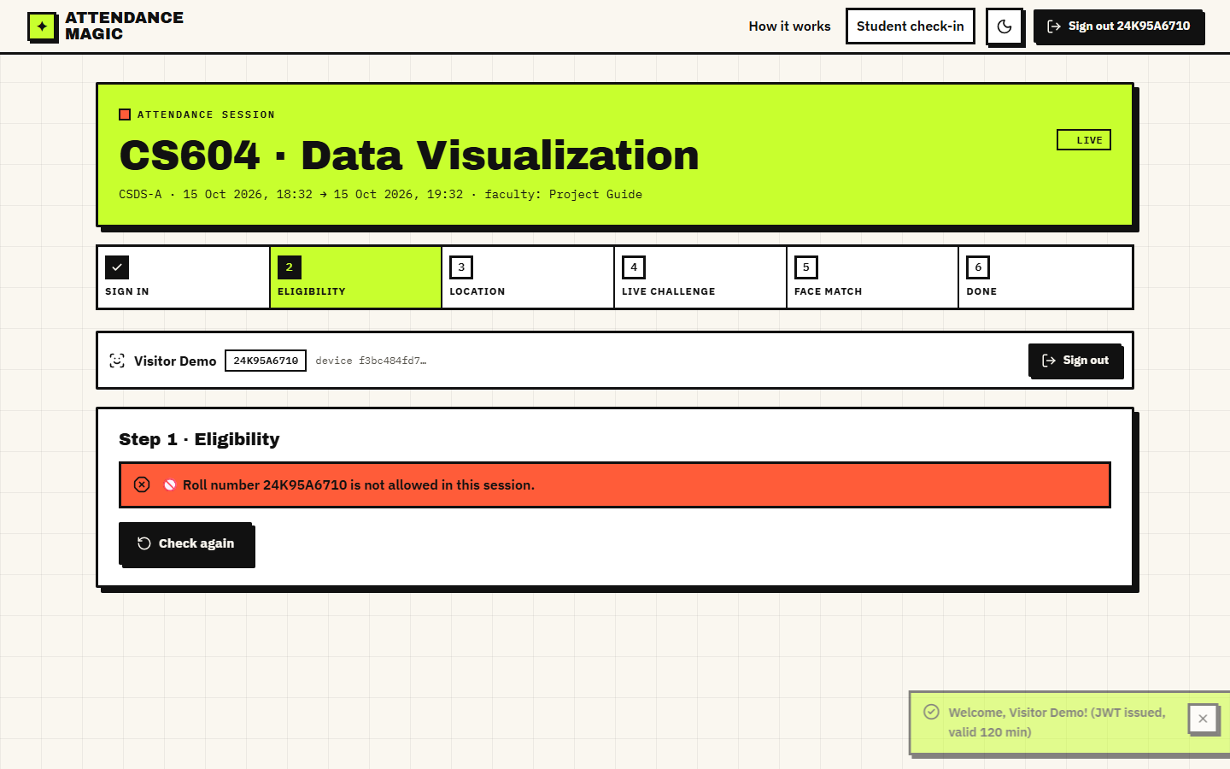  Fig. C.13: Blocked: roll number not allowed | 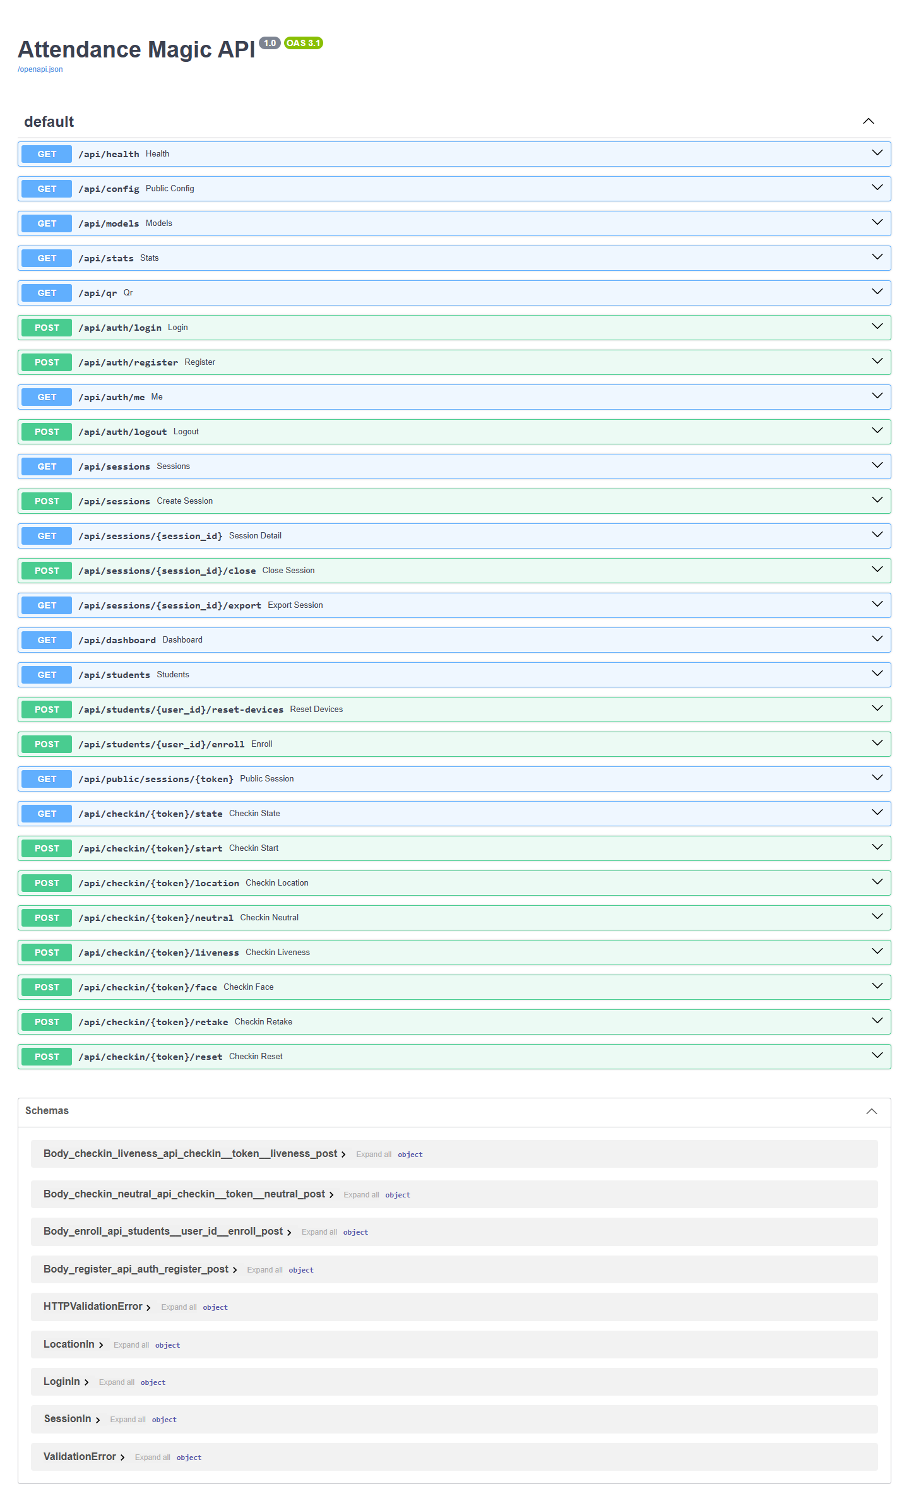  Fig. C.14: Interactive API documentation

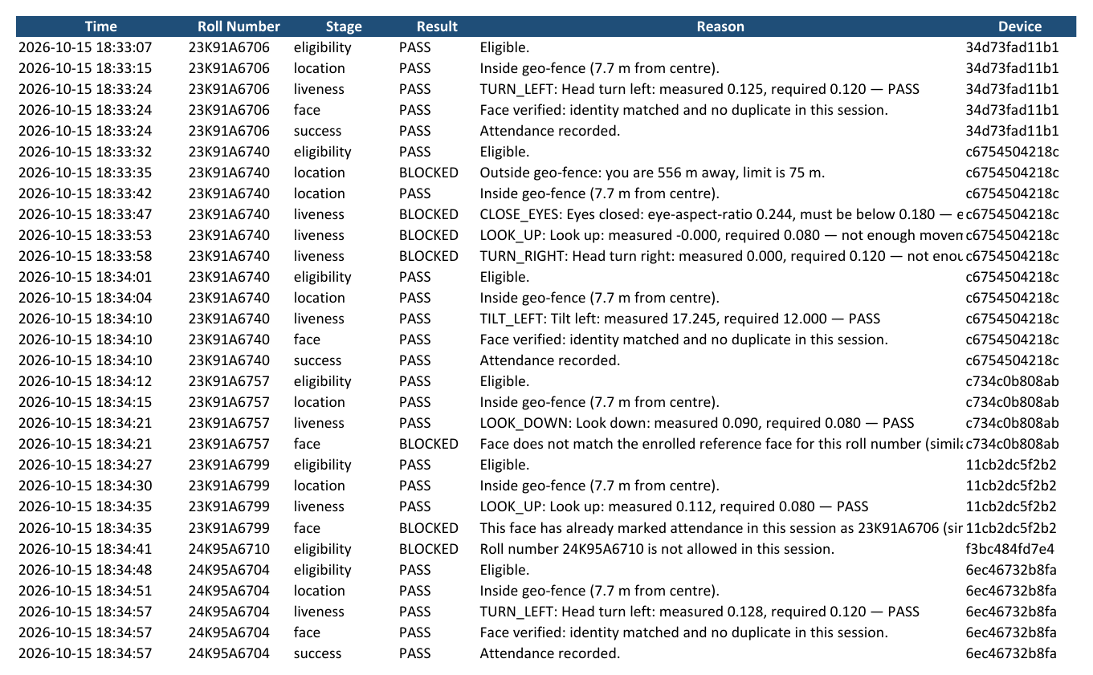
Fig. C.15: Excel export: Verification Log sheet

